Legacy Coaxial Connectors
Some Pictorial Identification & Brief Descriptions
Note – this resource is an edition (our 1st rendition) derived, in a major part, from that published by The Horsham Amateur Radio Club UK Web-Site (by their kind permission).
Warning: CASA cannot attribute authority to the comments stated by HARC and readers need to do their own due-diligence.
https://www.harc.org.uk/?page=technical&sub=connectors
Series 100/200 (PET)
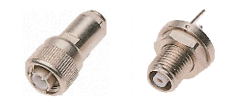
A range of non-controlled impedance, miniature screw coaxial connectors, also known as PET connectors (after the Precision Electronic Terminations Company who first produced them). The impedance of these connectors is not controlled although it approximates to 50 ohms. They are primarily intended as high voltage connectors, being rated at 3kV DC (Series 100) and 30kV DC (Series 200). Both series are available with either free (cable mounting) or chassis mounting plugs and sockets. Elbow versions, "T" junctions, inter-series adaptors and dust caps are also available. Mated plugs and sockets are retained by means of a knurled threaded ring. The body-parts were sometimes made from aluminium.
MUSA Series
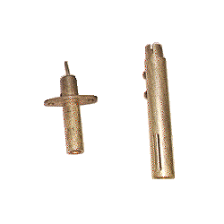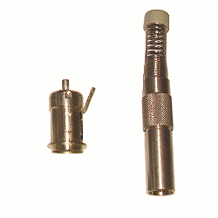.
"MUSA" is an acronym for "Multi-User Steerable Array" or "Maximum Use (of) Space Available". The first acronym relates to a connector apparently used for manually switching signals in very early experimental radar systems. Both acronyms may refer to the same series of connectors, the latter referring to a series of connectors used by the BBC and other broadcasting authorities in 75 ohm video distribution systems, typically used with a double screened, application specific, cable. There are at least two different connector ranges in the MUSA series, that shown in the first picture may have been designed and developed by the BBC but it was also often used in British telephone exchanges, so may have been designed by the GPO when they were responsible for the UK telephone system. The second picture shows a similar connector, designated 4/13 COAX, which may have been designed by Siemens and is used mainly on professional broadcasting equipment. The MUSA series of connectors are not impedance controlled but are designed to be nominally 75 ohm.
https://www.casa.co.nz/Connectors/Coaxial/MUSA/
Dezifix Connectors
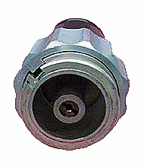
Dezifix connectors are very large, quick release, hermaphrodite coaxial connectors, retained by a ring operated cam locking device. These connectors are precision devices, normally only used on test equipment and are generally available in 50ohm, 60ohm and 75ohm versions but could easily be made for other characteristic impedances if required. The dielectric is usually polystyrene and the metal parts are silver plated. The external diameter of the shell is the same for all impedances but the internal diameter and the diameter of the centre pin are chosed depending on the impedance required. It should be noted that all impedance types are mechanically inter-mateable with each other, meaning that it is essential to ensure only similar types are inter-connected, otherwise serious electrical mis-match and high VSWR will result. This type of connector was developed by the Rohde and Schwarz Company and used primarily by them. The principle of operation is similar to that of the GR900BT connector.
https://www.casa.co.nz/Connectors/Coaxial/Gallery/
Belling-Lee (PAL)
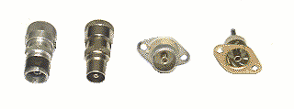
Originally developed in the 1940s by the Belling-Lee company they are now-a-days widely know as PAL connectors and they serve a similar role as their North American “F” connector. They are now standardised TV connectors complying with IEC Spec 60169-2. In the UK, the antenna input ports of TV receivers have almost always been fitted with these connectors. With the advent of UHF TV in the early 1960s, tests were carried out to ascertain whether this type of connector could be retained for use at those frequencies. The tests revealed that the good quality chassis mounted sockets then available were a reasonable match to 75ohm cable but the corresponding cable mounted plug had a lower characteristic impedance of around 50ohms. Chassis mounted plugs were a reasonable match to 75ohm cable but cable mounted sockets also had a characteristic impedance of around 50ohms. However, it was thought that this was of more academic interest than practical importance, although modern digital broadcasting protocols may suffer from reflection problems if the aerial system VSWR is too high. This implies that standard TV connectors are usable up to about 800MHz, exhibiting a reasonable VSWR and fairly low loss, provided that they are correctly fitted to the cable. The cable braid should be teased out and then trapped between the cable clamping ferrule and the body of the connector. The centre conductor of the cable must be threaded through and soldered to the centre pin of the connector in the plug versions or soldered to the appropriate solder bucket in the socket versions.
The impedance of these connectors is not controlled but can be regarded as being between 50ohms and 75ohms. The shells of commercial versions are usually manufactured from aluminium but military versions were made using nickel plated brass. The centre pin is retained and is usually manufactured from silver plated brass. The insulating material is usually polythene but other cheaper materials are found in lower quality devices. Both male and female halves are available in cable and chassis mounting versions and in both versions the male plug is a push fit into the female socket and is not otherwise retained.
Belling-Lee connectors were never intended to be used with high RF powers but they have been used successfully at 50MHz with powers of 100W.
Versions of these connectors have been produced, in which the cable is connected to the connector elements by means of small screws. These types of connector should be avoided as the VSWR is not likely to be within acceptable limits and the losses are likely to be much higher than those associated with the ‘standard’ types.
https://www.casa.co.nz/Connectors/Coaxial/PAL/
PYE Connectors
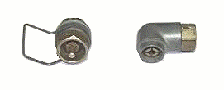
PYE connectors were developed by the Company of the same name in the 1940s and were used on many British military equipments. By modern standards, they are truly dreadful connectors, being unsealed with a totally uncontrolled characteristic impedance. Although, during WW2, they were used at frequencies up to 100MHz and perhaps even higher, it was because there was nothing else available in the UK, rather than because they were suitable for purpose.
The two halves of a mated pair are retained using a wire clip. The female half was always chassis mounting and was made of nickel plated brass or steel and the dielectric was usually paxolin. The female shell was always fitted with a male centre pin. The male half was always cable mounted and had a female centre pin. The dielectric was usually polythene and paxolin. As the male and female halves of the connector were made of dissimilar metals, there was always the risk of serious corrosion in damp environments, especially as they were not sealed in any way.
It is not recommended that this range of connectors be used by home constructors unless they are to be used with existing equipment that cannot be modified for historical interest reasons.
https://www.casa.co.nz/Connectors/Coaxial/gallery
Burndept Connectors
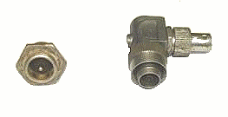
The Burndept Company developed this series of fairly large, non-controlled impedance coaxial connectors in the 1950s that were used in a variety of professional and military applications. They are not sealed and mated connectors are retained by a threaded ring. Both axial or radial (angle) cable entry versions were made. These connectors are no longer manufactured and their use in amateur radio applications should be limited to interfacing with existing equipment where modification to more modern connectors is not an option.
https://www.casa.co.nz/Connectors/Coaxial/gallery
Pattern 12 or "Miniature Pye" Connectors
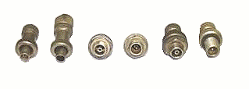
Pattern 12 or "Miniature Pye" connectors are not, as their name would imply, small versions of the classic PYE connectors described above. They are very different, hermetically sealed, small, coaxial connectors with retained centre pins, much favoured by the British Military in the 1950s and 60s and used by Racal and others. They are available with either male or female shells and either may be chassis or cable mounted. All types of shell may be fitted with male or female centre pins. The two halves of a mated pair are retained using a threaded ring. The characteristic impedance of this range of connectors is not controlled but this is thought to be around 50 ohms and they may be used up to 100MHz and 100W. The dielectric appears to be polythene.
It is surprising that a search of the Internet does not provide much information about this very useful and fairly rugged range of connectors. It is not thought that these connectors have ever been used on commercially made amateur radio equipment but there is no reason why the home constructer should not use them, assuming he has acquired adequate numbers of spares to account for future requirements.
https://www.casa.co.nz/Connectors/Coaxial/gallery
Note – there are many other ‘legacy’ coaxial connectors. We hope to add to the above as time permits. In the meantime, for further data on RF coaxial connectors please refer to:
https://www.casa.co.nz/connectors/coaxial/
https://en.wikipedia.org/wiki/RF_connector
https://en.wikipedia.org/wiki/List_of_RF_connector_types
https://commons.wikimedia.org/wiki/Category:RF_connectors
1st CASA edition 03/08/23 (AWD) – comments to sales@casa.co.nz (Subject - Legacy Coaxial Connectors - Discussion)

