,,....



· **ANDRE\N**

INSTALLATION INSTRUCTIONS

CONNECTORS FOR FSJ1-50

SUPER FLEXIBLE HELIAX® COAXIAL CABLE

BULLETIN 372248

,.,.j ••••

|  |  |  |  |  |  |  |
| --- | --- | --- | --- | --- | --- | --- |
|  | · 'iltPe Nwnber f | ---·- '  Tetmlhatlon | - - g Connector  Matin | Fig.1 A Dim. in. (mm) | Fig.1B Dim. in. (mm) | Fig.4C Dim. in. (mm) |
|  |
| 41SP  41SW  40622  41SWT | Type UHF Plug Type N Plug Type BNC Plug Type TNC Plug | S0-239A UG-23  UG-89  TNC Jack | 1-19/32 (40)  29/32 (23)  3/4 (19)  11/16 (17) | 11/16 ( 17)  13/32 (10)  15/64 (6)  13/64 (5) | - -  39/64 ( 15)  9/32 (7)  9/32 (7) |

TOOLS AND MATERIALS REQUIRED FOR ASSEMBLY

Garnet cloth

Knife

Wire brush

Scale, 6 in. (150 mm) Soft solder (rosin core) Wrenches (2) 7/16 in.

Soldering iron (50 watt max.) Solvent,comothene, vythene or other non-flammable cleaning fluid

READ THE INSTRUCTIONS THOROUGHLY BEFORE ASSEMBLY

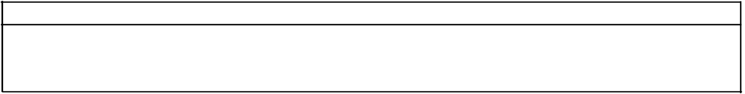

STEP 1. Cut cable as shown in Figure 1. Cable end must be square. New cut can be made with sharp knife in sawing motion. Use straight-edged piece of paper around cable to guide jacketing cut. Clean outer conductor with solvent. Cut off out.er con­ ductor and foam with knife. Use knife to remove burrs. Use wire brush to remove copper particles from foam. Continue with Steps 2 and 3 for Type

41SP connector. For Types 41SW, 40622, and

41SWT connectors, read soldering techniques in Step

2 and proceed with Steps 4 and 5.

A -

FIGURE 1

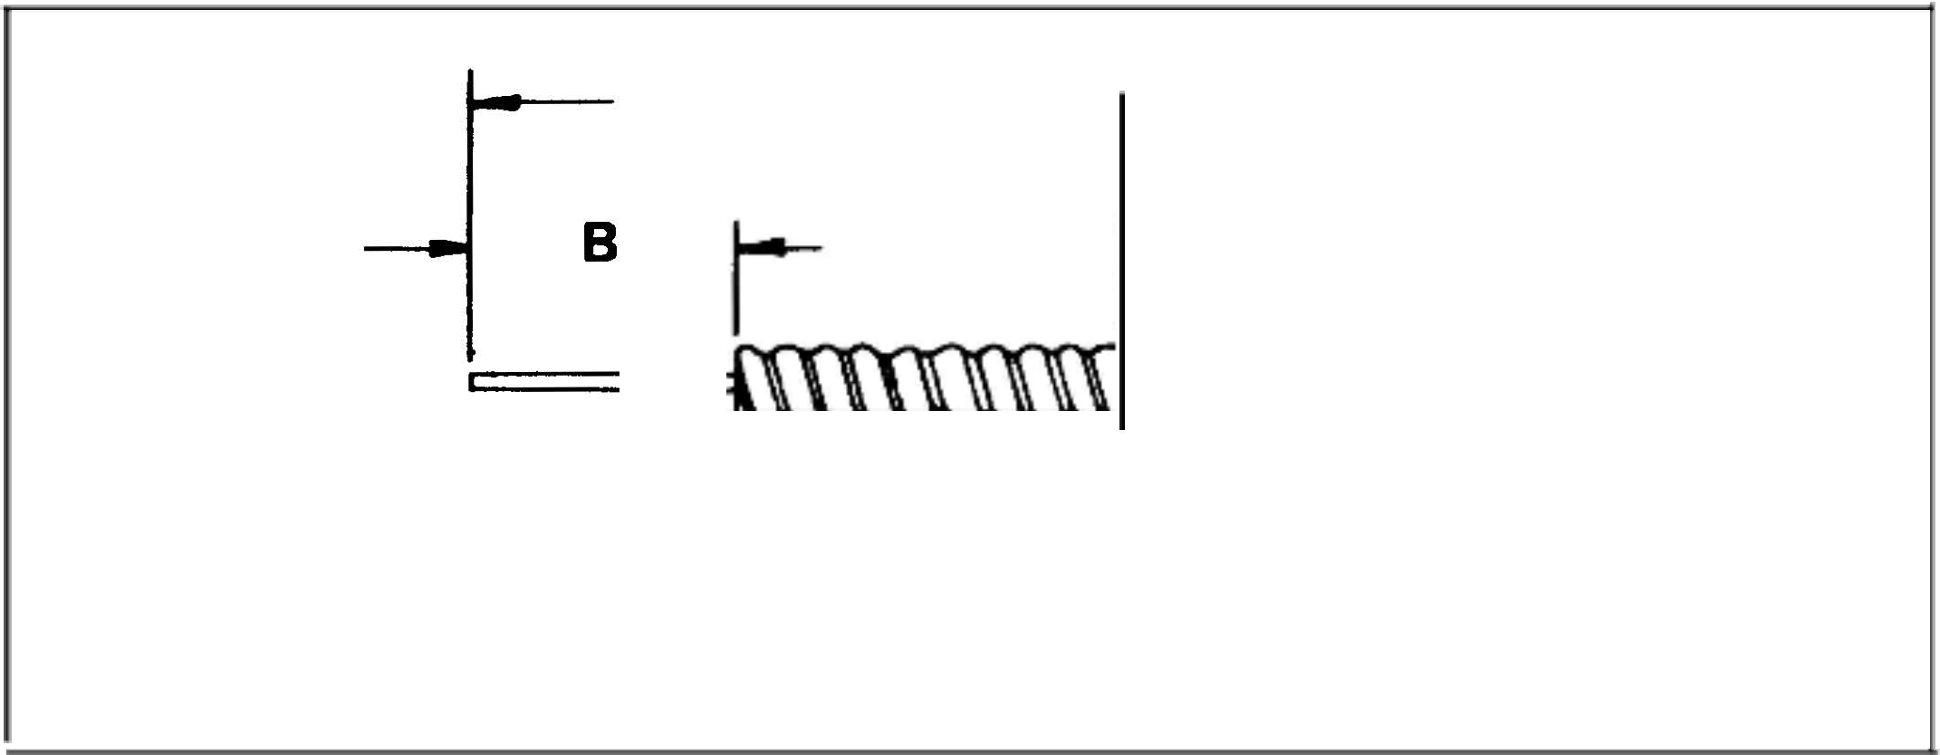

STEP 2. Slide UHF coupling nut onto cable with knurled end toward cable end. Add adaptor until flush with end of outer conductor. See Figure 2. Soft solder adapter to outer conductor. Use soldering iron or gun and rosin core solder. Avoid excessive heat. Keep inner conductor centered. Apply heat to adaptor to draw solder into hole. Wipe away excess solder and cool connection with damp cloth. Clean connection with garnet cloth. Do not use emery cloth or steel wool.

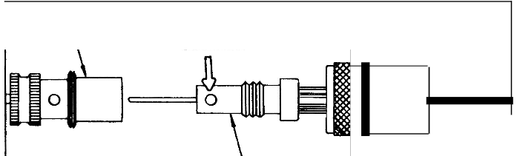

INNER CONNECTOR

FIGURE 2



SOFT SOLDER

ADAPTOR

COUPLING NUT

Andrew Corporation 10500 W. 153rd St. Andrew Antennas Andrew Antenas Umitada

Orland Park, IL U.S.A. 60462 Lochgelly, Fife, Great Britain Sorocaba, SP. Brazil

Antennas Andrew S.A.R.L Andrew GmbH

Buc, France Munich. West Germany

Andrew Antenna Company ltd. Whitby, Ontario, Canada

Andrew Antennas Antenas de Transmisi6n S.A de C.V Andrew Corporation

Campbellfield, Victoria, Australia Mexico, D.F. Mexico Tokyo, Japan

Andrew S.R.L Milan, Italy

6/83

PRINTED

IN U.S.A.

**STEP** 3. Screw UHF inner connector firmly onto adaptor. Soft solder connector to adaptor and to inner conductor as shown in Figure 3. Clean connec­ tion. Screw coupling nut *bnto* inner connector until nut spins freely.



**STEP 4.** Slide Type N, BNC or TNC adaptor onto cable until flush with end of outer conductor. See Figure 4. Soft solder adaptor to outer conductor. Slip inner connector onto inner conductor until it bottoms against inner conductor. Check reference "C" dimension in table. Soft solder inner connector to inner conductor.

INNER CONNECTOR

SOFT SOLDER

FIGURE 3

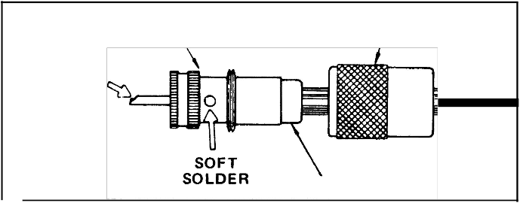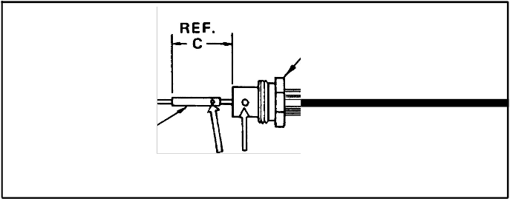

INNER

CONNECTOR SOFT SOLDER

COUPLING NUT

ADAPTOR

ADAPTOR

FIGURE 4

**STEP** 5. Screw Type N, BNC, or TNC coupling nut onto adaptor as shown in Figure 5. Tighten connec­ tion with wrenches. Turn coupling nut only; do not turn adaptor. Correct gap between coupling nut and adaptor after tightening should be approximately

3/32 in. (2 mm).

COUPLING NUT

FIGURE 5

