|  |  |
| --- | --- |
| [www**.Eiectrojumble.org.uk**](http://www.Eiectrojumble.org.uk/)  RADIO FREQUENCY PLUGS AND SOCKE'IS  NOTES | SECTION 15/D |
| SHEET NO. 1 |
| ISS. NO. 5 1/60 |
| COMPONENTS COVERED: THIS SECTIOH COVERS THE FOLLOWING TYPES LISTED IN THE ORDER GIVEN:-  50 OHM CONCENTRIC  50 OHM MOULDED  60 OHM CONCENTRIC  GENERAL PURPOSE  ALL I'IEMS ARE SUITABLE FOR USE AT FREQUENCIES ABOVE 1Mc/s  MATCHED IMPEDANCE TYPES: THESE ARE DESIGNED TO MINIMISE REFLECTIONS AT FREQUENCIES ABOVE 600Mc/s, WHEN INSERTED IN THE APPROPRIATE CABLE  CABLES: WHERE POSSIBLE, SUITABLE CABLES HAVE BEEN INDICATED. IT SHOULD BE NOTED THAT SUCH CABLES DO NOT NECESSARILY HAVE THE SAME TEMPERATURE RATING AS THE ASSOCIATED PLUGS AND/OR SOC.KE'IS. THE SPECIFICATION DEALING WITH CABLES IS DEF-14  MATING COMPOJ\'ENTS: WHERE POSSIBLE, THE JOINT SERVICE APffiOVED MATING COMPONENTS ARE  TABUUTED WITH THEIR ASSOCIATED ITEMS  DAMP HEAT: THIS EXPRESSION COVERS BOTH CLIMATIC AND TROPICAL EXPOSURE CONDITIONING  PATTERN 12: THESE SUPERSEDE PATTERN 1 NOW OBSOLESCENT. THE MAXIMUM DIMENSIONAL INCREASE  IN BODY LENGTH DOES NOT EXCEED 13/32. THE WORKING VOLTAGE IS -INCREASED TO 500 VOLTS  u  ASSOCIATED DATA SHEETS:  NO GENERAL INFORMATION CONCERNING THE USE OF R. F. PWGS HAS BEEN ISSUED  SEE SECTION A FOR PANEL PIERCING DIMENSIONS AND ACCESSORIES :fuR  PATTERNS 4 , 8 AND 40  [www**.Eiectrojumble.org.uk**](http://www.Eiectrojumble.org.uk/) | |



1z-i

*0*

gj

**RADIO FREO u'1JE S & SOCKETS**

**WITH BARRIER AND PANEL SEALS**

'

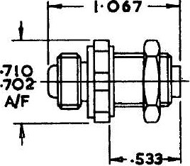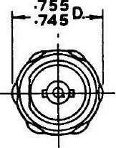

I **f**

**1·255**

**PATTERN 2**

|  |  |  |  |
| --- | --- | --- | --- |
| e | **STYLE AR 2 B** | **STYLE A8R2G** | **STYLE SR2E** |
|  | MAXDm!l PANEL TRICKN | ESS 1/8. ALL 'l'RREA.D8 9/16. DIA. x | 26 T.P.I. WHITWORTH FORM |

MATERIAL - ALm.cr:l'fiUI! BRONZE OR APPROVED ALTERNATIVE. FINISH - CLEAN

5 -------T-

il_ oR _2_B_I_S S ----- --Y_ IT_ t i T --- --B_TBREE PL_U_Gs_ -4

HUMIDITY CLASS: H1.

0 TEMPERATURE CATEGORY: 40/70 A

I WORI<mG VOLTAGE: (NORMAL AIR DENSITY)

I

WORKING VOLTAGE: (LOW AIR DENSITY)

PROOF VOLTAGE: INSULATION RESISTANCE: CONTACT RESISTANCE:

I

IMPEDANCE

500 VOLTS PEAK

NOT SPECIFIED

2kV PEAK

NOT LESS THAN 1OOMO OOTIALLY OR 1O:Mn AFTER DAMP BEAT

POIE. INITIALLY 2 MILLIOHMS MAX. AFTER DAMP HEAT .5 MILLIOHMS MAX.

SCREEN. INITIALLY 1 MILLIOHM MAX. AF'.IER DAMP HEAT 5 MILLIOHMS MAX.

INSERTION OF ITEM IN SUITABLE CABLE PRODUCES :taSMAroH WHICH, EXPRESSED

ISEALING:

MATCH.niG:

. AS VOL'rAGE STANDING WAVE RATIO, IS lESS THAN 1• 2:1

AIR u:.AKAGE. NOT GREATER THAN 1 c.c. PER HOUR AT 20lb/sq. in. APrER ALL

CABLE FIXING:

VIBRATION:

CORROSION: ENDURANCE:

CONDITIONING

WITHSTANDS 30lb FULL AWNG CABLE AXIS

WITHSTANDS FREQUENCY CYCL!NG TO RCS-11 WITHOUT RESONANCE, LOOSENING OR DISENGAGEMENT

WITHSTANDS RCS-11 TEST WITHOUT MECHANICAL DETERIORATION WITHSTANDS RCS-11 SALT WATER TEST

WITHSTANDS ENGAGEMENT AND DISENGAGEMENT .500 TIMES AND SIX WEEKS HIGH TEMPERATURE CYCLING·WITH NEGLIGIBLE ELECmiCAL AND MECHANICAL DETERIORATION

MATING COMPONENTS, APPROPRIATE CABlES AND JOINT SERVICE CATALOGUE NUliBERS

IU.TING APPROPRIATE JOINT SERVICE COMPONENT CABLES CATALOGUE NO.

STYLE TYPE

ilAPTOR,FREE,

AR2B PLUG TO PLUG PR2A NOT SPECIFIED 054-0013

TO PLUG PR2C

MALE SHELL PR2E

SOCKET,FIXED1 PR2A

SR2E

MA.LE SHELL PR2C NOT SPECIFIED 054-0014

PR2E

ilAPrOR,FIXED , PR2A

**SECTION 15/0**

fiR2G PLUG TO PLUG, PR2C NOT SPECIFI 054-0015

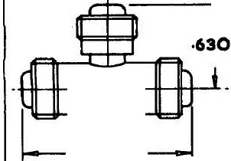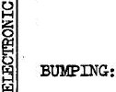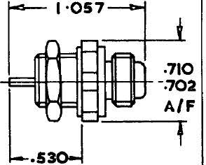

MALE SHELL PR2E



**SHEET No.2**

**ISS.No.3 *9/63***

RADIO FREQOEYmt\jt;S & SOCKETS

PATTERN 2

50 OHM CONCENTRIC

I A6R2G

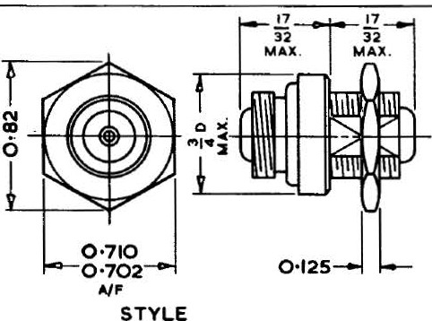

AIF

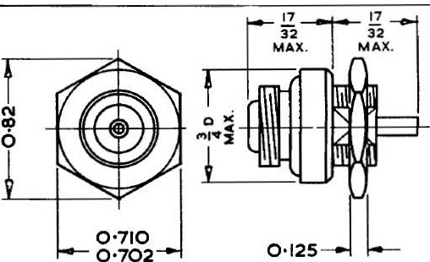

ALL THREADS i\ DIA. X 26 TPI. 85 WHIT.

STYLE SR2E

MATERIALS - ALUMINIUM BRONZE. FINISH CLEAN

IDJKIDITY CLASS:

TEKP.ERATURE CATEGORY:

WORKING VOLTAGE: (NORMAL AIR DENSITY)

I

liORKING VOLTAGE:

(U>W AIR DENSITY)

PROOF VOLTAGE: INSULATION RESISTANCE: CONTACT RESISTANCE:

I

lliP.IIDANCE MATCHING:

I

SEALING:

CABLE FIXING:

I

VI:BRATION:

:&lltPING: CORROSION: ENDURANOE:

H1

40/85

NOT SPECIFIED NOT SPECIFIED

NOT SPECIFIED

NOT lESS THAN 100140 INITIALLY OR 1OMO AFTER DAMP BEAT

POLE. INITIALLY 2 la.LLIOHIS llAX. AF'lER DAMP HEAT 5 MILLIOHMS :MAX.

SCREEN. llUTIALLY 1 MILLIOHW llAX. AFlER DAMP HEAT 5 Jm.LIOB15 VAX.

INSERTION OF ITEM IN SUITABLE CABLE PRODUCES M:ISMA'.OOH WHICH, EXPRESSED

AS VOLTAGE STANDING WAVE RATIO, IS LESS 'mAN 1• 2:1

Am LEAKAGE NOT GREATER THAN 1 c,c. PER HOUR AT 20lb/sq. in. .AFlER ALL

CONDITIONING

WITBSUNDS 30lb PULL ALONG CABLE AXIS

WITHStANDS FREQUENCY CYCLING TO ::BC)-11 WITHOUT RESONANCE, WOOEN!NG OR

DISENGAGEMENT

WITHSTANDS :RCS- 11 TEST WI'IHOUT lo!ECBANICAL DETERIORATION WITHSTANDS RCS-11 SALT WATER TEST

WITHSTANDS ENGAGEMENT AND DISENGAGEMENT 500 TIMES .AND SIX WEEKS HIGR

TElo!PERA.TURE CYCLING WITH NEGLIGIBLE ELEC'lRICAL AND :MECHANICAL DETERIORATION

IIATING COMPONENTS, .APPROPRIATE CABlES AND JOINT SERVICE CAULOGUE NUMBBBS

|  |  |  |  |  |
| --- | --- | --- | --- | --- |
| STilE | Tm: | MATING  COMPONENT | APPROPRIATE  CABI&S | JOINT SERVICE CATALOGUE NO, |
| ABR2G  SR2E | ADAPTOR, FIXED, PWG TO PUJG, MALE SHELL  SOCKET, FIXED,  MALE SHELL | PR2A PR2C PR2E  PR2A  PR2E | NOT SPECIFIED  NOT SPECIFlED | z. 540015  z. 540014. |

PR2C

ALL Z NUMBEllS TO BE FRECE.DED BY 5935-

[www.Electrojumble.org.uk](http://www.Electrojumble.org.uk/)

SECTION 15/0

SHEET No.3

ISSUE No.I

**RADIO FREQU W<Se"roj LU& SOCKETS**

**WITH BARRIER AND PANEL SEALS**

**GENERAL PURPOSE**

**- -1·681 - --c**

**PATTERN 4**

**FW PW SG**

**PR40**

I

**SG PW FW**

**PR4E**

**CO CE**

**SR4G**

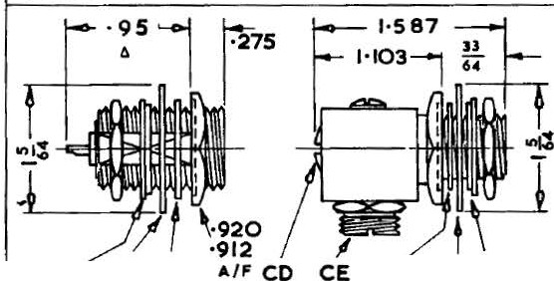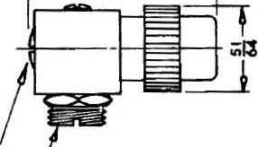

**FW PWSG**

**ABR4F**

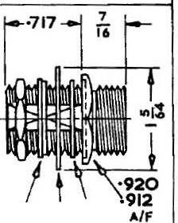

Panel Thickness 3/16 max.1/2 min.

Finish:- Flanged Washer - tinned brass

All other parts - Sllver plated

FW:- Flanged Washer

PW:- Packing Washer

(Syn. Resin Bonded Fabric)

SG:- Panel Sealing Gasket

0 CD:- Cap,Detachable

t CE:- Cable Entry

NOTE 1 On PR4E and SR4G the Cable Entry and Cap are detachable and interchangeable to give a straight cable entry.

NOTE 2 The Flanged Washer and Packing Washer are used when fitting component to a panel of dissimilar metal or finish.

NOTE 3 Accessories for PR4E9 SR4G and

Cables, see Sheet No.1

**8--------------------------------------------------------------------------------------**

m

ES

{/)

*r3*

i

HUMIDITY CLASS:

TEMPERATURE CATEGORY: WORKING VOLTAGE:

(NORMAL AIR DENSITY)

WORKING VOLTAGE:

H2

40/70

500 VOLTS PEAK

NOT SPECIFIED

(LOW AIR DENSITY) PROOF VOLTAGE: INSULATION RESISTANCE: CONTACT RESISTANCE :



IMPEDANCE MATCHING:

0

I

SEALING:

CABLE FIXING: VIBRATION:

BUMPING: CORROOION: ENDURANCE:

MATING COMPONENTS AND JOINT SERVICE CATALOGUE NUl!BERS

|  |  |  |  |
| --- | --- | --- | --- |
| STYLE | TYPE | MATING  COlfPONENT | JOINT SERVICE CATALOGUE NO. |
| PRltD PR4E SR4G  ABR4F | PWC., FIXED,  FEMALE SHELL  PUJG, FIXED,  FEMALE SHEIJ..  SOCKET , FREE  MALE SHELL  ADAPTOR, SOCXET TO  SOCKET, **.!§W4Uo,** | SR4G  SR4G  PRl+E | 011-9484  054-0018  054-0022 |
| ABR4P  I 054-0019 | |

2kV PEAK

1OOMO UNDER ALL TEST CONDITIONS

POLE. INITIALLY 2 MILLIOID.B MAX. .AYlER DAMP HEAT 5 MI.LLIOHMS MAX. SCREEN. INITIALLY 1 MILL!OHM·MAX. AFTER DAMP HEAT 5 MILLIOID.f> l!AX.

INSERTION OF ITEM IN SUITABLE CABLE PRODUCES MISMATCH WHICH, EXPRESSED AS VOLTAGE STANDING WAVE RATIO, IS lESS THAN 1 • 2: 1

AIR LEAKAGE NOT GREATER THAN 1 c.c. PER HOUR AT 20lb/sq. in.AFTER ALL

CONDI'riONING

WITHSTANDS 30lb PUU.. ALONG CABLE AXIS

WITHSTANDS FREQUENCY CYCLING TO RCS- 11 WITHOUT RESONANCE, LOOSENING OR DISENGAGEMENT

WITHSTANDS RCS-11 TEST WITHOUT MECHANICAL DETERIORATION

WITHSTANDS RCS-11 SALT WATER TEST

WITHSTANDS ENGAGEMENT AND DISENGAGEMENT 500 TildES AND SIX WEEKS HIGH

TEMPERATURE CYCLING WITH NEGLIGIBLE ELECTRICAL AND MECHANICAL DETERIORATION

ALL J .S. CAT.NUM'BERS

TO BE PRECEDED BY

595)-99-

,hle k

**SECTION 15/0**

**SHEET No.4**

**ISS . No. 3 9/63**

----------------------------------w-w-w-.E-i-ec-t-ro-ju-m-b-l-e-.o-rg-.-uk------------------------------------;

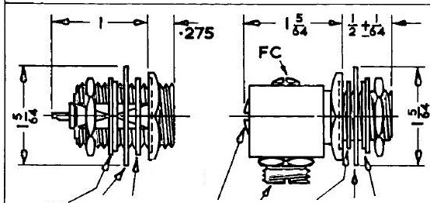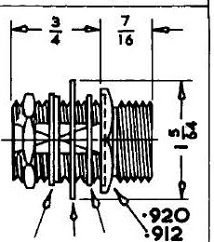

**RADIO FREQUENCY PLUGS & SOCKETS**

**PATTERN 4** *t.*

**60 OHM** CONCENTRIC

(IMPEDANCE 60 OHMS WHEN Fll.I..ED

WTI H SUITABLE COMPOUND)

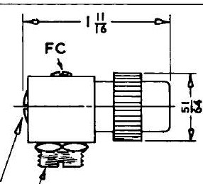

**'·920**

**·912**

**FW PW SG A/F CO CE**

**PR40**



**SG PW FW**

**PR4E**

**CD CE**

**SR4G**

**FW PWSG Alf**

**A8A4G**

Finish:- Flanged Washer - tinned brass

All other parts - silver plated

FW·- Flanged Washer

PW:- Packing Washer

(Syn. Resin Bonded Fabric)

SG:- Panel Sealing Gasket

CD:- Cap, Detachable

CE:- Cable Ent ry

NOTE 1

NOTE 2

· NOTE 3

On P.R1tE and SR4G the Cable Entry and Cap are detachable and interchangeable to give a straight cable entry.

The Flanged Washer and Packing Washer are used when fitting component to a panel of dissimilar metal or finish.

Accessories, see Sheet No.1.

HUMIDITY CLASS:

TEMPERATURE CATEGORY: WORKING VOLTAGE:

(NORMAL *AIR* DENSITY)

WORKING VOLTAGE: (LOW AIR DENSITY)

PROOF VOLTAGE: INSULATION RESISTANCE: CONTACT RESIS CE:

IMPEDANCE MATCHING: SEALING:

CABLE FIXING: VIBRATION:



BUMPING: CORROSION: ENDURANCE:

MATING COMPONENTS AND JOINT SERVICE CATALOGUE NUMBERS

|  |  |  |  |
| --- | --- | --- | --- |
| STYLE | TYPE | MATING COMPOm NT | JOD'IT SERVICE CATALOGUE. NO. |
| PR4D PR1lE SR4G  ABR4-F | PlliG, FIXED,  FEMALE SHELL  PilJG, FIXED , FEMALE SHELL  SOCKET, FREE MALE SHELL  ADAPTORS, S ffRtro m  SOCKET, FEMALE SHELL | SR4G  SR4G  ( PR4D  PR4E  ABR4F  bl e,.w.uk | Z. 11 9484  Z•.540018  Z.540022  z.540019 |

H2

40/70

500 VOLTS PEAK NOT SPECIFIED

2. 0kV PEAK

1OOMO UNDER ALL TEST CONDITIONS

POLE. INITIALLY *2* MILLIOHM:) MAX. .AF'.I!E:R DAMP HEAT 5 MILLIOHMS .MAX.

SCREEN. INITIALLY 1 MILLIOij}l MAX. AFTER DAMP HEAT 5 MILLIOFOO MAX.

INSERTION OF ITEM IN SUITABLE CABLE .PROD!JCES MISMATCH WHICH, EXPRESSED AS VOLTAGE STANDING WAVE RATIO, IS LESS THAN 1 .2:1

AIR LEAKAGE NOT GREATER THAN 1 c.c. PER HOUR AT 20lb/sq. in. A.F'I!ER ALL CONDITIONING

WITHSTANDS 301b POLL ALONG CABLE AXIS

WITHSTANDS FREQUENCY CYCLING TO RCS-11 WITHOUT RESONANCE, LOOSENING OR DISENGAGEMENT

WITHSTANDS RCS-11 TEST WiffiOUT MECHANICAL DETERIORATION WITHSTANDS RCS-11 SALT WATER TEST

WITHSTANDS ENGAGEMENT AND DISENGAGEMENT 500 TIMES AND SIX WEEKS IUGH TEMPERATURE CYCLING WITH NEGLIGIBLE ELECTRICAL AND MECHANICAL DETERIORATION

SECT iON 15 /D

ALL Z NUMBERS TO

BE PRECEDED BY

.?9.3.?-

SHEET No.4A ISS. No. 2 2/59

**RADIO FREQU&N.GYroj dJGS AND SOCKETS**

**NON-SEALED**

**GENERAL PURPOSE PATTERN 8**

**ALL STYLU ,.NISH- IILY!A PLATE**

**r**

**9**

**2fi**

0

i

H

0

(/)

**STYLE SR8C**

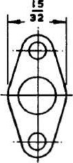

**STYLE PR8A**

HUMIDITY CLA.SSI H2

r

**1 ·518**

l

**STYLE AR80**

< TEMPERATURE CATEGORY1

A WORKING VOLTAGE:

§ (NORMAL AIR DENSITY)

H WORKING VOLTAGE:

(LOW AIR DENSITY)

*en* PROOF VOLTAGEr

1.-.'.1,

0 INSULATION RESISTANCE:

H

CONTACT RESISTANCE!

40/85

250 VOLTS PEAK NOT SPECIFIFID

1.5kV PEAK

NOT LESS THAN 100Wl AFl'ER ALL CONDITIONING

POLE. INITIALLY 2 MILLIOHMS MAX. AFTER DAMP HEA.T 5 MILLIOHMS MAX.

SCREEN. INITIALLY 1 MILLIOHM MAX . AFTER DAMP HEAT 5 MILLIOHMS JlAX.

0 CABLE FIXING1

H

i

VIBRATIONa

llUMPINGa CORROSIONI ENDURANCEI

WITHSTANDS Olb PULL ALONG CABLE AXIS

WITHSTANDS FREQUENCY CYCLING TO RCS-11 WITHOUT RESONANCE, LOOSENING OR DISENGAGEMENT

WITHSTANDS RCS-11 TEST WITHOUT MECHANICAL DETERIORATION WITHSTANDS RCS-11 SALT WATER TEST

WITHSTANDS ENGAGEMENT AND DISENGAGEMENT 500 TIMES WITH NEGLIGIBLE MECHANICAL DETERIORATION

MATING COMPONENTS, APPROPRIATE CABLES AND JOINT SERVICE CATALOGUE NUMBERS

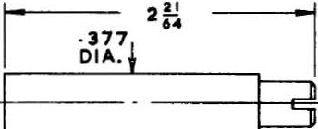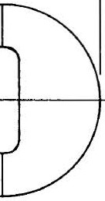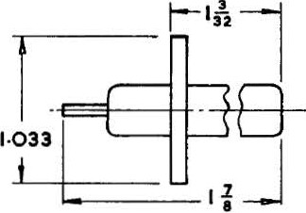

A

|  |  |  |  |  |
| --- | --- | --- | --- | --- |
| STYLE | TYPE | MATING  COMPONENT | APPROPRIATE CABLES | J.S. CAT. NUKBER |
| PR8A SRSC  ARSD | PLUG,FIXED  (MALE}  SOCKETF, REE  (FEMALE)  ADAPTOR.  PLUG TO ·PLUG | SRSC PRSA PRSA | UNIRADIO No.  6 OR 39  NOT SPEC!FlED  NOT  SPECIFIED | 054-0201  054-0203  012-2924 |

**SECTION 15/D**

ALL J .s. CAT. NUMBERS TO BE PRECEDED BY 5935-99- **SHEET No. 5**

WITH BARRIER AND PANEL SEALS

50 OHM PATTERN 12

1·610

0,0_·---4q

•935 A

2 0 ·

A 1:-0- 7 c.:_ .

1·610

.

t:;;t r1 *r-*

'

.

0 - 1()

'!'q l *1*

CABLE ENTRY

f.

.....__

t-.'.Ct.j.,rrr ' CABLE ENTRY

CABLE

EZY

STYLE SA12H PA12E •567

·55

*

STYLE SAI28 PR12 A STYLE SR I2C Pll120

STYLE SAiaF PRiaG *lit* STY LE SRI2J PRI 21< APPROPRIATE CA6LE FOR ALL STYLES UNIRAOIO 4) OR 76

-- WITHOUT NUT ANO WASHE-R ------------------.-f --f-H-'-i----S-T-Y-L-.-E---A-R-E-C-ONSIDERED GENERAL

HUMIDITY CLASS: H2 TEMPERATURE CATEGORY: 40/85

()



0 WORKING VOLTAGE:

PROOF VOLTAGE INSULATION RESISTANCE: CON'UCT RESISTANCE:

SEALING:

CABLE FIXING: VIBRATION:

BIDfPING: CORROSION : ENDURANCE:

500 VOLTS PEAK NORldAL AIR DENSITY

NOT SPECIFIED FOR LOW AIR DENSITY

2kV PEAK

NOT LESS THAN 1OOWO AFTER ALL CONDITIONING

POLE. INITIALLY 2 l£ILLIOI:OO MAX. AFTER IlA}!p HEAT .5 MILLIOHMS l&AX.

SCREEN. INITIALLY 1 MILLIOHM MAX.. AFTER DAlrlP HEAT 5 MILLIOHMS MAX.

AIR LEAKAGE NOT GREATER THAN 1 c.c. PER HOUR AT 20lb/ sq. in. AFTER ALL CONDITIONING

WITESTANDS .30lb PULL AWNG CABLE AX1S

WITllSTANDS FREQUENCY CYCLING TO RCS-11 WITHOUT RESONANCE , LOOSENING OR DISENGAGEMENT

WITHSTANOO RCS-11 TEST WITHOUT MECHANICAL DETERIORATION

WITHSTANOO RCS-11 SALT WATER TEST

WITHSTANDS ENGAGEMENT AND DISENGAGEMENT 500 TI.lt!ES AND SIX WEEKS HIGH TEMPERA'RJRE CYCLING WITH NEGLIGIBLE EIETRICAL AND MECHANICAL DETERIORATION

4

|  |  |  |  |
| --- | --- | --- | --- |
| STYLB | TYPE | MATING  CaMP. | J.S. CAT. NO. |
| ffi12A PR12D  PR12E  tPR12G  PRf2K | PWG FIXED FEMALE SHELL  PLUG HlEE  MALE SHELL  PWG FIXED  FEMALE SHELL  PWG mEE  FEMALE SHELL  PWG FREE  MALE SHELL | SR12C SR12J  SR12B SR12F SR12H  SR12C SR12J  SR12C SR12J  SR12B SR12F SR12H | 011-9806  012-282  012-2624  012- 2826 |

|  |  |  |  |
| --- | --- | --- | --- |
| STYLE | TYPE | MATING  COJ.!P. | J. S. CAT. NO. |
| SR12B  SR1 2C  t SR12F  SR12H  SR12J | SOCKET FIXED  FEMALE SHELL  SOCKET FREE  MALE SHELL  SOCKET FREE  FEMA.U: SHELL  SOCKET FIXED FEMALE SHELL  SOCKET mEE  MALE SHELL | PR12D PR12K  PR12A PR12E PR12G  PR12D PR12K  PR12D PR12K  PR12A PR12E PH12C | 011- 9810  012-2627  012-2829  012-26 0 |

4

t PR12G AND SR12F SHOULD BE PROCURED AS PR12E AND SR12M RESPECTIVELY,THE ITEMS ARE IDENTICAL EXCEPI' FOR TBE NUT AND WASHER.

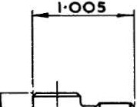

WITH THE EXCEPTION OF SR12B AND PR12A ALL ITEMS REQUIRE ACCESSORIES WHICH MUST BE ORDERED SEPARATELY (SEE SHEET No.1 )

ALL J.S. CAT. NUMBERS TO BE PRECEDD BY 59 5-99•

SECTION 15/D SHEET No.6

ISS. No. 4 9/63

NON-SEALED

GENERAL PURPOSE PATTERN40

l

FILL : 1 •745

CAP

CAP *--n c §* n

- -H=3--tt-+

.-.--1· 875

FILLER f---1·300-­

C AP --r---.

CAP--

*--------{-+ ++*

6

"0'

q l )J

, ...,.!..,

- ""' 2

PA NEL THICKNESS i MA X.

t

1111111111111--

NUT

'11111111111-- NUT A

ST YLE PR40A

C ABLE OUTLET

STYLE SR408

PANELTHICICN£SsfM.t.lC t C ABLE OUTLET

STYLE SR40C

MATERIA L - BODY, A LUMINIUM ALLOY. W ASHERS, BERYLLI UM COPPER . FINIS H.A LL CLEAN.

SPECIAL NOTE1- THE NUT, BUSHING REl'AINER ON SR40B .llfD SR40C CAB BE INTERCHANGED WITH THE CAP TO GIVE .&. STRAIGHT CABLE OUTLET .

HlThrrDITY CLASS: H1

TEMPERATURE CA'n:GORY: 40/85



WORKING VOLTAGE:

(NORMAL AIR DEl'SITY)

WORKING VOLTAGE:

(LOW AIR m:t ITY) PROOF VOLTAGE : INSULATION RESISTAllCE : CONTACT RESISTANCE:

Iw.PEDANCE MATCHING:

CABLE FIXING• VIBRATION•

!lUMPING: CORROSION I ENDURANCE I

500 VOLTS PEAK

NOT SPECIFIED

2kV PEAK

NOT IESS THAN 1OOM.O INITIALLY OR 1OM.fl AFTER OOlP HEAT

POlE. INITIALLY 2 MILLIOHMS MAX. AF1'.ER DAMP HEAT *5* MILLIOlM> MAX. SCREEN. INITIALLY 1 MILLIOHM MAX, AFTER DAloiP BEAT *5* lliLLIOIDlS MAX.

INSERTION OF ITEM IN SUITABLE CABlE PRODUCES KI5.\1ATCH WHICH , EXPRESSBD AS VOLTAGE STANDING WAVE RATIO , IS LESS 'l'f!AN 1 .2: 1

WITHSTANDS 30lb PULL ALONG CABLE AXIS

WITHSTANDS FREQUENCY CYCLING TO RCS-11 WITHOUT RESONANCE, LOOSENING OR DISENGAGE>dENT

WITHSTANDS RCS-11 TEST WITHOUT MECHANICAL DETERIORATION WITHSTANDS RCS-11 SALT WATER TEST

WITHSTANDS ENGAGEMENT AND DISENGAGDIENT 500 TINES WITH NIDLIGIBLE

l!ECHANICAL DEl'ERIORATION

MATING COMPONENTS, APPROPRIA'n: CABLES AND JOINT SERVICE CATALOGUE M.1MB:ERS

|  |  |  |  |  |
| --- | --- | --- | --- | --- |
| STYlE | TXPE | }lATING CO!I.PONENT  D , SR40B  LL SR40C  *REE ,* PR40A  L  XED , | APPROPRIA'n: CABLES  UN!RADIO (DEF-14-A )  SEE SHEET NO • 1 | JOINT SERVICE  CATALOGUE NO,  054-0101  054-9026  054-9027 |
| PR40A SR40B SR4DC | PUJG, PIXB  FE).IAJ...E SHE  SOCKET, *F*  MALE SHEL  SOCKET, FI MALE SHELL |

Accessor ies are required for styles SR40:B and SR40C (See Sheet No .1 ) ALL J.S. CAT . NUKBERS TO BE PRECEDED BY 5935-99-

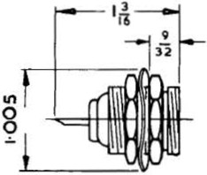

SECTION 15/ 0

SHEET No.8