
CASA Modular Systems, New Zealand

Subject:

Some Fuse & Fuseholder Basics
Respecting their Importance

^{2nd} Draft (4 pages for comment/criticism)

Preamble:

Having been working on CASA’s fuses consistently for the past 10 days it seems time to reflect upon their importance… …and upon their value so often trivialised!

CASA probably has 5~10,000, current, legacy and special type, fuse elements and fuse-holders ranging from 2mA to 800 Amps and they (perhaps 300 line-items) need to be catalogued and sold…. …a job that has received only sporadic/spasmodic attention… …except for some on-a customer’s apparent need-to-know… …an overview of the assortments and the beginning of stock-keeping consolidation essential following the various moves of the past 25 years.
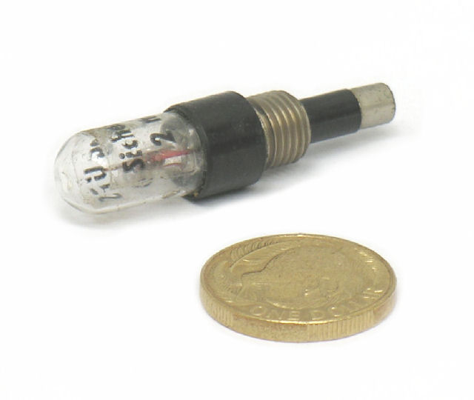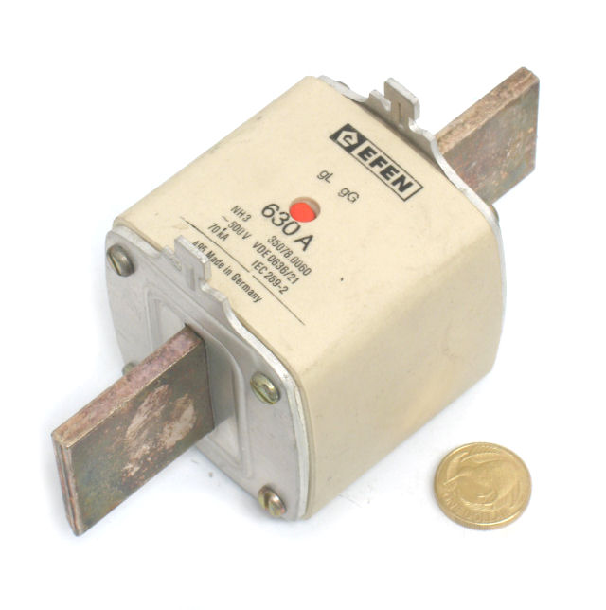
We do have a small representation of fuse-products listed on our ZenCart eCommerce site under “Circuit-Protection”:
http://casamodularsystems.com/index.php?main_page=index&cPath=65_137

The maturing lists and accumulating data/reference resources are on our local server:
http://www.casa.co.nz/Electrics/Fuses/

Introduction:

With the reducing price (higher production volumes) and availability of resettable fuses (PTC), circuit-breakers and other current limiting and transient-energy absorbing devices, conventional fuses seem to be less in demand… …furthermore, fuses are being ‘engineered’ out of electrical/electronic circuitry or internalised rather than visible to the equipment owner/user. This begs the question:

Q: Who are the fuse customers of the new millennium?
A: The multiplicity of electrical merchants and their shelf stocks may deserve a little recognisance… …and a few pertinent questions to their staff… …and hand-out a picture-listing of CASA’s galleries to show what CASA has to help them satisfy any enquiries they can’t meet from their current shelf-stock.

So What is an Electrical Fuse?

A fuse is one kind of over-current safety-protection device for electrical equipment.

An electrical fuse is essentially a sacrificial energy absorbing short-duration explosive device, contained within a suitable enclosure to eliminate (or minimise) secondary effects in its near vicinity… …the ‘exploded’ fuse hereby protects electrical apparatus from bigger explosions or other (extraneous) destructive effects of the out-of-design condition ☺.

As described, a fuse must be carefully chosen so as to ensure that, under conditions that exceed its design-limits (continuous current carrying rating for the load equipment/apparatus the fuse ‘explodes’ melts or vaporises or otherwise) the fuse becomes a strategic discontinuity, and the fault condition is rendered safe or minimal damages occur except to the sacrificial fuse element itself.

The fuse is hereby a short-duration electrical-energy absorbing device that acts in defence of some defined or un-defined fault condition. A fuse is an insurance-device with a premium paid in the equipment-design and fuse-implementation… ..post event, the fuse’s replacement cost is but a tiny fraction of the potential costs of damages to the otherwise under-protected electrical apparatus.

Note – an electrical-fuse does not ‘fuse’ (bond-together or fuze), however, given the energy that electrical-fuses are often connected too it is not surprising that the ‘fuse’ was so named…☺
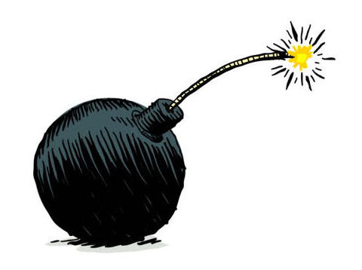
Design Diversity

Because the defined and undefined conditions needing to be addressed in the diverse operational contingencies, many kinds of electrical fuses have been created and the proven popular amongst these are widely adopted into international standards and patronised by industry and others seeking to identify with the specifications that regularise design integrity and risk-management.

As new generations of electrical apparatus are invented and commissioned new fuse designs are needed for the safety of the equipment, its infrastructure, and the safety of persons using, or near to, the equipment.

Energy Absorption & Fuse Ratings

To be effective a fuse must be carefully chosen so as to sacrifice itself (by melting or other discontinuity) under any over-current or transient condition for which the equipment was/is not designed operate (or safely endure). The chosen/specified fuse must be capable of dissipating the maximum rated fusing energy without dangerous consequences to the fuse-holder (or equipment or container etc.).

The energy is expresses in Watt-Seconds (Joules) and is a function of the current flowing, the resistance of the fuse-element and the voltage. The energy numbers can get very big once we get out of the modest home supply environment:

Volts x Amps x seconds = Joules
250V @ 10 Amps for 1 second (the hypothetical time for a fuse to respond) = 2,500 Joules (2.5kWatt-Seconds)
An arc-welder primary of 400V @ 60A for 3 seconds = 72,000 Joules

Above illustrates that as the energy gets high we need to adopt the use of HRC (high-rupturing capacity) fuses which are designed to endure (contain) the dissipation of large fusing energy. Arcs, flames, fires and plasma are typical consequences of improper fusing design and implementation or maintenance.

http://arcadvisor.com/faq/electrical-explosion

Note - As an appreciation of 2500 joules we may relate this to calories:

What Makes up a Typical Electrical Fuse?

Various pre-fusing and post fuse-conditions may exist that differ with AC and DC voltages and Radio-Frequency Voltages and the materials of which the fuse-cartridge and its container are made and their dimensions and other properties are all carefully selected to ensure reliable performance and the durability of containers where re-use by the installation of new fuse-cartridges is practical.

The fuse-cartridge and fuse-holder manufacturing industries are well practiced in the selection of materials and the designs that meet recognised specifications required by the electrical and related industries and appropriated by national and international standards etc.

According to the Deverell Filter Theory, “everything is a filter” (or my be considered as such for the purpose of analysis)… …therefore a fuse is a filter… …a fuse is a filter with a finite current carrying capacity… …a band-pass-filter till confronted with an excess of current when it changes into a band-stop-filter and stays in that state till physically replaced.

Everything in an electrical circuit is a potential ‘fuse’… …the impedance of any continuous circuit limits the current that can flow so that in order to ‘act’ any fuse must be of a resistance less than the resistance of any other component in the circuit… …the combined thermal and physical characteristics of the fuse needs to be chosen so that it melts (or otherwise become discontinuous) according to the strategic requirements of the system-design.

What are the 3 most critical parameters for fuses?

- The working voltage rating… …must suit or exceed the operational voltage to which the equipment is connected
- The carrying current capacity… …this rating must provide continuous/indefinite running of the equipment under its normal (appropriate) functional conditions.
- The time/response-characteristic under start-up and/or fault/transcient conditions

Warning - a fuse that does not ‘fuse’ when needed is a ‘fizzer’ ☺… …an anti-band-stop filter ☺ …perhaps a bi-stable-filter?

What do others have to say by way of descriptions or definition?

https://en.wikipedia.org/wiki/Fuse_(electrical)

“…a fuse is an electrical safety device that operates to provide overcurrent protection of an electrical circuit…”

https://www.dictionary.com/browse/fuse?s=t

“…a protective device, used in an electric circuit, containing a conductor that melts under heat produced by an excess current, thereby opening the circuit…”

A Scotsman tells it all… …or nearly enough to encourage appropriate caution… …and some very pertinent warnings t’-boot:
https://www.youtube.com/watch?v=kx35WN3uLis

Amongst the competition and/or potential wholesale customers are:

https://www.vynco.co.nz/products/circuit-protection/fuse-holders

https://www.jaycar.co.nz/components-electromechanical/fuses-circuit-protection/c/2D?sort=popularity-desc&q

https://nz.element14.com/c/circuit-protection/fuses-fuse-accessories/fuses/cartridge-fuses

https://www.alliedelec.com/Circuit-Protection/Fuses/?gclid=CjwKCAjw9L_tBRBXEiwAOWVVCU9n4uSjx4uOsb1HVys2knMYFf2nw9VFGwVFcc0rUCTuHILbzyF-WxoCdDwQAvD_BwE&gclsrc=aw.ds

https://nz.rs-online.com/web/c/fuses-sockets-circuit-breakers/fuses/cartridge-fuses/

A few graphics, illustrations, cartoons or real-world examples to further encourage our respect:

TBA

Kind regards - AlanD

