**BULGIN Fuses, Quick Action, Heavy Duty, etc**



Llot NoJ F.l70/Ratinl



Llot No: F.lOO/Ratlnl

x·

*y.*

Bulgin Cartridge Fuses or Fu se -Links are manufactured by the latest El ect ronic Automation

*S* mm.Ill X *20* mm.

*.· 4·8* mm.lll )(

*/S·9* mm

Equipment, unique to the

Bulgin Factocy. These special Machines, with mo r e-than-human precision and uniformity un tiringly wire, apply caps

x· *6*Liot No: F.xto·, •tc.



fix caps and solder wires,

:t..•

*• 3* mm.lll )(

Liot N o: F.t oo, etc.



*6•3* mm. Ill X t• *2.5·4* mm.

*15·9* mm,



Li1t N o: 1'.11 •tc.

x· 1 *8* mm.

*6.3 mm."* )( 1 .· *31·*

all i nternally and quite automatically, usi ng R.F. beating, the finished fuses finally receivi ng clea r transfer-labels and colou r­ code marks. They are Water proof and Triple­ tested. Element-wires are visible through the clear glas5 tubes,and the majority of caps a,re electro-plated Tin or S l L VER f or excellent contact in holders. This Automation ensures bigb uniro rmity and efficiency, a nd l owest po ssib l e pri cin g b y economy of production. Bulgin Cartridge Fuses are

t h e si mpl est, s u. rest , cheapest and safest circuit­ protection device. Tbey are consistent, reliable,

All 1*y.•* X Y,B;ulcin Fusu can bo packed in

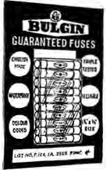

**units of ten in the quick dispenser pack, as**

**i11ust,-.at•d above.. The cut.-out window enables**

**instant ratina/cotour tode. idencif'iation. State.**

If this packinc is required when orderinc.

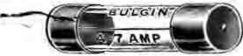

Llot No:F.240, •tc.

/0 mm, 0 '>< *38 mm.*

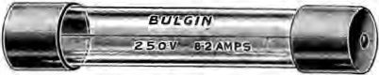

Litt No: F.61, etc.

:t,• 12·7 mm. 0 X l:t,•*63•5* mm.

Avaih•ble only to quantity ord•n of

SOO or more item• of tam• reti n1.

16

fireproof, accu rate to specifications, and easy to

renew. They arc rated by tbe current they will safely carry for 1,000-hou rs. ( Blowing-rating is also given). Select your fuse by the danger current of tbe circuit. Thus, a circuit may have a oonger-rating of

5A., the normal current being only X or XA. Then, use a "2Amp" Fuse (wbicb blows at 4-4 XA.) These fuses are made and tested under full guarantee, and Millions upon Millions

have performed t be most arduous duty without - failure.