Contents
Preface 2
Section Ⅰ Equipment Instructions 3
Chapter Ⅰ Equipment Installation Instructions 3
1.1Schematic diagram and instruction of controller 3
1.2 Schematic diagram of marking head 4
1.3.Connection instruction of controller and print head 5
1.4.Connection instruction of remote control switch 5
Chapter Ⅱ Function Brief 5
Chapter Ⅲ Agreement 6
Chapter Ⅳ Interface Instruction 7
4.1 System keyboard shown in figure: 7
4.2 Operating interface instruction 7
Chapter V Note 26
SectionⅡ Repair and maintenance instructions 26
Chapter Ⅰ Common knowledge for maintenance 26
Common knowledge for use 27
Common knowledge for use of mechanical part 27
Chapter Ⅱ Common faults and solutions 27
1.Faults of controller 27
2. Equipment failure of marking machine 28
Chapter Ⅲ Table of wiring 32
Appendix I Cross reference table of ASCLL codes of special symbols 33

Preface
Jinan Golden Bridge Pneumatic Marking Machine is special equipment controlled by single controller , which is used to mark the workpiece with figures, characters and drawings. It can mark clearly, beautifully and quickly, which is the preferred equipment in manufacturing industry used to replace such marking method as artificial, mechanical, hydraulic and laser etc..
The operation of Golden Bridge Pneumatic Marking Machine is easy and quick. Through auto interaction, we can set the size, position, direction, font and print speed of characters and drawings needing to be marked, and we can also set the increment on the serial number according to the need of production.
Compared with the variety of current laser and mechanical hydraulic press, Golden Bridge Pneumatic Marking Machine has such advantages as simple installation and operation, powerful, small volume and flexible working condition(can be installed in any working position) and low operation cost etc.. Taking Golden Bridge Pneumatic Marking Machine as your choice will not only make your work more effective, but also can improve your product image, establish brand awareness, maintain enterprise benefits and establish enterprise in an unassailable position.

Section Ⅰ Equipment Instructions

Chapter Ⅰ Equipment Installation Instructions

1.1Schematic diagram and instruction of controller
1.1.1 Figure of the front panel

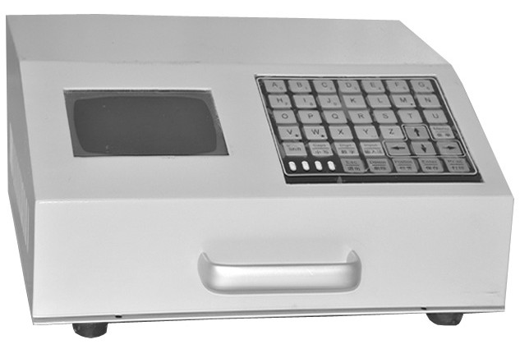
Display screen

Power switch
Power switch

Keyboard

Indicator light
Indicator

Control holder

Figure 1 Front panel

S232interface
RS232interface

19-core wire interface

1.1.1 Figure of the back panel
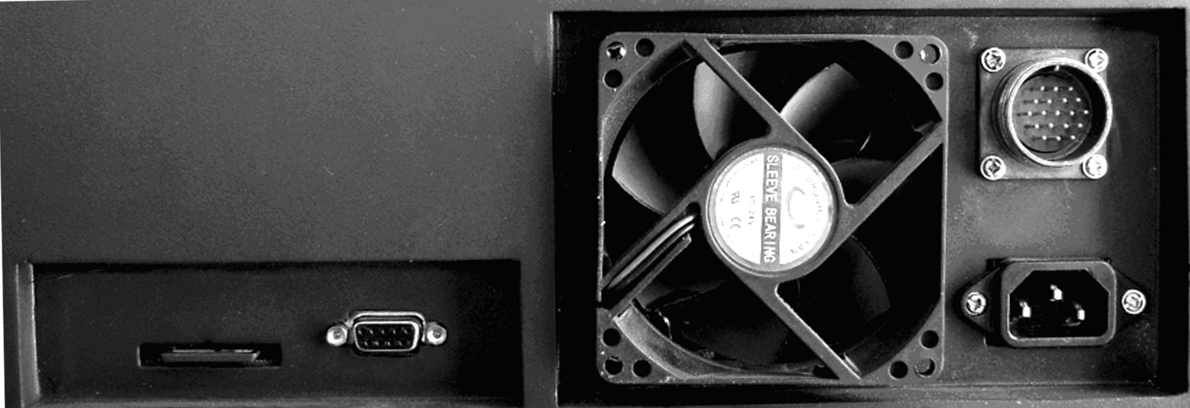
power interface

memory card
Figure 2 Back panel

1.2 Schematic diagram of marking head
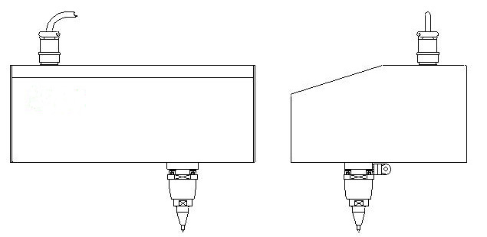

Figure 3 Marking head

1.3. Connection instruction of controller and print head
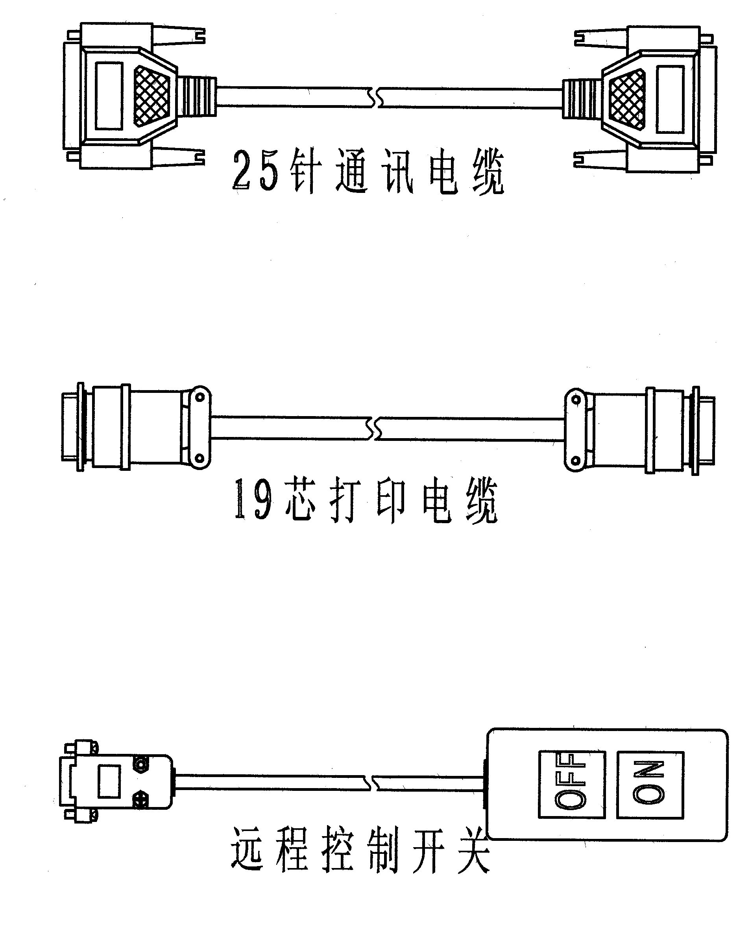
19-core print cable
Remote control switch

1. Ensure the controller switch is “OFF”.
2. Connect one end of the controller power cord to an external power supply, another end to power slot of controller.
3. Connect both ends of cable wire of controller to air slots of controller and print head respectively, and tighten the fix screws.
4. Connect air supply of compressed air to triplet, and tighten the air tube.

1.4. Connection instruction of remote control switching
Connect the nine-pin slot of remote control switch to the nine-pin plug of controller, and tighten the fix screws.

Chapter Ⅱ Function Brief
Golden Bridge Pneumatic Marking Machine is easy to operate and practice. The major functions are as follows:
- Automatic memory
The system can memorize the attribute of the set print data automatically (like character height, width of letter and letter-spacing). When it starts up the next time, it can automatically recover the status set before last shutdown, and can immediate work without initialization.
- Workpiece memory
The system can keep the established workpiece of different formats with different file names, in order to mark the workpiece of different formats separately.
- Serial number add one automatically
After the marking of one workpiece, the serial number can add one automatically when marking the next workpiece.
- Various marking speed for choice
There are different marking speeds for choice, which can adjust the print effect in order to meet different production rates.
- Multi-line marking
It can mark the content up to 40 lines once.
- A wide range of characters for choice
The system can provide four types of digital character repertoire and can add 10 more types of character repertoire by occasion of the user need, including figures, letters, Chinese characters and special characters, etc. The size of each character can be set freely. Additionally the system can provide anti-fake graphic identifier if required.
- A variety of input methods
There are two ways to input the serial number, i.e., auto increment and manual input.
- Character reprint
If it is not clear for the first time print, the reprint can be done if the position is not changed.
- Graphic print
It can meet any graphic print requirements of user.
- Auto-dating
It can fill the current date into the parameter of workpiece to mark, very convenient for users.
- Automatic serial number
The same serial number can be used by different workpieces, or it can also be set through increment to adopt different series number.

Chapter Ⅲ Agreement
For the convenience of users, the agreements are as follows:
3.1 The units of numerical value (except for speed) referred in the marking procedure are 1mm, i.e., 1 means the actual size is 1mm. If the set character height is 10, then the height of the printed character is 10mm.
3.2 Press “set” to activate menu bar (anti-bright display for menuitem), operate the menu bar though adjusting of the direction keys. For example, “parameter setting-print parameters”, first press “set” key, the menu displays anti-bright, after that press direction key to choose “parameter setting”, then press downward direction key Y to display pull-down menu, at last move direction key to “print parameter”, press “OK” to open “print parameter” dialog box.
3.3 During the print process, if you want to cancel printing, press “shift” key for 2 seconds to 3 seconds.
3.4 When modifying one item's data, it is required to press “OK” key to keep the modification.

Chapter Ⅳ Interface Instruction

4.1 System keyboard shown in figure:
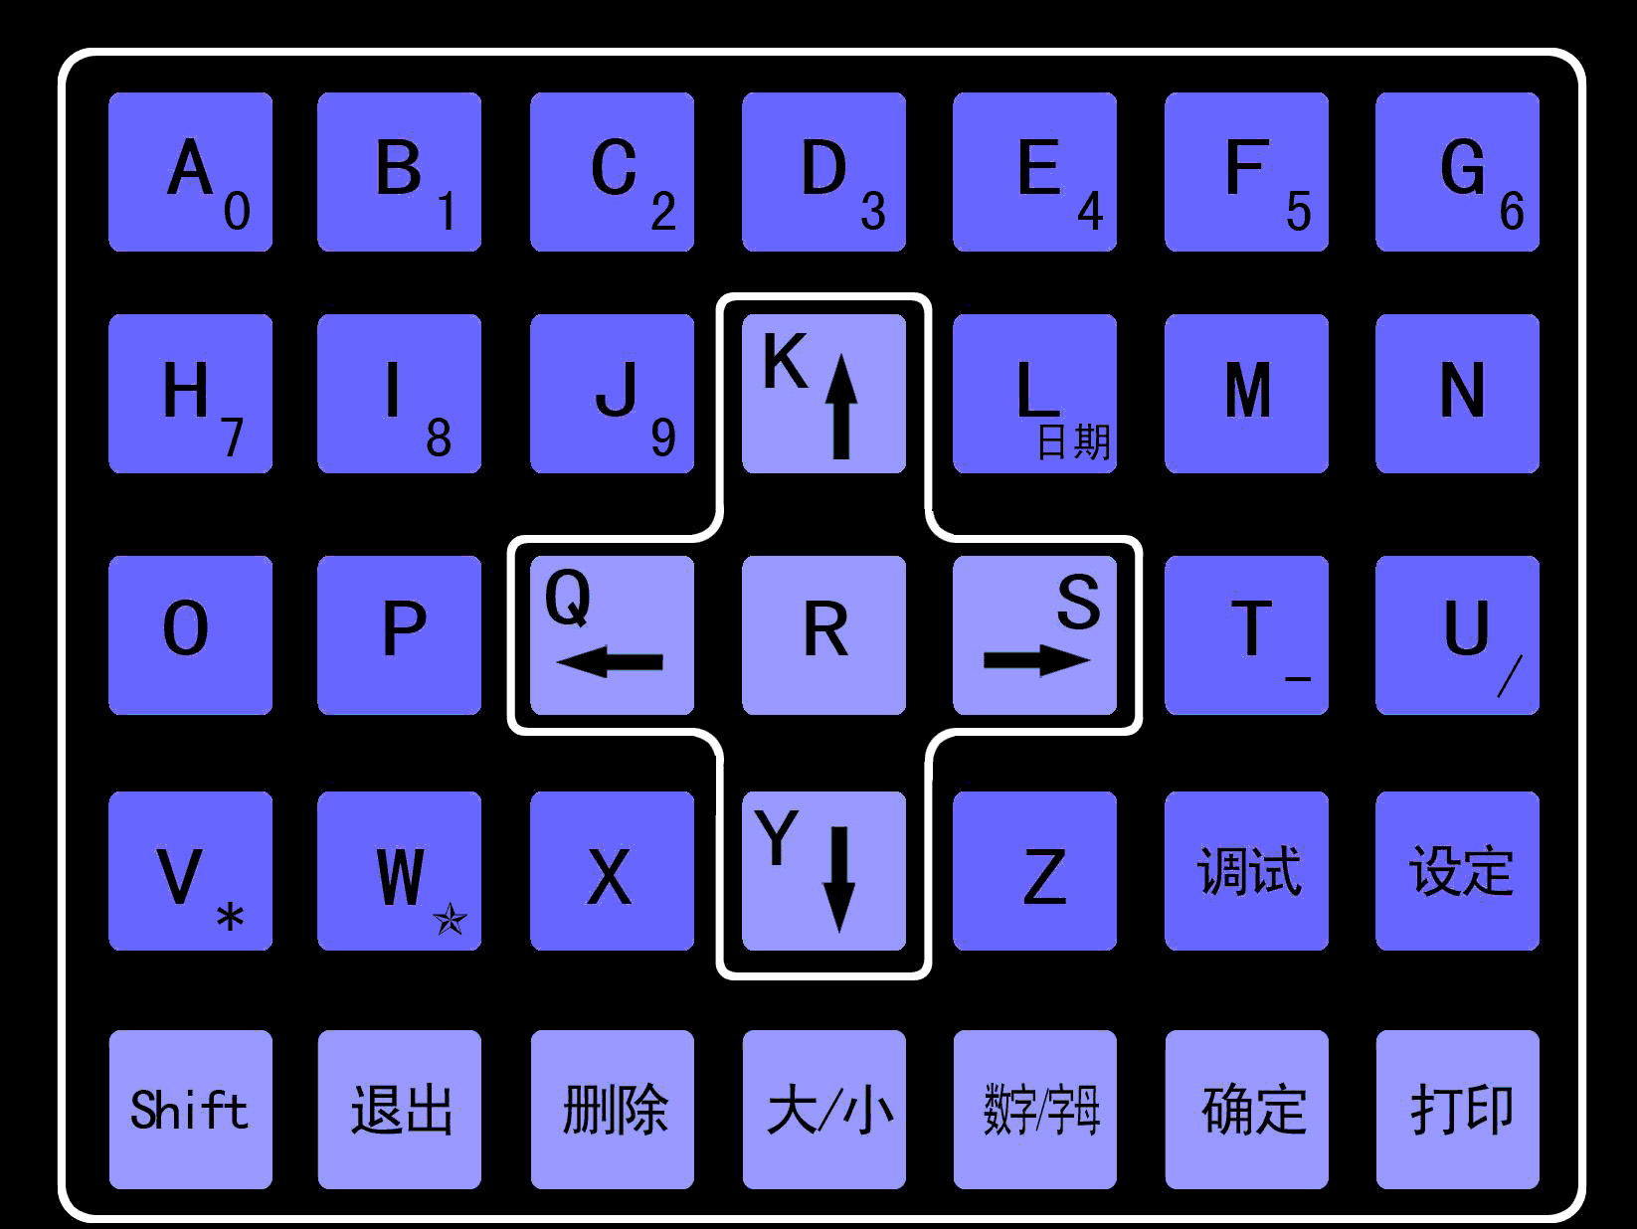

4.2 Operating interface instruction
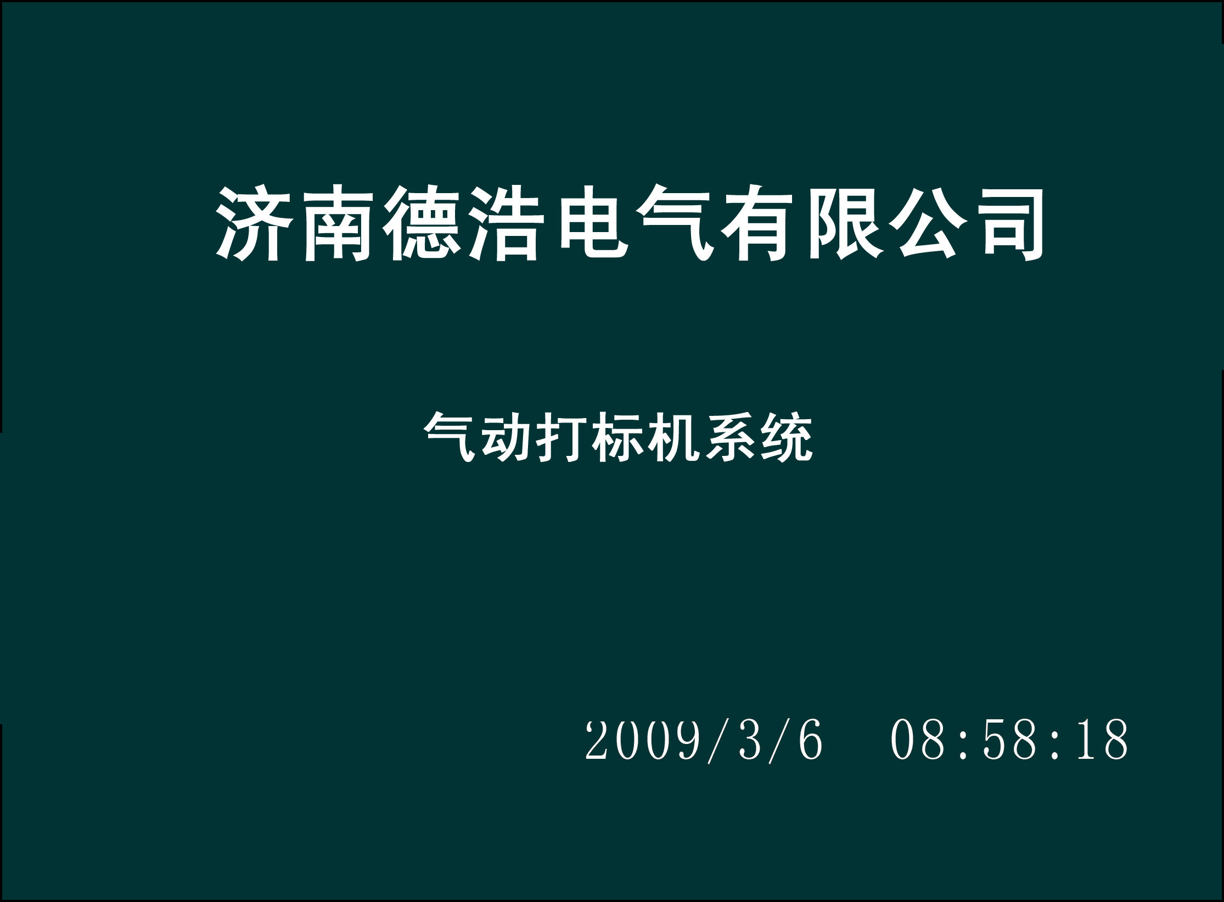
Title bar

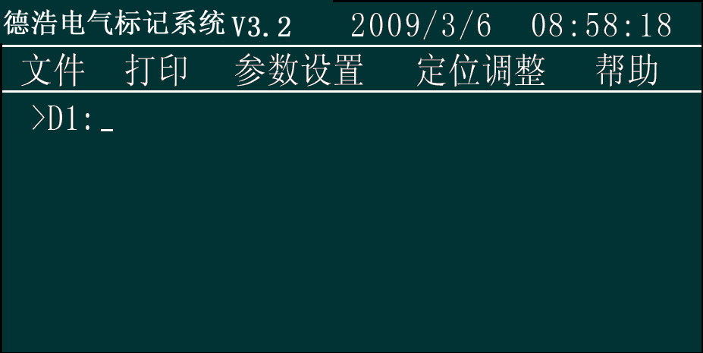
Work area

Menu bar

4.2.1 Title bar
In Dehao marking system, this bar is the title bar, 2009-4-21 9：10：30 means system time.
4.2.2 Menu bar
Menu bar includes of “file”, “print”, “parameter setting”, “alignment”, “help”.

4.2.2.1 File
The pull-down menu of file include “open (O)”, “save”, “delete”, “load PLT”, “shutdown (G)”.
A, Open …
Operation steps: “set”-“file”-“open”

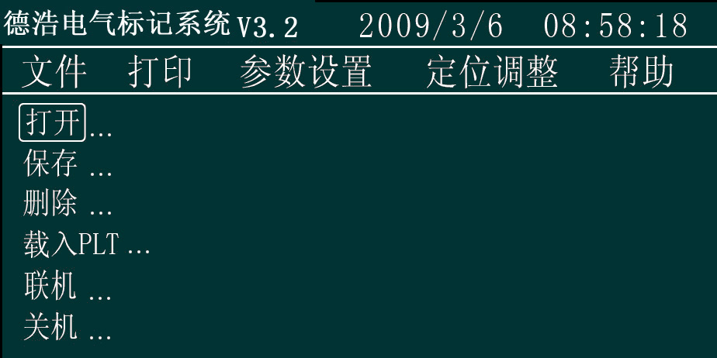
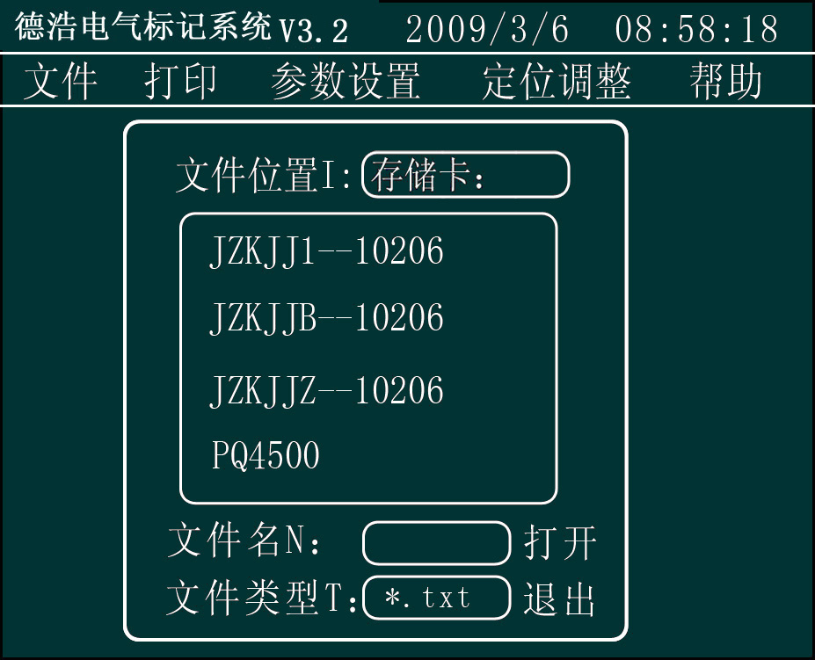
the saved file

loading file name

Figure 1
Open file operation: input the file name, press “OK” to open the file.
Note: the input file must be the saved file, or there will be some mistakes.
B, Save…
Operation steps: press “set”-“file”-“save”

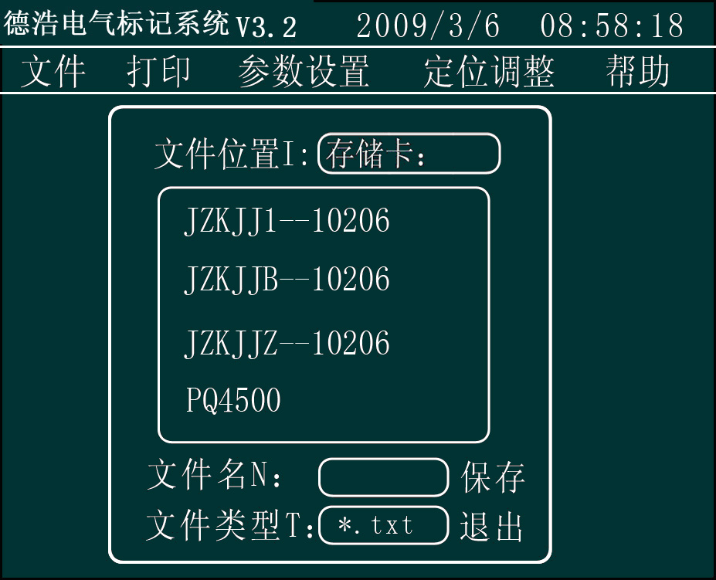
输入文件名
Figure 2
- To save file: input file name, press “OK” to save the file.
- File name format: file name can be figures or uppercase or lowercase English letters but the length can not over 8 characters.
- The saved file area: display the recent saved file.
- Press “Exit” to cancel saving file action and return to the operating interface.
C, Delete…
Operation steps: press “set”-“file”-“delete”.
- Delete file: input file name, press “OK” to delete the file.
Note: The file to be deleted must be the existing file.
loading file name

the saved file

Figure 3
- Press “Exit” to cancel deleting file and return to the operating interface.
D, Load PLT…
Operation steps: press “set”-“file”-“load PLT” to open the figure 4 dialog box.
- To load PLT: input file name, press “OK” to load PLT file in the current data.
Note: The loaded PLT file must be the existing file.
● Icon height and icon width: means the height of the PLT icon (unit: mm)
Input method: adjust direction key to “icon height”, input corresponding numerical value and press “OK” to complete the setting.
● Direction: means the rotating angle of the PLT icon (unit: degree)
Input method: adjust direction key to “Direction”, input corresponding numerical value and press “OK” to complete the setting.

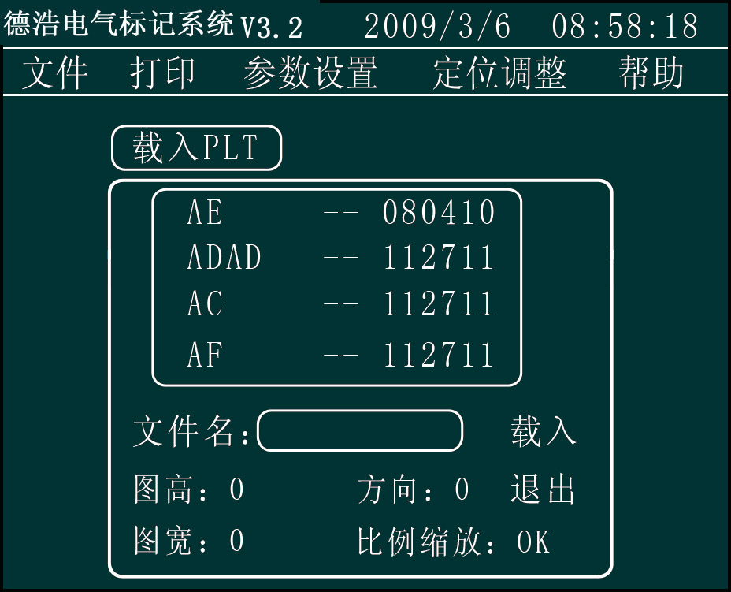
loading file name

the saved file

Figure 4
● Proportional zoom: it means the proportional zoom between the height and the width of PLT icon.
Input method: adjust direction key to “proportional zoom”, press any number key, the setting of proportional zoom will switch between “OK” and “NO”. When choosing “OK”, the icon width will be proportional-zoomed according to the icon height, while choosing “NO”, the icon width and icon height will not do proportional zoom according to the user setting.
●Press “Exit” to cancel loading PLT file and return to the operating interface.
Note: a: the icon width and icon height can be set zero.
b: when there is “Y” and “K” included in the file name of the files bound to be saved, opened and deleted, you should press “Delete” first, then input the orders.
c: when the saved files are not shown on the display screen, press “Y” and “K” to file up and down.
E，Shutdown (G)…
Operation steps: press “set”-“file”-“shutdown” to open figure 5 dialog box.
- Press “OK” to shutdown the marking machine system.
- Press “Exit” to cancel shutdown and return to the operating interface.
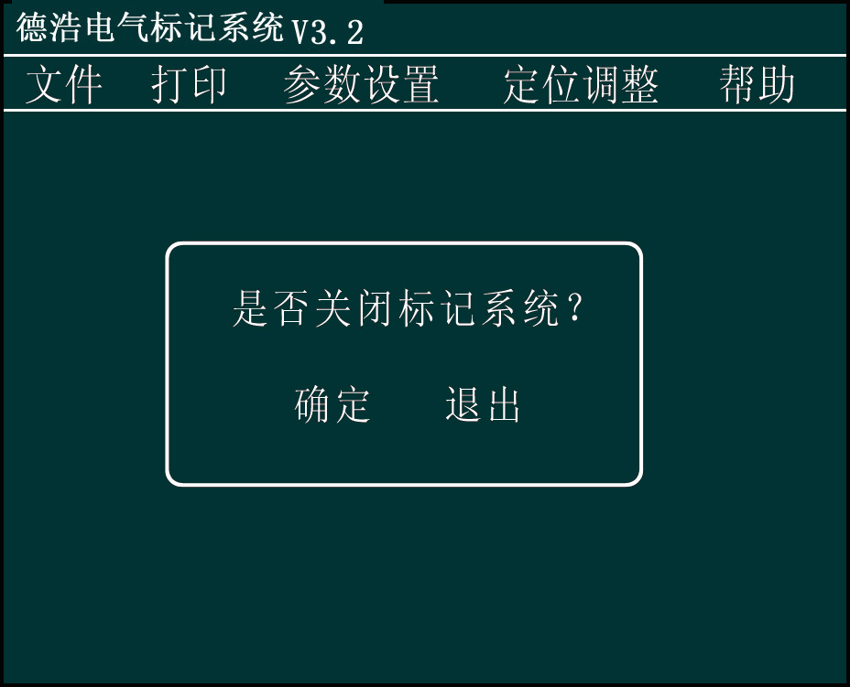
Figure 5
4.2.2.2 Print
The pull-down items of print menu include “continuous print, print one, re-print, create new field, test printing, and insert symbols…
- Continuous print
Continuous print means to print the content repeatedly which et by the user.
Operation steps: press “set”-“print”-move cursor to “continuous print”, after pressing any numbering key, then the “continuous print” will switch between “OK” and “NO”, correspond with whether continuous print or not (or Shift + PRINT). The time interval of continuous print shall be set in “system parameter”, see “system parameter” for the details of setting method.
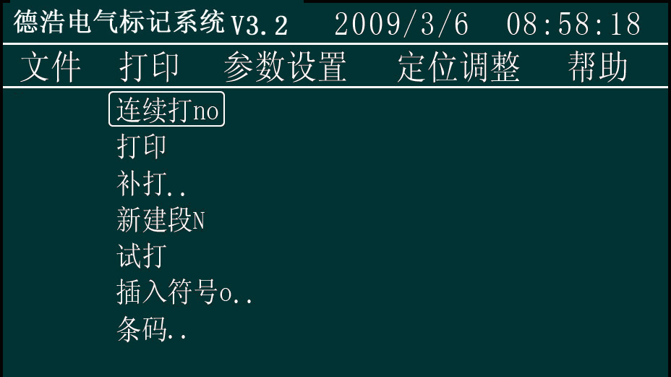
If you want to stop the continuous print, press “Shift” for 2 or 3 second.
- Print
Marking machine begins operating, printing according to the set parameter.
Operation steps: press “Set”-“Print”-“Print” to realize one printing action (or press the printing key on the keyboard).
- Re-print (M)…
When creating many data field, you can input field number to print a certain field.
Operation steps: press “Set”-“Print”-“Re-print” to realize the printing of certain field.
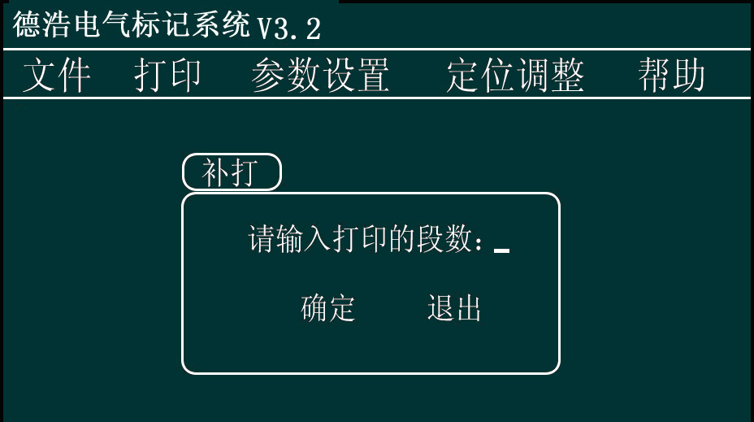
Figure 6
Input the print field number under the interface of figure 6, press “OK” to print corresponding field.
- New field(N)
New field is the new data field added on the basis of current data field (shortcut key shift + N)
Operation steps: press “Set”-“Print”-“New field” to create a new data field
The format of data field: “>D1:” “>D2:”
- Test printing
Test printing means printing the data needing to be printed without opening the solenoid valve.
- Insert symbols
When there are some special symbols need inputting, it can be realized by inserting symbols. See appendix Ⅰ for the symbols that can be input.
Operation steps: press “Set”-“Print”-“Inserting symbol” to open inserting symbol dialog box (shortcut shift + o), input the ASCLL code(see appendix I) of symbols at the cursor blinking position, the corresponding symbol can be seen in the browsing table. Press “OK”, then the symbols can be inserted into the current data communication field.
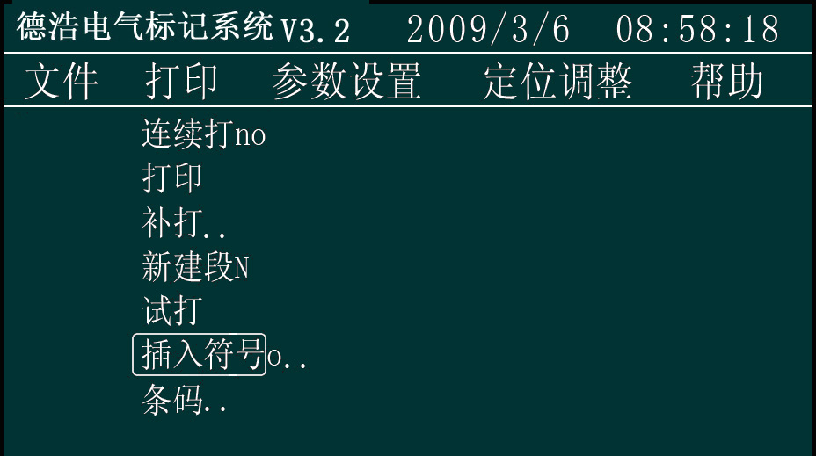
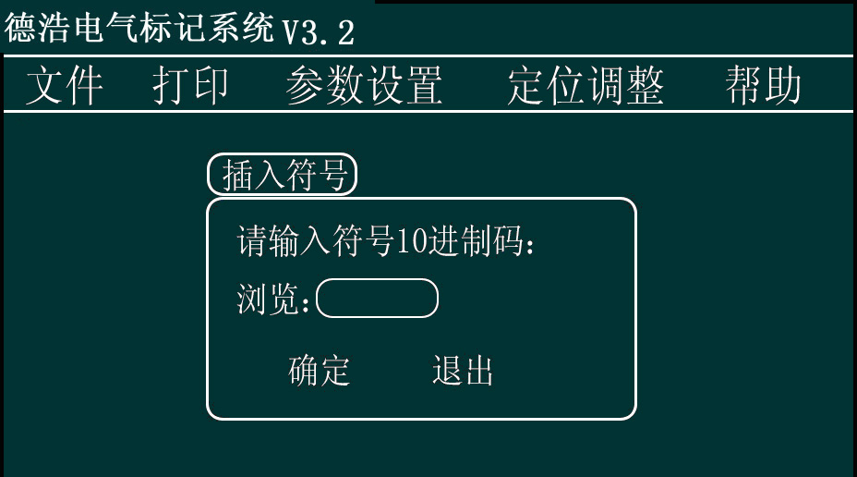
4.2.2.3 Parameter setting
The pull-down menu of parameter setting includes “system parameters, print parameter, modify parameter, modify date, modify position, VIN code and modify content.”
  - System parameter(Z)
The setting of system parameter includes: print speed, print range, pendown delay, penup delay, continuous print interval time. Press “set”-“parameter setting”--“system parameter” to open dialog box 7(shortcut shift+ Z)
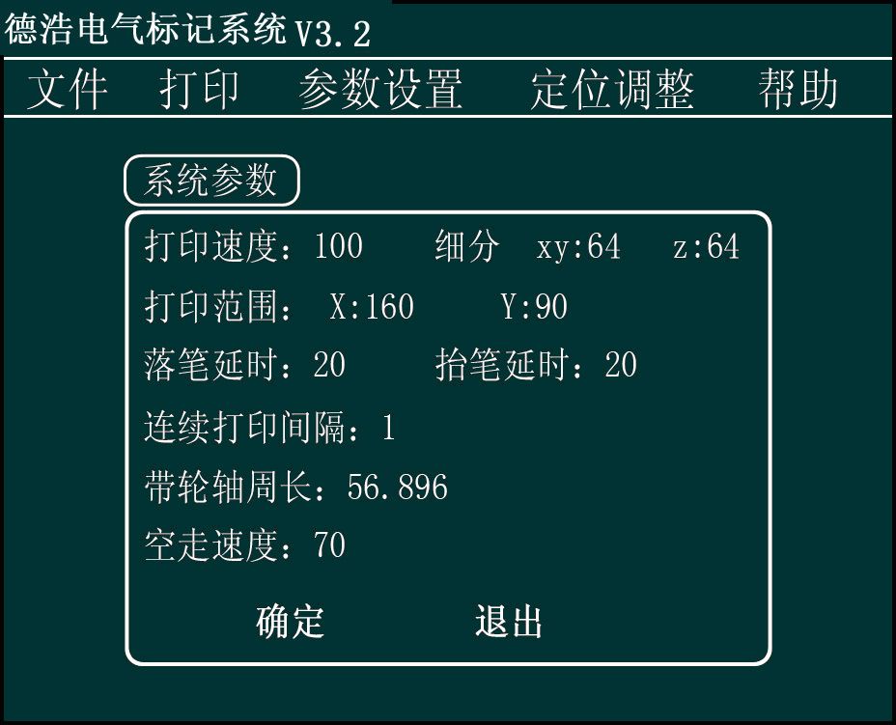
Figure 7
      - Print speed
Print speed means the movement speed of the marking head when printing data. No-print speed means the movement speed of the marking head from the origin to the printing position when not printing.
Operation steps: under figure 7 interface, use the direction key to move the cursor to “Print speed”, first delete the original data, then input corresponding data, press “OK”(save the input numerical value) to modify the parameter(meanwhile the cursor moves backward automatically).
The smaller this numerical value is, the faster the marking head runs, to the contrary; the bigger, the slower.
Note: the numerical value shall not be too small, or the font will not be aesthetic if the print speed is too fast. If the numerical value is smaller than the specified minimum value, the system will give an alarm.
      - Print range
Print range means the maximum stroke of the marking head.
Operation steps: under figure 7 interface, use the direction key to move the cursor to “Print range X”, first delete the original data, then input corresponding data, press “OK” (save the input numerical value) to modify the parameter (meanwhile the cursor moves backward automatically). Modifying “Print range Y”: is the same with modifying “Print range X”.
      - Pendown delay
Pendown delay means the residence time of the marking head moving from the origin of coordinates to the printing data. When the marking machine begins to mark, the printing action shall be restored after a certain period of delay in order to prevent the phenomenon of strokes missing. The pendown delay time shall be set according to the system speed and the marking speed, the default value of the system is 15. (Note: when the value is too big, there will be a groove at the initial position of each stroke)
Operation steps: under figure 7 interface, use the direction key to move the cursor to “pendown delay”, press “delete” to delete the original data, then input corresponding data, press “OK” (save the input numerical value) to modify the parameter(meanwhile the cursor moves backward automatically).
      - Penup delay
Penup delay means when marking machine completes one stroke, there shall be a certain period of delay before the next stroke begins, so as to prevent the phenomenon of pen dragging. The penup delay time shall be set in accordance with the system speed and the marking speed, the default value of the system is 15. (Note: when the value is too big, there will be a groove at end position of each stroke)
Operation steps: refer to “Pendown delay”.
      - Continuous print interval time
Continuous print interval time means the interval time when continuously printing.
Operation steps: under figure 7 interface, use the direction key to move the cursor to “Continuous print interval time”, press “delete”, first delete the original data, then input corresponding data, press “OK”(save the input numerical value) to modify the parameter(meanwhile the cursor move backward automatically).
      - Subdivision
XY subdivide means the subdivision of the driver which lies in the control box and controls the movement of XY axis. This numerical value is marked at equipment operation card. If it is not correct, the equipment may not find the original point, or the size of printing character may not be correct. (This figure is generally unchanged)
      - Girth of axle
It is the fixed value set by the system and will not be changed generally.
After the parameter setting, press “OK” or “Exit” to return to the operating interface.
  - Print parameter(D)
Print parameter means the attribute of the current data field (not the attribute of the whole print data), so the attribute setting should be done each time after the establishing of each print data. The attributes include character height, width of letter, between word spacing, serial number, character library and print date.
Operation steps: press “Set”-“Parameter setting”-“Print parameter” (shortcut: shif+D) to set the print parameter.
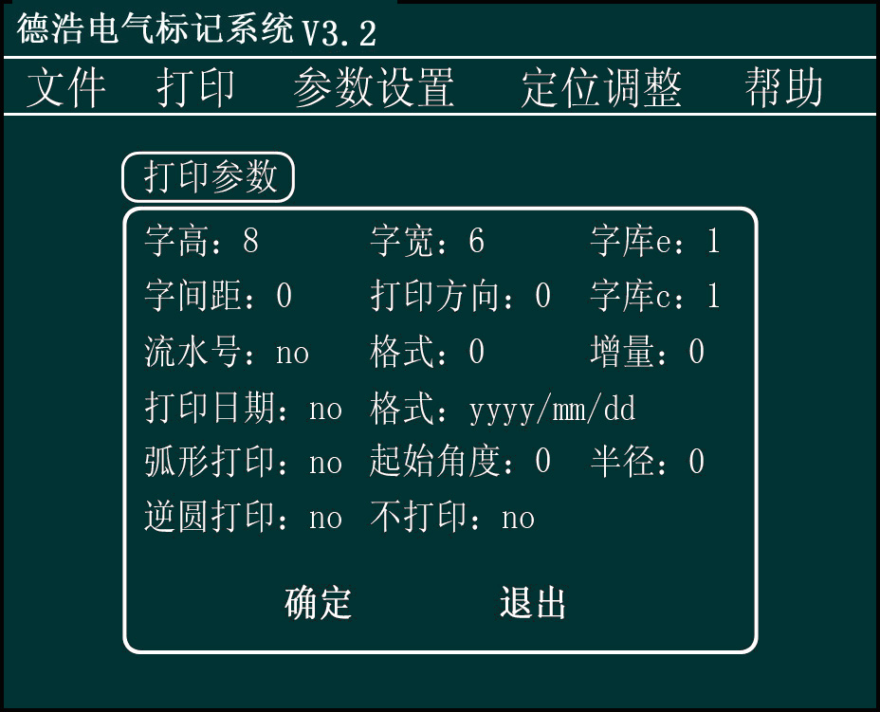
Figure 8
- Character height
Character height means the character height of the current data field.
Operation steps: under figure 8 interface, use the direction key to move the cursor to “character height”, first delete the original data, then input corresponding data, press “OK” (save the input numerical value) to modify the parameter(meanwhile the cursor moves backward automatically).
The unit of this numerical value is mm and ten means 10mm. The range of numerical value is from 0mm to Ymax (Ymax is the maximum stroke of axis Y), which can be accurate to two decimal places.
- Width of letter
Width of letter mans the width of the letters in the current data field.
Operation steps: refer to the operation steps of “character height”
- Between word spacing
Between word spacing means the spacing between words.
Operation steps: refer to the operation steps of “character height”. The calculation method of between word spacing: width of letter+between word spacing required. For example, with width of letter is 6, if you want to set the between word spacing as 2, then you should input 6+2=8.
- Print direction
Print direction is the lay direction of the current data field.
Operation steps: under figure 8 interface, use the direction key to move the cursor to “print direction”, first delete the original data, then input corresponding data, press “OK”(save the input numerical value) to modify the parameter(meanwhile the cursor moves backward automatically).

The unit of this numerical value is degree, 10 means contrarotating 10 degrees. The range of the numerical value is from 0 to 360.
- Print date
To print date means to add the current date to the current data field,
Date format:
Y means year M means month D means day.
There are three kinds of formats, i.e., YYYY—MM—DD, YYYY/MM/DD and YYYYMMDD; the format will be set according to the system setting (referring to date setting)
- Serial number
Serial number is the suffix number of the current data field. The suffix number can add x (x is the increment) automatically.
Operation steps: under figure 8 interface, use the direction key to move the cursor to “print date”, the coordinate is blinking at “the output value of print date” by then, press any numbering key can switch between “yes/no print date”, press OK(save the input numerical value) to modify the parameter(meanwhile the cursor moves backward automatically).
（7）Character library：
Character library means the character library of the current data. Character library e means western character library (letter, figure, symbol), c means Chinese character library. Choose the relevant character library under certain requirements.
Operation steps: under figure 8 interface, use the direction key to move the cursor to “character library”, first delete the original data, then press the corresponding key to input numerical value, press “OK” (save the input numerical value) to modify the parameter(meanwhile the cursor moves backward automatically).
After the completing of parameter setting, press “OK” or “EXIT” to return to operating interface.
（8）Arc printing
Arc printing means rotating the content of current data field according to the set radius.
Operation steps: under figure 8 interface, use the direction key to move the cursor to “arc printing format”, press any numbering key to choose whether to choose arc printing or not, press “OK” to modify the parameter(meanwhile the cursor moves backward automatically).(“YES” means arc printing, “NO” means no arc printing)
Start angle: the rotation start angle of the content of current field.
Operation steps: under figure 8 interface, use the direction key to move the cursor to “start angle”, first delete the original data, then input corresponding data, press “OK”(save the input numerical value) to modify the parameter(meanwhile the cursor moves backward automatically). The unit of this numerical is degree: 10 means clockwise rotating 10 degree. The range of numerical value is from 0 to 360.
Radius: The based radius of rotation angle of content of the current field.
Operation steps: under figure 8 interface, use the direction key to move the cursor to “radius”, first delete the original data, then input corresponding data, press OK(save the input numerical value) to modify the parameter(meanwhile the cursor moves backward automatically). The unit of this numerical value is mm, the range of numerical value is from 0mm to Ymax/2(Ymax is the maximum stroke of axis Y).
(9) Counterclockwise arc print
It is printed in the opposite direction of arc print, the operation steps are the same with that of arc print.
  - Modify parameter(X)
To modify parameter means to modify the attribute of the appointed data field. The attribute include character height, width of letter, between word spacing, serial number, character library and print date.
Operation steps: press “Set”-“Parameter setting”-“Data modification” (shortcut: shif+X) to modify the data.
    - Input modified data field number
Input modified data field number is the field number modified by the user.
Operation steps: under figure 9 interface use the direction keys to move the cursor to “input modified data field number”, first delete the original data, then input the figures, press “OK” and the corresponding field attribute will shown, by then, use direction key to move the cursor to the parameters which need modifying and then rectify it. .
2) As to the modification of character height, width of letter, between word spacing, serial number, character library, print direction, print date and arc printing, refer to the settings of print parameters
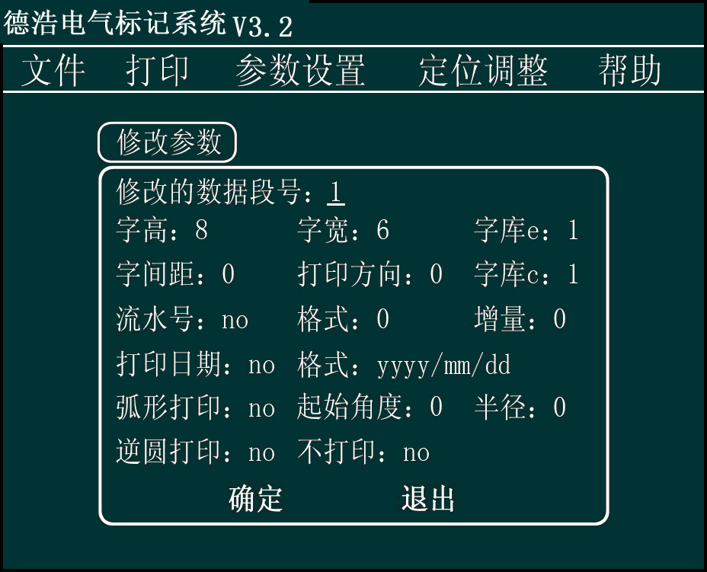
Figure 9
  - Modify date(L)
System date can fill into the marking content automatically.
Operation steps: press “Set”-“Parameter setting”-“Modify date” (or “shift”+ “L”) to modify date.
- Date
Operation steps: under figure 10 interface use the direction key to move the cursor to “input year NO.”, the coordinate is blinking at “the input value of year” bar then, input numerical value of year (must be four significant digits), press “Ok” to save the numerical value (meanwhile the cursor moves backward automatically). The modifying of month and day values is the same.
For example: set the time as October 1, 2008
Input “2008”-“OK”-input “10”-“OK”-input “1”-“OK”

- Time
Operation steps: under figure 10 interface, use the direction key to move the cursor to “time”, the coordinate is blinking at “the input value of time” then, the input numerical value, press “Ok” to save the numerical value(meanwhile cursor move backward automatically).
For example: set the time as 20:1:30
Input “20”-“OK”-input “1”-“OK”-input “30”-“OK”

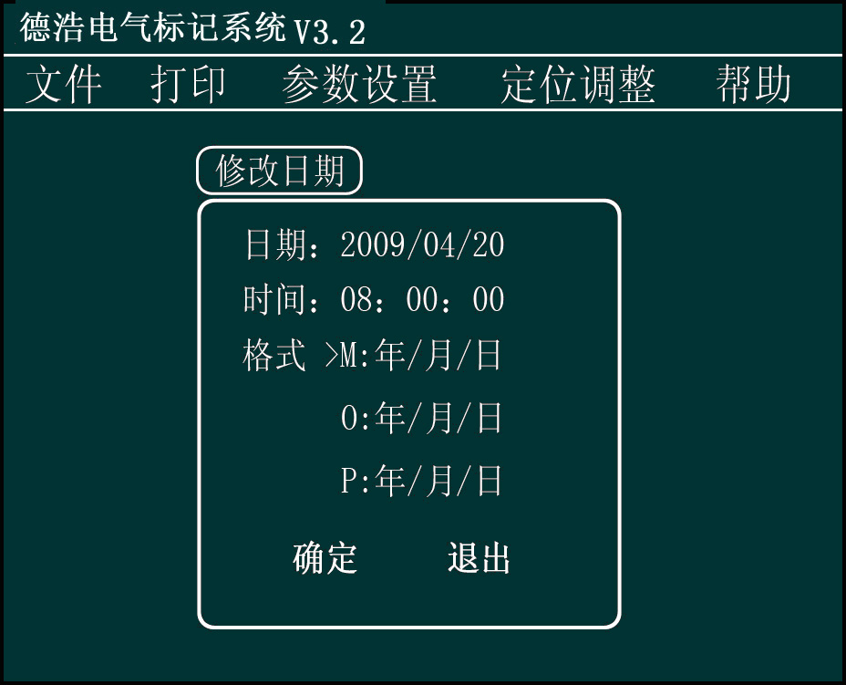
Figure 10

- Format
Under the figure 10 interface, press M, the format is YYYY/MM/DD
press O, the format is YYYY－MM－DD
press P, the format is YYYYMMDD
Y means year, M means Month, D means date.
E， Calculation of VIN
Print standard VIN code through the calculation methods of VIN and the specific procedure is that: first, input the first 14 digits of VIN, set serial number, format, increment as “OK”, “last 3 digits” and “1” respectively during the modification of parameters. Find VIN in “parameter setting” and press “OK”, which is as shown in the following figure
Input the appropriate data segment in “Calculation segment NO. of VIN”, for example, if the set VIN is located at D1, then input D1 in the block and press “OK”. If the data bits or format of the input data are incorrect, the system will alarm.
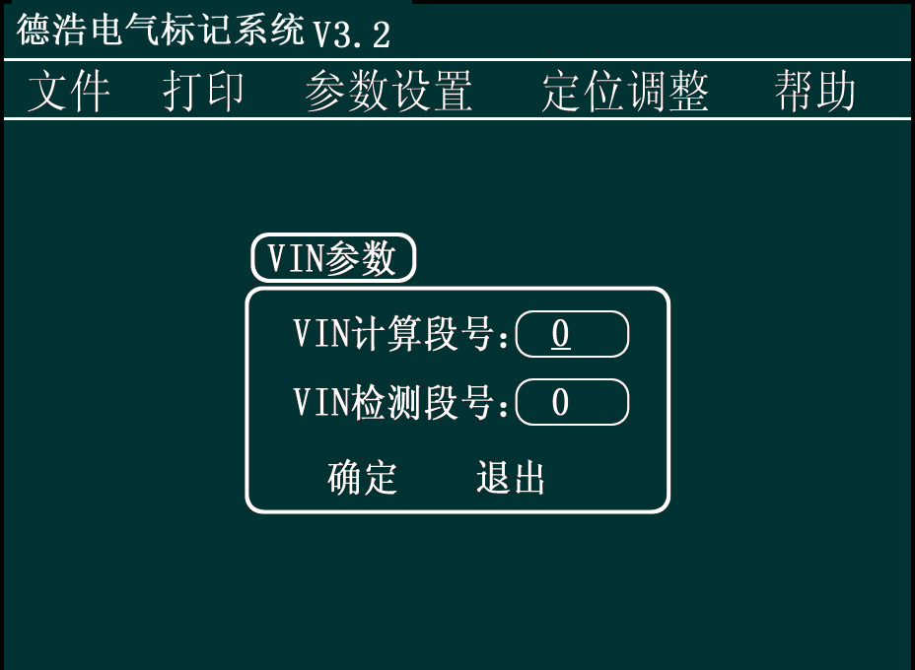
    - Two-dimension code
Operating steps: “set” →“parameter setting” →“two-dimension code” →“OK”, select the proper segment number and press “OK”, press “T” or “U” for selecting “open” or “close”, press direction key for “height” and “width” to set size, then transfer to “code” and press “OK”, press direction key for selecting the form and then press “OK”, press direction key for “shape” and use direction key for selecting the shape ,then press “OK”,.
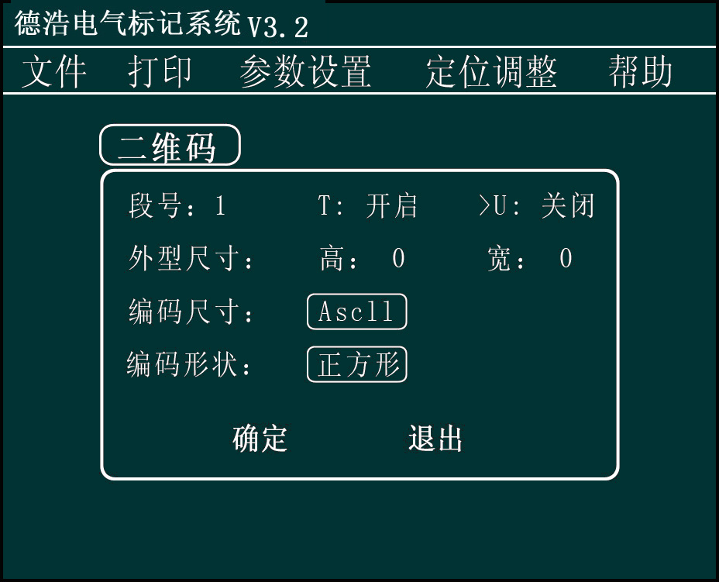

4.2.2.4 Positioning adjustment
The pull-down items of positioning adjustment menu include “debug, return to origin and ready position
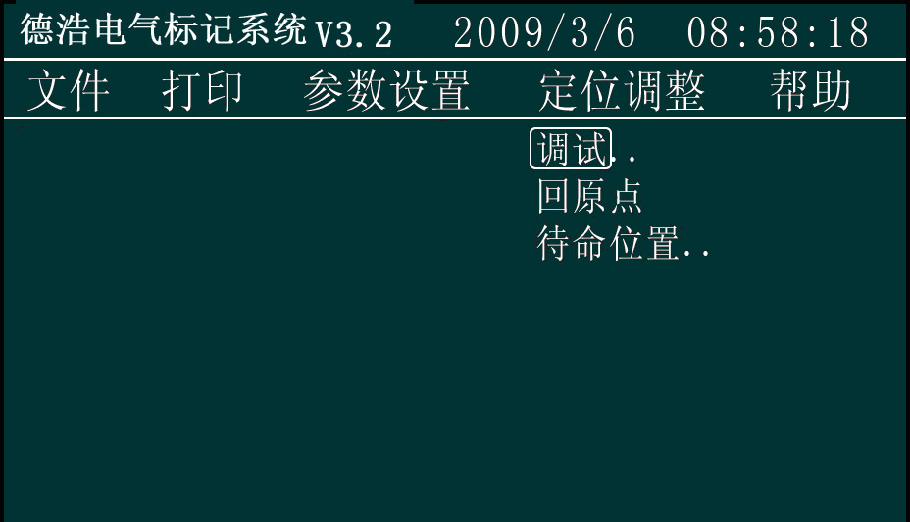

A．Debug
Operation steps: press “set”-“positioning adjustment”-“debug” to complete the test on the system
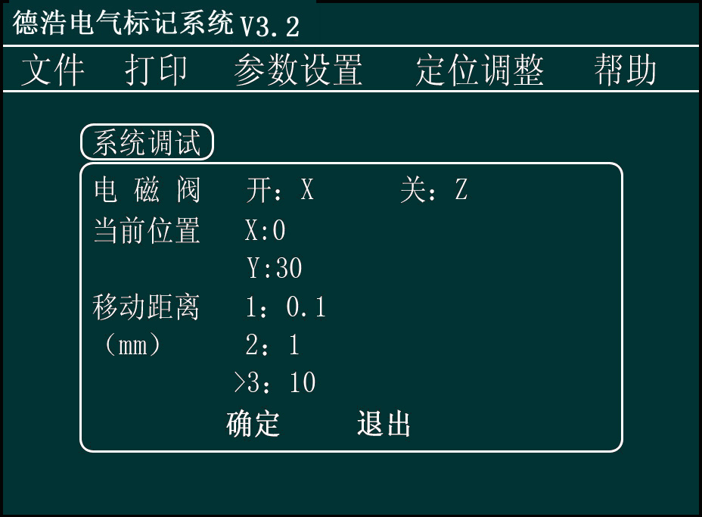
Figure: 11
- Solenoid valve
Under the interface of figure 11, press “X” for opening the solenoid valve and “Z” for closing the solenoid valve
- Position
Under the interface of figure 11, press the direction keys on keyboard for adjusting the coordinate position of the marking head
- Displacement distance
Under the interface of figure 11, press
“1” means that press the direction key once, the marking head will move 0.1 mm.
“2” means that press the direction key once, the marking head will move 1 mm.
“3” means that press the direction key once, the marking head will move 10 mm.
After the location of the marking head is adjusted, press “OK” key for storing the existing coordinate and meanwhile the marking head will return to the origin
Return to the operation interface by pressing “cancel” key without storing the coordinate and meanwhile the marking head will return to the origin
B．Return to the origin
Operation steps: press “set”-“positioning adjustment”-“return to the origin” to return to the origin
4.2.2.5Help
A，About..
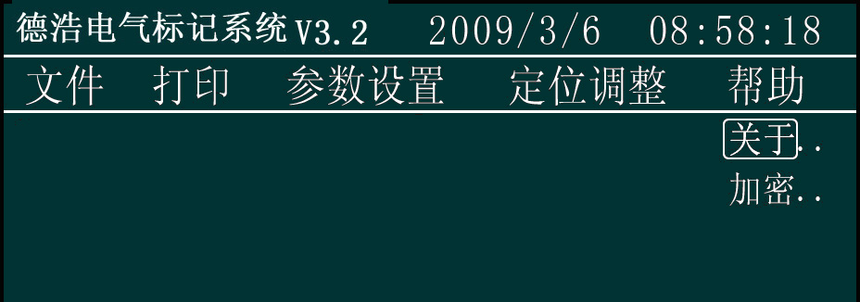
Figure: 6
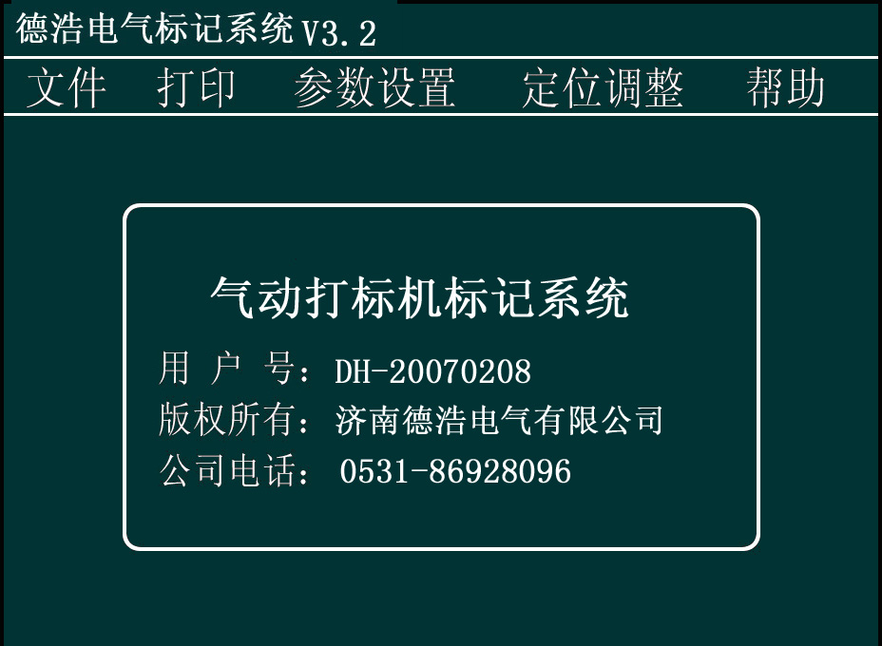
4.3 Text input
Under the input state (the interface entered into by pressing any key (except for shift) when turning on the computer), press the appropriate keys for the data to be printed. Press “upper/lower” key for the changeover of “upper and lower cases” (the indicator of changeover key is on). Press “Number/Letter” for the changeover therebetween (its indicator is on). Input special characters by pressing “Shift corresponding key”.
When Chinese characters are required to be input, press Shift+“upper/lower” key, and then the character “拼” will appear at the lower left of screen, which is as shown in the following figure
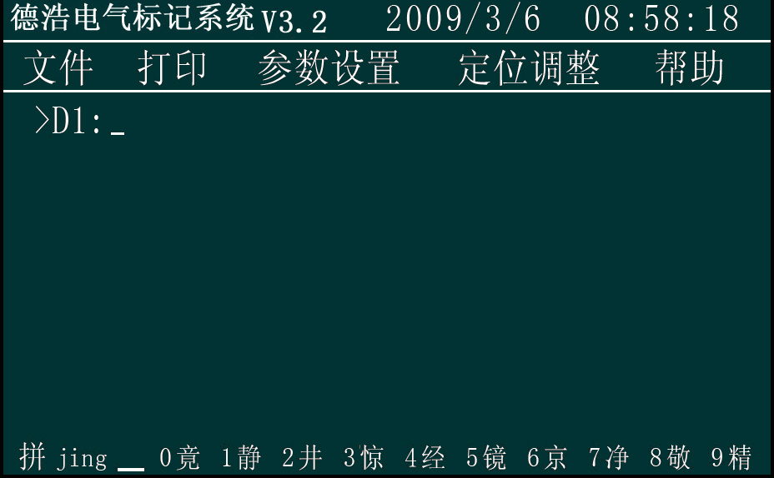
Input corresponding Pingyin of Chinese characters, Click "OK" button to enter the selection mode, you can press the left or right key or the corresponding figure to choose; press up and down keys for flip options, when the alarm sounds, that means it comes to the last page.
If the input is error, you can use the “Delete” key to delete a character, press "Exit" key to delete the entire data segment to be printed.

Chapter V Note
The modification may be made to the software; if your software contains the contents not stated in the manual, please operate according to the instructions in the software, and if you still have any problem, please contact us.

SectionⅡ Repair and maintenance instructions

Chapter Ⅰ Common knowledge for maintenance

Common knowledge for use
1. Keep controller and the surrounding environment clean
2. Ensure that the power supply and voltage of the controller are within the scope of safe operation
3. Plugging in any cables or signal lines is forbidden when the power supply is on.
4. After the end of the work, please exit the system normally, and then turn off the power, and finally leave the scene
5. After the abnormal power outage, be sure to turn off the power supply of the controller
6. Use it in strict accordance with the operation instructions and specifications
7. Forbid the non-operating personnel to operate the controller

Common knowledge of use for mechanical part
1. Maintenance requirements:
      - After using marking equipment, clean the iron scraps of printing head and guiderails with the brush to maintain them clean every day
      - Check whether the marking pin cavity is loosen before using the marking machine every day
      - Check whether the marking pinpoint is damaged before using the marking machine every time, so as to prevent generating waste
      - Check the marking pin cavity weekly and remove the dust therein to reduce its abrasion
      - Check whether the toothed belt and toothed belt pressure plate in the X and Y direction of the marking head are loosen and tighten the belt by adjusting the wheel spacing of the toothed belts monthly
2. Lubrication requirements
1. After cleaning the marking machine, apply 40# lubricating oil of 2-3 ml evenly on the guide rails in the X and Y direction of the marking head (note: don’t splash the oil on the toothed belts to prevent shortening their service life)
2. The lubrication of the pin cavity and marking pin is achieved by putting the lube oil in the triplet into the compressed air through atomizer
3. Fill the triplet with lube oil: fill up 10# or 20# lube oil when the oil amount in the oil cup is less than 1/5 of its capacity ( refer to Chapter 5 main component of triplet for details)

Chapter Ⅱ Common faults and solutions
The master of basic operation knowledge of Windows Software is necessary for the maintenance of Dehao DF System Software. Due to space restrictions, operation knowledge of Windows will not be explained in details.

1. Faults of controller

1.1 Controller can not be connected to power supply
- Check whether the local power grid is black out
- Check whether power socket outlet or UPS power switch is on
- Check whether the power of the controller is plugged into the power socket
- If the above problems do not exist, please check whether the power supply fan behind the controller is rotating,
1.2 The Controller fails to start up normally
- First of all, check whether the communication cables are plugged properly, and whether the marking head is normal. If no problem is found and the controller still fails to start, please contact the controller company, or to contact with maintenance personnel of the company.

1.3 Display screen fails to display normally
- Check whether the power of the controller is connected properly or power switch thereof is on
- Regulate the contrast adjusting knob to see whether there is something wrong with it
- Check whether the display screen is damaged
- Replace the display screen

1.4 The key-press refuses to operate
- Please check whether the key-press is connected to the control panel
- Replace the key-press

2. Equipment failure of marking machine

2.1 Faults of software

2.1.1 Indicate that there is the error of font library after the marking system is started
- Check whether the characters matches the font library and whether there are characters that are not included in the font library

2.1.2 Incorrect loading position
- Press “set”-“positioning adjustment”-“return to the origin” to enable the equipment to return to the origin.
- Please check whether the position of marking head in the working area meets the requirements
● Please check whether the work piece is put in place.

2.1.3 Multi-line input contents input fail to display
- Such problem generally is due to the reduction of guiderail length in the marking parameters which results in cross-limits of marking and failure of displaying characters. Please check out whether the positions of characters in each line are beyond the range limit.
- Such problem may be encountered in printing graphics and the system fails to indicate that the graphics to be printed are beyond the scope. In such occasion, the dimension of the graphics is required to be modified.
2.1.4 The printed contents can’t be modified
- Whether the auto-plus-one of serial number is selected
- Whether the unified mode of serial number is selected
- Whether the auto-date mode is selected

2.1.5 The system prompts that some characters are not included in the font library
- Check whether the font library is existing
- Whether such line of characters input is consistent with the selected font library
- If the above-mentioned two items are correct, it means that there is something wrong with the document of font library or the characters to be printed are not included in the defined font library, at the time ,please contact with us

2.1.6 The added line of characters fails to display and print
- Check whether the keyboard is damaged

2.1.7 The pen is delayed or missed during the marking
Please check out whether the settings of “delay of pen rising” and “delay of pen dropping” in the “system parameters modification” are correct, and whether the default value of the equipment is 15 ms

2.2 Faults of hardware

2.2.1 The system indicates that the origin can’t be found

The motor refuses to operate when entering into the system
- The motor fails to operate when entering into the system and the power indicating light of the controller is on. At such time, checks can be done in the following respects: 1) confirm that 19-core cable between the controller and the marking head is correctly connected and aviation plug is screwed tight; 2) open the controller to observe whether power indicating light of the motor drive is on; if one light is off, the driver the dark light indicating is damaged and the fault will be cleared through replacement.
- When entering the system, the motor moves towards the origin and continue to move when pressing the origin switch with the sound of “da da”.
- The motor arrives at the position of the origin switch without pressing it and the method to confirm it is that, turn off the power of the controller, then push the marking pin to the location far away from the origin switch, turn on the power reentering the system, press the origin switch manually when the marking head is moving in the direction of the origin with problem, then the marking head will change the direction. The solution is to regulate the location of the origin switch or the pressed spring thereof to make the origin switch be pressed when the marking head reaches the origin;
- In Condition 1): origin switch is damaged. Steps taken to check out： press the origin switch by hand and the marking head still moves towards the origin, at this occasion, measure it with multi-meter to see whether it is damaged and if damaged, replace it;
- In Condition 2) , if the origin switch is in good condition, please check whether the lines relevant are broken, and measure with reference to “Wiring table of aviation plug and printing head”. If feasible, replace the injunction panel, control panel, 19-core cable for printing and 25-pin data cable.

2.2.2 The printed characters are deformed
- The screws of the toothed belt pressure plate are loose
- The marking head is not screwed tight
- The pin cavity is in serious abrasion
- The work piece is not fixed securely
- The marking head is not fixed securely
- The distance between the printing pin and the work piece is too close.
The method to identify the problem: 1) at first, check the distance between the printing pin and the work piece, and the adjustment and set thereof are related to the printing pneumatic pressure, thus, when the pressure is 0.5 Mp, the distance 5-6 mm, the distance will decrease along with the pressure. If the pressure is large while the distance is short, the printing pin will not be able to vibrate, as a result, the step-loss of the motor will be likely to occur, which will cause the deformation of characters printed and line changes by pressing; 2) when the power of the marking head is off, grasp the printing pin by hand and push/pull it lightly in the direction of the guide rail to identify the fault point.

2.2.3 Strokes missing and dragging of the printed characters
- Air source pressure is too low
- Some part of air line is blocked or bent
- The printing distance is too far
- The interior of the printing pin cavity is too dirty
- The interior of the printing pin cavity is in short of oil
- The spring in the printing pin cavity is broken or in fatigue
- There is no oil or poor atomization inside the oil mist device on the triplet
- The parameter settings of “delay of pen rising” and “delay of pen dropping” are incorrect

2.2.4 The printed characters appear dotted
- The printing pin cavity is damaged due to abrasion, replace it
- There is a gap between the guide rails, replace them
- The printing pinhead is broken, replace or sharpen the print needle (the angle of it is 60°)

2.2.5 Fail to print by pressing the remote control switch
- The wire of the remote control switch is damaged (whether it is scalded or bent)
- The remote control switch and controller are not screwed securely
- The remote control switch is damaged

2.2.6 Fail to print when the marking head is moving
- Check whether there is air in the source; whether the triplet switch is open; whether the pressure is too low
- When printing, listen to the solenoid valve to see whether there is the sound “da da”; if any, remove the pinhead of the marking head and reinstall it
- Otherwise, please check whether the cables are connected properly

Chapter Ⅲ Table of wiring
Table of wiring of aviation plug and printing head
Designation of signals | Aviation plug | Connection terminal | No. of line | Color of line | Color of terminal
X_A+ | 1 | 1 | 1 | Red | Grey
X_A- | 2 | 2 | 2 | Green | Grey
X_B+ | 3 | 3 | 3 | Yellow | Grey
X_B- | 4 | 4 | 4 | Blue | Grey
Y_A+ | 5 | 5 | 5 | Red | Grey
Y_A- | 6 | 6 | 6 | Green | Grey
Y_B+ | 7 | 7 | 7 | Yellow | Grey
Y_B- | 8 | 8 | 8 | Blue | Grey
Printing switch | 9 | 9 | 9 | White | Orange
Printing switch | 10 | 10 | 10 | White | Orange
Electromagnet | 11 | 11 | 11 | Red | Olivine
Electromagnet | 12 | 12 | 12 | Red | Olivine
Solenoid valve | 13 | 13 | 13 | Yellow | Blue
Solenoid valve | 14 | 14 | 14 | Yellow | Blue
24V | 15 | 15 | 15 | Red | Orange
24V |  | 16 | 16 |  | Orange
Y Origin | 17 | 17 | 17 | Blue | Grey
X Origin | 18 | 18 | 18 | Green | Grey
GND | 19 | 19 | 19 | Black | Grey
GND | 16 | 20 | 20 | Black | Grey

Note: a. the origin switch is of mechanical type, 18 and 19 (mean aviation plugs) are connected to the X origin switch and 17 and 16 are connected to the Y origin switch
b. the origin switch is of photoelectric type, 15, 18 and 16 are connected to the X origin switch and 15, 17 and 19 are connected to the Y origin switch.
c. 15 and 16 are connected to each other on the terminal block

Appendix I Cross reference table of ASCLL codes of special symbols
Decimal system | Symbol |  | Decimal system | Symbol
28 | ￥ |  | 46 | .
29 | ※ |  | 47 | /
30 | ◇ |  | 58 | :
31 | ☆ |  | 59 | ;
32 | Space |  | 60 | <
33 | ！ |  | 61 | =
34 | ” |  | 62 | >
35 | # |  | 63 | ?
36 | $ |  | 64 | @
37 | % |  | 91 | [
38 | & |  | 92 | \
39 | ' |  | 93 | ]
40 | ( |  | 94 | ^
41 | ) |  | 95 | _
42 | * |  | 96 | `
43 | + |  | 123 | {
44 | , |  | 124 | |
45 | - |  | 125 | }
 |  |  | 126 | ~

