

GM328A Component Tester & Pulse Generator

General Purpose Multifunction Component Tester

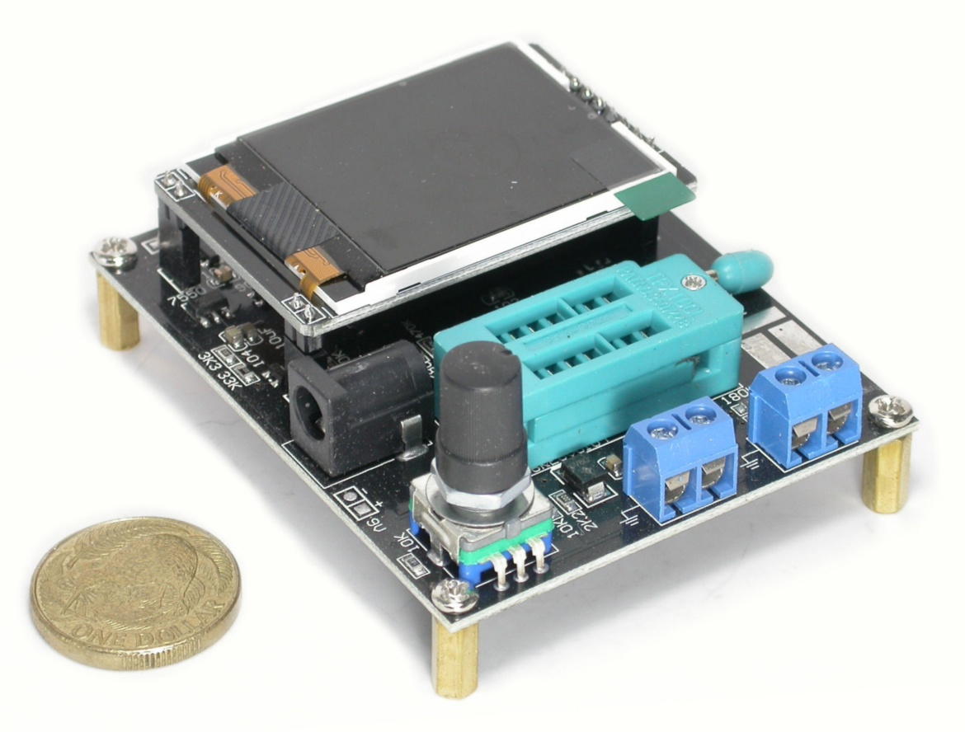

**Introduction:**

The **GM328A** is a very small low-cost advanced microcontroller based semi-automatic component tester suitable for general use with many common types of conventional electronic components including; ***Resistors***, ***Capacitors***, ***Inductors***, ***Diodes***, ***Transistors***. In addition, several innovative additional functions enable a variable PWM *(5V pulse-wave)* output and some basic frequency measurement facilities. Power *(nominal 9Vdc)* to the tester can be via an external plug-pack or a simple battery connection etc.

Once the test-programme *(mode)* is selected and the **to-be-tested** component is loaded *(connected)*, the ‘xx’ microcontroller and LCD display quickly renders legible component data at modest accuracy.

The instrument’s functions are controlled/selected using a combination of encoded-knob rotation and knob-depressing with test inputs and outputs as covered in the user manual that follows.

While the basic unit is supplied with mounting studs *(threaded standoffs)* no outer case is or leads are included. These may become an option or accessory in future production.

**Basic Specifications:**

**Display:** LCD 160*128 pixels

**Supply-Power:** 6.8~**12Vdc** @ **30mA** *(nominal)*

**Resistance** Measurement: Up to **50MΩ** *(can be as good as +/- 0.1Ω)*

**Capacitance** & **ESR** Measurement: <**25pF~100mF** *(and resolve as good as 1pF)* combined with an **ESR** *(equivalent series resistance)*: from 0.01 Ohms

**Voltage** Measurement: Up to **50Vdc**

**Frequency: TBA?**

**Inductance:** <0.015mH ~ >20H *(as currently tested)*

**Transistors:** Auto-detect NPN, PNP, FET, SCR Bipolar & Darlington with display of some technical parameters.

**FET:** Measures FET gate threshold voltage and gate capacitance.

**Diodes & LEDs:** Forward-voltage-drop, leakage-current, polarity identification

**Pulse-Generator:** DC to **2.1MHz** *(increments from 0.1Hz)* at 5V p-p (1~99% PWM)

**Auto-Shutdown:** after 1?m unit goes into quiet-mode (approx 20nA quiescent drain on power/battery)

**Screen Size:** 37 x 30mm *(1.45 x 1.18 in)*

**PCB Size:** 78 x 62mm *(3.1 x 2.44 in)*

**Net Weight:** 78gms

**General Operation:**

**CAUTION** - Please observe appropriate **ESD** *(electrostatic-discharge)* protection for the instrument and all static-sensitive components being tested.

Before measuring capacitance, the capacitor must be discharged; otherwise damage to the tester is likely.

1. Place the tester in a working space suitable for operating the tester and connect to a suitable power source.
2. Turn on the power-source and depress the knob to allow the tester to initialise.
3. The tester will default to auto-recognition of some pre-installed component.
4. If sensible auto-selection is not achieved then manually select the test or signal mode required using the knob and interacting with the LCD display text.
5. Connect the test component into the ZIF-Socket and clamp… …or make connections to the appropriate input/output terminals.
6. Initialise the test or measurement or signal output by down-pressing the control knob.
7. Test results or signal output will be presented after a short wait.

