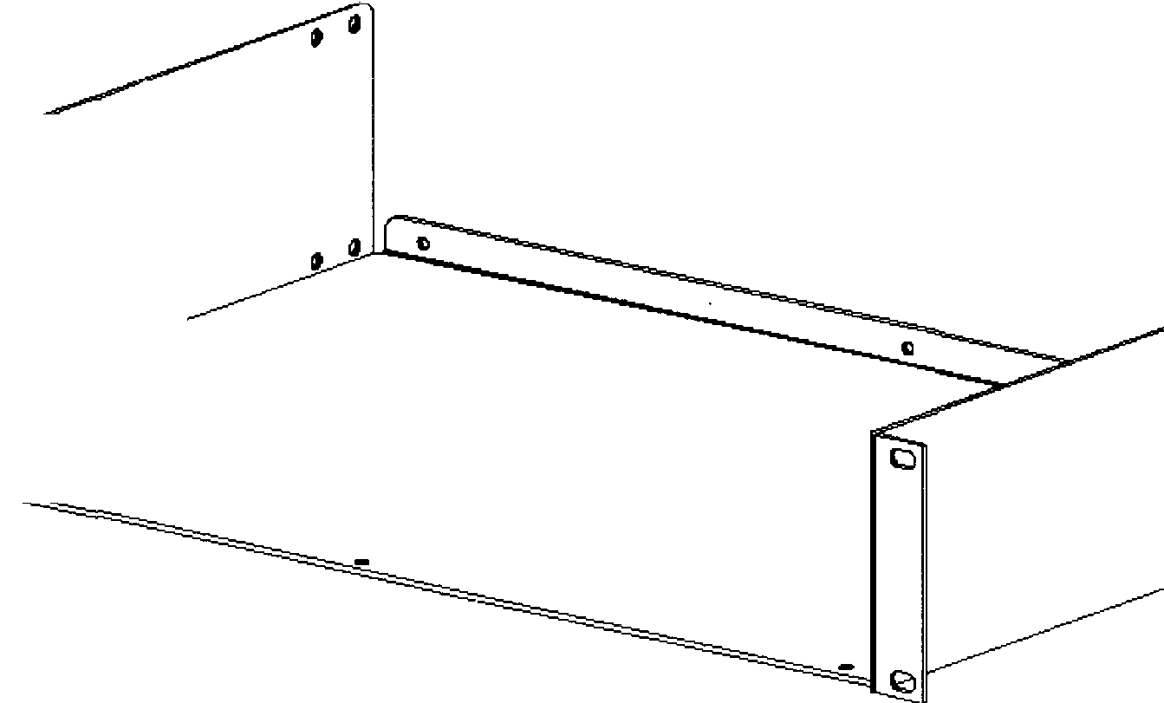
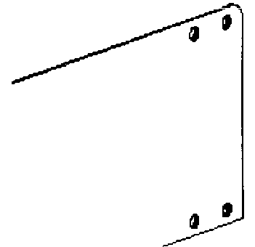

P.O. Box 38-828
PETONE, Wellington
DATA SHEET Phone - (64-4) 9393 777
FAX - (64-4) 9393 778
Date - 9th February, 2000 e-mail = sales@ casa.co.nz Ref - RACK-SHL.FRP
or 19" RA C
This SHELF has been designed to provide 19" Rack mounting/fixing for FREE STANDING equipments such that many non-standard products can be installed in Standard 19" Equipment Racks. Typical equipment include Audio, Video, Industrial, Telecommunications, Data Systems, Modems, Batteries and other Electronic Apparatus not exceeding 437mm (17.2") wide.
Features Include:
1) Standard UNIT heights (44.45mm 1.75") from 2-4 units @ 200, 300 or 400mm deep (other sizes 350, 450 etc. to order)
2) Folds at rear and/or front can be applied as "Fold-Up" and/or "Fold Down" to give added stiffness and strength to shelves.
3) Simple Basic design permits standard & SPECIAL lengths, finishes and variants to be produced economically even in small
quantities with features including punching for ventilation and retrofittable / rear fixing for larger or heavier equipment.
4) Custom design can be undertaken for special requirements. Please enquire giving details of desired/required features,
facilities, and quantities etc. (a sketch or drawing will be appreciated). Many variations can be processed from "blanked" stock.
CASA's Design Philosophy: Compatability, Adaptability, Symplicity and Acceptability achieves sound Engineering, Cost
Economy and Aesthetics. NOTE - See reverse of this Data Sheet, or separate drawings, for basic dimensional information.
Specification Details:
Preferred / Standard Sizes:
Special Heights & Depths to order: (minimum quantity may apply) Cutting & Nominal Dimensional Tolerance:
2 Unit (88.1mm) Stock
-3 Units (132.5mm) Stock, -
4 Units (177mm) Stock
_
-------- --------------
1-10 Units (1 U=44.45mm)
+l- 0.25mm (to 500mm)
Powder Coat, Zinc Plated or Anodized (if Aluminum) 2 Unit = 3Kg (approx.)
Unit _ _3.5Kg (approx.)
4 Unit = 4Kg (appro# _
((depends upon depth etc.)
Finishes:
Material: Mild Steel (or Aluminum)
Part Number.- RS-xxUxYYzz=MAT=F adder/suffix
(full deburring of all cut, drilled, punched and tapped holes & edges is standard)
Weight:
(typical/nominal weights for 300mm deep using 2mm Mild Steel)
Please compose a
Part Number
according to this
system and use on
your official order.
RS - ,Prefix to indicate "RACK SHELF".
xxU - ,HEIGHT in RACK Units (multples of 44.45milimeters)-_ _ _
YY - ,Depth behind mounting face, in_'mm"-X200, 300, 400 others made to orders .
zz - _ Fold designations (F = Rear Fold UP, FF = Front & Rear Folded UP etc.)- _
MAT - Material used MS20 = Mild Steel 2mm AL20 = Aluminum 2mm
F - ,.Finish applied to the base material (GGP = Ghost Gray Polyester powder coated
(XXX) Special Suffix to indicate CUSTOM features or other variants etc
PROFESSIONAL QUALITY IN COMPUTER & ELECTRONIC HARDWARE, COMPONENTS & MATERIALS

