Review of Commercial Electronic Ceramic Materials in
Australia; 50 years onwards

Gerry Triani1 and Peter Bryant2

1) Institute of Materials Engineering, Australian Nuclear Science and Technology Organization (ANSTO), Lucas Heights, NSW 2234
2) Thales Australia, Rydalmere NSW 2116

Email: gtx@ansto.gov.au and peter.bryant@thalesgroup.com.au

Available Online at: www.austceram.com/ACS-Journal

Abstract
This review paper will address the Australian history of electronic ceramic materials which were used primarily for their dielectric properties rather than their insulation properties. The history of these materials can be broken down into three main periods. The first period is that prior to 1950, when the electronic components industry was
first set-up. The second period from approximately 1950 to 1975 involves the expansion and decline of the capacitor product lines and production capacity under the Ducon Condenser Company. The third period from approximately 1975 and continuing to the current day, involves the manufacture of piezoelectric components and
devices through Ausonics Pty Ltd and a group at Plessey Ducon, which was subsequently managed in turn by its successors, Plessey Australia, GEC Marconi, Thomson Marconi and the Thales Australia companies.

THE PRE 1950 PERIOD
This early period is undocumented in the current
Thales Australia technology database. A brief history can be gleaned from historical newspaper records.

Following the commencement of commercial radio broadcasting in Australia in 1922, the radio found increasing acceptance in households in Australia and many companies were setup to manufacture radios and the components that were used to support this manufacturing. Companies such as Nilcrom Porcelains Pty. Ltd. and Ferro Enamels Ltd. developed locally manufactured insulators from porcelains and steatite [1].

Ducon Condenser Pty. Ltd. was another such company started in 1932 to supply capacitors into this market and it quickly grew to dominate the Australian market [2]. The company was founded by a German immigrant, Hans? Hecht who after a chance conversation with Andrew Perrson, a Swedish immigrant, decided to invest £5000 in this new venture. This gave Hecht 50% ownership in the new company [3]. Hecht had wide ranging business interests involving a number of import- export companies and for a while in the mid 1930s was involved with the Jubilee radio. [4] Hecht claimed that the growth of Ducon was largely due to the efforts of Perrson and also Cliff Gittoes who later became managing director and chairman [3].
The expansion of Ducon and the other companies was furthered by the need to develop a self- sufficient Australian industrial capability during World War II. In some cases, this involved identifying and utilising Australian raw materials. [1]. In other cases, Ducon took over companies with specific product ranges such as Simplex Products Pty Ltd which made mica based capacitors [5] and where significant industrial shortcomings were identified, Ducon undertook technology transfer arrangements with companies such as Compagnie Générale De La Télégraphie Sans Fil of France, General Ceramics Corp, Erie Resistor and P. R Mallory Inc. of the USA [6, 7].

In this period, Ducon developed some capability with manufacture of ceramic capacitors. People such as J.M. Gleeson of General Ceramics and Steatite Corp. helped set up the ceramic facility in the 1940s with particular emphasis on the steatite (magnesium silicate) based materials. The low dielectric losses and high dielectric and mechanical breakdown strengths of such ceramics found a ready market in many communications systems [8]. Unfortunately, there are no detailed records of the materials used and manufactured at that time.

FROM 1950 TO 1975
The technology and manufacturing developments
of this period are well documented by internal company reports written by Hans Ruckert. These

reports are currently held in the Materials Laboratory of Thales Australia at Rydalmere. Hans Ruckert was a German scientist who had worked in the HF Dielectric Laboratories of Rosenthal- Insulator GmbH. Barium titanate was discovered and developed independently in the USA, Russia and Japan [9]. It quickly became the key dielectric material as it allowed the manufacture of products with a wide range of dielectric constants, dissipation factors and temperature coefficients. The management at Ducon recognised the need to make products based on barium titanate and initially sought to procure the expertise through technology transfers with the Erie Resistor company. These efforts were not particularly successful because the American personnel were only employed on short term contracts and secondly, because the manufacturing equipment used (e.g. oil fired furnaces) were poorly suited to advanced ceramic manufacture.

Australia had established a Ministry for Industrial Development in the late 1940s to make the country more independent from imports and so the migration of people with special experience was organised. Hans Ruckert was one of these people. As Hans himself noted, he had no precise formulation experience but by the end of 1951 had established the compositions and processes to manufacture the N750, NPO and K4000 materials which could be used for both tubular and disc capacitors. Over the next 20 years the list of dielectric materials was improved and expanded and even today some of his NPO formulations have not been bettered [10].

It is instructive to note many of the issues that Hans
Ruckert faced in the development of such materials.
• A failure of management to quickly appreciate that a high performance product requires more stringent manufacturing conditions
• Incomplete transfer of information during a technology transfer
• The possible over-reliance on a single person as the source of the technology
• The need to produce materials to international standards (IEC or EIA classifications)
• Inadequate test equipment
• Oil fired furnaces producing reducing atmospheres rather than oxidising
• Inadequate furnace materials e.g. zircon setter rather than the less reactive stabilised zirconia
• Inadequate raw materials
• The need for cleanliness and a dust free environment
• The need for a superior electroding material

Component production and engineering activities reached a high standard in the late 1960s and 1970s but the component designs remained at the discrete level. Electronic equipment designs had also stagnated and left the television and radio manufacturing industries very vulnerable to competition. When Japanese companies were allowed to establish television manufacturing plants in Australia in the early 1970s, they imported completely assembled circuit boards. The Australian companies were forced to do the same thing and with the tariff reductions in 1973, the Australian component industries which included capacitors, resistors, semiconductors, ferrites and volume controls etc. were all decimated [10].

Thousands of jobs and much experience were lost in this period. Yet in hindsight, one might also reflect that given the ways in which the electronics components industry has developed over the last forty years with devices such a multilayer chip capacitors and integrated circuits that Australian industry was in a poor position to be at the forefront of such developments. One might also pinpoint a tendency for the companies to be primarily focussed on just the static Australian market, to have a restricted research and development group centred on one person who focussed on materials rather than one with a multi-disciplinary team with a focus on product applications and efficient material processing, and the existence of government policy which effectively destroyed an industry rather than encouraging its evolution and long term survival [11].
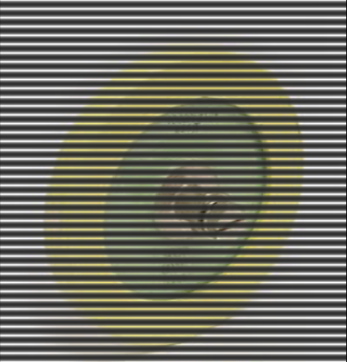

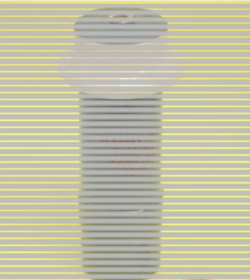

THE DUCON CERAMIC DIELECTRIC MATERIALS TECHNOLOGIES

Ducon manufactured a full range of dielectric materials and produced materials to the International Electrotechnical Commission (IEC) standards of the time. A similar classification applies today where IEC/EN 60384 series is the appropriate standard. This document series defines the class 1 (the temperature stable materials) and class 2 (high dielectric constant) ceramic dielectrics. The old class 3, barrier layer dielectrics, is now considered obsolete but was a competitive product in the late 1960s and early 1970s.

The class 1 dielectrics based on paraelectric materials were defined by both their dielectric constant or “K” value and their temperature coefficient of capacitance. The temperature coefficients were designated in accordance with the IEC standard as P100 or N750 where the “P” or “N” designated either a positive or negative temperature coefficient in ppm/K respectively. The temperature stable materials were designated as NPO.

The starting points for development of the type I ceramic dielectrics range were the K6.5/P150 steatite and the K90/N750 titanium dioxide base ceramics. The importance of using a fully oxidising atmosphere and the usefulness of additives such as manganese dioxide in controlling the dissipation factor were key early developments. Subsequently, in line with other manufacturers, medium K/TCC dielectrics based on barium titanate + titanium dioxide were produced and commercialised.
Ideally, one would prefer a temperature stable material but there was usually some trade-off between temperature stability and dielectric constant and a larger dielectric constant allowed a particular component to be physically smaller. In many instances, the negative temperature coefficient of capacitance was selected to balance positive coefficients of other circuit components such as ferrites in tuned circuits so that the overall circuit stability was improved. For the NPO materials, a range of dielectric constants was available. For leaded components with low capacitance values, it was preferable to use a lower dielectric constant material to enable easier handling and soldering. For very large high-voltage capacitors, a lower dielectric constant was often preferred as the breakdown voltage of the unit could then be optimised.

The K105 NPO was a development of the early
1970s. This represented a significant advance over previous best K values in the 60-80 range. A draft
patent for this material had been prepared and discussions on licensing to foreign firms had also commenced at the time the dielectric ceramic
manufacturing plants were shut down and so never saw any significant production. Even today, this material would represent state of the art in such
temperature stable ceramic dielectrics. Modifications to this NPO composition allowed the production of novel composition such as the
K200/N1000 material.

A listing of the more frequently produced materials and their base compositions is given in the following table [12].

Table 1. The Plessey Ducon range of Class1 dielectric materials and their key properties

Ceramic names
Temperature coefficient α

α-Tolerance ppm /K

IEC/ EN- letter-code

DUCON
Main compositional components

ppm/K
P150 150 ±50 -- magnesium silicate
P100 100 ±30 AG TiO2+ZrO2+SnO2
NP0 0 ±30 CG K16: magnesium titanate
K37: barium titanate + TiO2
K105: barium titanate + rare earth titanate
N33 −33 ±30 HG Barium titanate + TiO2
N75 −75 ±30 LG Barium titanate + TiO2
N150 −150 ±60 PH Barium titanate + TiO2
N220 −220 ±60 RH Barium titanate + TiO2
N330 −330 ±60 SH Barium titanate + TiO2
N470 -470 ±60 TH Barium titanate + TiO2
N750 −750 ±120 UJ K90:TiO2subscripts?
K160: barium bismuth calcium titanate
N1500 −1500 ±250 VK calcium titanate + zirconate
N3300 -3300 -- -- barium titanate + strontium zirconate titanate
N7500 -7500 -- -- barium titanate + strontium titanate

Ducon’s range of class 2 dielectrics was based on ferroelectric compositions and was quite conventional. A range of barium titanates doped with Curie Point shifters such as calcium zirconate and strontium titanate was employed. Again, significant use was made of manganese dioxide to better control the dissipation factor. Up until the
1970s, Ducon classified all its type II dielectrics purely in terms of their dielectric constants. In more
recent years, the IEC have defined the temperature coefficients of capacitance more precisely. Although a very large number of possible compositions are allowed under the standard, most
production seems to comply with the following three categories.

2X1 Temperature range – 55°C to +125°C;
variation +/- 15%
2E6 Temperature range +10°C to +85°C; variation
+22%/-56%
2F4 Temperature range – 25°C to +85°C; variation
+30%/-80%

Although the variation of capacitance with temperature was measured for the Ducon compositions, it was not reported in accordance with the latest IEC standards. The following table lists the various Ducon grades produced in the
1970s along with the reported temperature variations and possible allocations to the IEC equivalents. It is the authors’ opinion that these Ducon materials may not be fully compliant to the IEC standards particularly at the temperature extremes as such requirements were not design criteria when the materials were developed.

It is also interesting to note that in practical terms, the Ducon materials were developed so as to be blendable, so that adjacent pairs could be mixed so as to generate intermediate values of the dielectric constant if required. Shortly prior to plant closure, this concept was to be extended so that the production department would only need to make the two end members of this series and any intermediate members would be obtained by blending [13].

The Class 3 dielectric materials used for what are commonly called “barrier layer capacitors” are obsolete in the latest IEC standards as they have effectively been replaced by the higher dielectric constant class 2 dielectric in multilayer packages. The class 3 dielectrics were originally purported to have dielectric constants well in excess of 100,000. Such high dielectric constants enabled the production of high capacitance values in small package sizes. The drawback to these components was their low insulation resistance and low working voltages.

Hans Ruckert and his team at the Ducon
capacitor” was in many ways a misnomer. They were able to identify a number of key factors which enabled the production of such devices with high capacitance, insulation resistance and good working voltages. These devices were better described as reduced core ceramic capacitors.

The key parameters include

i) A starting composition comprising a barium titanate with an excess of TiO2 and a rare earth titanate with is readily fired in an oxidising atmosphere to give a ceramic with a dielectric constant of ~6000 at 25°C and a tan δ of ~ 1.5%
ii) The sintered ceramic should have a fine uniform grain structure. Contamination and damage to the parts must be avoided. Use of raw materials with very low alkali metal components as the presence of such compounds can prevent the proper re- oxidation of the outer layer.
iii) A reduction firing which reduces the ceramic parts fully through their
thickness. This was typically done by
firing the parts stacked on their sides in inconel boxes while sitting on a
layer of carbon black.
iv) An acid etching process to increase the surface area followed by
impregnation with a manganese
nitrate solution.
v) A re-oxidation firing which re- oxidises the skin and subsequently fully separates the metal electrodes and the reduced core. The skin layer must be greater than 2.5 microns (or at least two grain layers) otherwise the reduced core will be partially exposed and the device will remain semi- conductive. The temperature and time of the re-oxidation firing was precisely controlled to obtain a sharply defined oxidised skin with a high insulation resistance.
vi) Green density variations within the part must be minimised
vii) The re-oxidation must proceed
uniformly on both major surfaces
viii) When using fired on electrodes, the glaze type and amount must be optimised. The glaze oxidises a reduced ceramic skin and then further insulates the skin from further oxidation preventing it from becoming too thick.
ix) The electrode firing cycle must be optimised and each face of the part must be exposed to an identical

Table 2: The Plessey Ducon range of Class 2 dielectric materials and their key properties

Ceramic name

Maximum
KT33
Temperature for
maximum KT33
°C

T
K
33
max
- X%

Lower temperature for -X% °C

Higher temperature for -X% °C

Possible IEC grade

K2400 2400 25 5% 0 98 2X1
K4500 4500 25 10% -15 50 2E6/2F4
K6500 6500 25 20% 10 38 2E6/2F4
K10000 10000 23 50% -20 57 2F4
K14000 14000 20 50% 7 57 2F4
K15700 15700 23 50% -12 45 2F4

Ducon made millions of these types of capacitors which it called “red caps “for the transistor radio market. Working voltages from 3V to 100V were achieved by adjusting the re-oxidising process to increase the skin thickness from ~2.5 microns to ~
100 microns. As noted above the skin layer could not be made thinner than 2.5 microns without the reliability of the device being affected [10, 14].

THE PIEZOELECTRIC ERA
With the closure of the Plessey Ducon ceramic dielectric department in Villawood NSW, much of the skills and knowledge was virtually lost.
However, a small group was retained to work on piezoelectric materials, primarily for projects for the Department of Defence. One of these programs
involving the Barra sonobuoy was the primary driver ensuring the survival of electronic ceramic manufacture to the current day. Some of the
equipment was moved to the main Plessey
Australia site at Meadowbank NSW and remained there until 1996 when the facility was transferred to
a new site at Rydalmere operated by Thomson
Marconi sonar.

Ducon had made a piezoelectric barium titanate for a number of years in the 1960s. In addition many of the class 2 dielectrics would have been piezoelectric below their Curie Points but as this temperature had been deliberately adjusted to around 25°C, such materials had no practical application as piezoelectrics. The piezoelectric composition used was compliant to the Type IV requirements as defined by MIL_STD_1376 (SHIPS) 1970 Piezoelectric Ceramic for Sonar Transducers.

The situation changed in 1967 when DSTO expressed as interest in using PZT based compositions. Hans Ruckert and his team then commenced a development program focussed on PZT ceramics. For the first few years, considerable effort was expended in reviewing the literature regarding the compositions and processing of PZT materials. In addition to this, experience was collected on PZT processing and in particular the calcining and sintering of a material with a highly volatile ingredient. The lead oxide component of
PZT bodies is so volatile above 900°C that a useful component cannot be manufactured unless a practical way is found to control its volatilisation [15].

It was also realised that the principal commercial compositions were those produced and licensed by the Brush Clevite Corp (subsequently Vernitron and then Morgan Electro Ceramics) throughout the USA and Europe. The importance of the Brush Clevite materials was further emphasised by the release of the US Military standard MIL_STD_1376 (SHIPS) 1970 Piezoelectric Ceramic for Sonar Transducers in December 1970. This document quickly became a de facto standard for the piezoelectric industry [16].

The situation in Japan and Russia was different. In Japan, Ouchi and his co-workers at Matsushita developed materials based on the lead magnesium niobate-PZT system. [17]Ref The Russians also developed a range of very similar compositions. The Ducon team realised that the lead nickel niobate-PZT system offered similar, if not superior performance and ease of processing to the Matsushita system, and Hans Ruckert was awarded a patent for this compositional family in 1970 [18].

This patent enabled a continuum of soft PZT materials to be produced with dielectric constants ranging from ~ 1500 to ~ 6000 by simply varying the amount of lead nickel niobate. This exceeded the range defined in MIL-STD 1376. Use of nickel rather than magnesium, as in the Matsushita material, enabled the manufacture of a material which more consistently could be made in the active perovskite form. The patent also defined manganese dioxide (or similar) as the critical additive for converting the soft PNN-PZT materials into harder materials suitable for active transducers. An appropriate selection of the amount of lead nickel niobate and the amount of manganese allowed compositions virtually equivalent to those defined in MIL_STD_1376 (SHIPS) 1970.
With this understanding and patent protection, Plessey Ducon began manufacturing PZT ceramics in 1969. Major early markets for these materials
included the Sonalert transducer for telephones for
the then PMG (now Telstra) and discs for the

Ausonics Pty Ltd Octoson medical ultrasonic scanner. The principal market and the driving force which ensured the survivability of the ceramics manufacturing capability was the Barra hydrophone and sonobuoy developed in conjunction with AWA and DSTO.

Hans Ruckert retired in 1979 and Technical and Business reins were taken up by Dr Gavin Tulloch. Over the next 10 years Gavin Tulloch greatly expanded the product range and technical skills of the department so that it became an integrated Sonar Products house with both design and manufacturing capability for both piezoelectric components and sonar transducers. The products manufactured in this Plessey Australia period included the Mulloka active transducers arrays, the Jezebel hydrophones, the active and passive transducers on the Oberon class submarines and the Kariwarra hydrophones and towed arrays.

In the GEC Marconi period from 1988 onwards, the growth of the facility stabilised and the department was involved in the supply of transducers for nearly all the major sonar platforms of the Australian navy. These included the Scylla Sonar on the Collins Class submarine, the 2093 Minehunter sonar on the Huon Class minehunters, the EMATT expendable sonar training targets, the Spherrion hull mounted sonar, and the Coltas/Shortas towed array sonars.

From the early 1990s to 2006, the company was involved in the design and manufacture of slimline towed array sonar systems for the seismic industry. The department was then involved with the design and manufacture of over a million hydrophones into this market over a 10 years period. Since the end of this program the department has again concentrated on supplying the military market and has also exported a significant amount of ceramic and transducers to sister companies in Europe. This activity is ongoing and the export represents the majority of the current business.

Another commercial activity utilising piezoelectric ceramics in the mid 1970s was the medical diagnostics company Ausonics Pty Ltd located at Lane Cove in Sydney. This company emerged to develop and manufacture an Australian innovation from the Ultrasonics Institute, then part of the Commonwealth Health Department, later transferred to CSIRO. George Kossoff, David Robinson and colleagues pioneered the use of ultrasonic medical diagnosis using ‘grey scale ultrasound’ for obstetrics imaging utilising a 2.5
MHz transducer fitted with piezoelectric ceramic
elements [19]. Ausonics Pty Ltd commercialised the UI Octoson technology in 1976, developing hospital systems where the patient would lie on a water bed covered with a flexible membrane. The ceramics for this application were originally manufactured by Plessey. Pulse-echo responses were transmitted through the water providing images of the foetus inside the uterus. In the mid
1980s, Ausonics developed ‘real-time’ diagnostic equipment using mechanical section scanner to
generate ultrasonic images of the body. Although
robust for their application, piezoelectric ceramics of specific frequency (i.e. 2.5-7.5MHz) were
required to drive the transducer around a pivot point at the front of the scanner. This was achieved by machining a large block of ceramic to a specific
radius of curvature and thickness to achieve the desired frequency range. However, by the 1990s the trend in the diagnostics industry was to move away
from mechanical systems to arrays, which allowed the transducer beam to steer electronically, thus avoiding moving parts.

In the late 1980s the Australian Nuclear Science and Technology Organisation (ANSTO) applied its nuclear ceramic expertise to the field of piezoelectric ceramics. ANSTO conducted a 3 year project with Ausonics focused on developing the next generation piezoelectric ultrasonic transducers using composite (ceramic/polymer) structures [20]. This project involved advanced powder processing suitable for tape-casting as a means to produce cost effective near net shaped ultrasonics devices.

Tape casting has become an established ceramic processing method for forming, thin, flat, large area ceramics in the thickness range 10-3000 µm with high precision and is used to fabricate ferrite memories, ceramic capacitors and electrically insulating substrates for thick and thin film multilayer circuitry [21]. The tape-casting process involves the suspension of finely divided ceramic powders in an aqueous or organic vehicle comprised on solvents, deflocculants, plasticisers and binders to form slurry that is cast onto a moving carrier tape. The slurry passes beneath the knife-edge of a blade that levels the slurry to form a layer of controlled thickness and width as the carrier surface advances along a supporting table (Figures 2a and b). When the solvents have evaporated, the fine solid particles coalesce into a quite dense flexible sheet which is essentially a collection of particles bonded by the polymer phase. The flexible “green ceramic” sheet may be stored on take-up reels or stripped from the carrier, into continuous rolls.

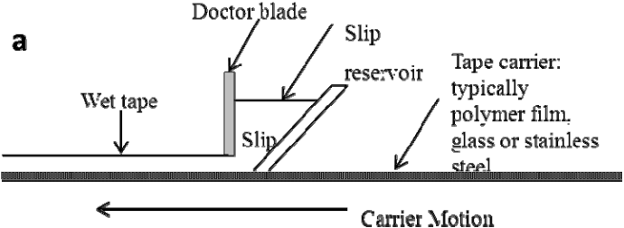


Fig. 2: (a) Doctor blading process used to produce ceramic tape and (b) Ceramic cast tape drying on a polymer
carrier to produce large surface area PZT material for shaping and sintering. Typical wet cast gap 1.0 mm
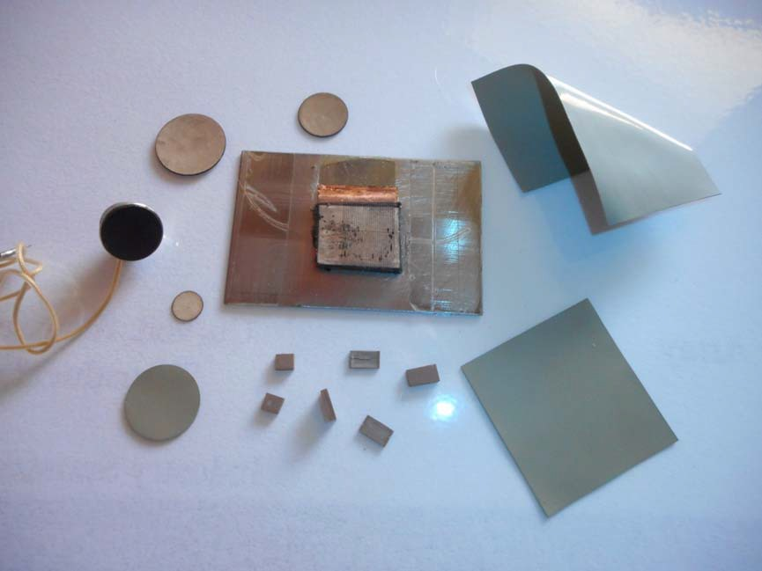

Fig. 3: PZT tape (bottom and right hand elements) and sintered ‘net-shaped’ curved discs. A curved piezoelectric ceramic disc is embedded into the mechanical sector transducer (left). A linear array with 20 elements aligned upright is also shown (centre).

Table 3: Piezoelectric ceramic specifications of ANSTO formulation in comparison to commercial product

Property Vernitron 7A Toshiba C-24 ANSTO formulation

Q 600 920 <920
ε33/ε0 425 209 100-250
Kp 0.51 0.04 <0.04
K33 0.5 0.52 >0.52 d33 10-12 m V-1 150 68.2 >68.2 g33 10-3 V.m N-1 39.9 36.8 37-50
Z ( 106 kg m.s-1) 36 32 32-36
Curie temp (ºC) 350 255 200-350

A key challenge of the composite piezoelectric project was to sinter tape ceramic to high density
strictly fails to meet the aging rate criteria of the
MIL-STD 1376B (its aging rates are too low) and
33

final dimensions. Linear shrinkage was
the percentage change in KT
is too high. The d33

approximately between 14-20% depending on the
solids loading but could be controlled to +0.5%. Alumina substrates fabricated for production
purposes had tolerances for thickness of + 10%, and flatness (camber) of + 0.4%, so one of the goals for this project was to fabricate ceramic to thicknesses
of between 150-300 µm that had tolerances which were equivalent to or better than industry standards. Piezoelectric elements were sintered to greater than
97% of theoretical density and had grain sizes
between 2 and 10 µm. The bulk density and grain size markedly influenced the piezoelectric properties of the sintered ceramic [22]. An outcome of this project was the development of some intellectual property centred on a process for shaping piezoelectric ceramic and fabricating arrays from taped material [23]. Distortion-free piezoelectric tapes and laminates were prepared forming a variety of shapes such as disks with curved surfaces and flat rectangular elements used to form tiers in piezoelectric/polymer composites. Figure 3 below illustrates some of the piezoelectric elements fabricated from green tape.

The specification of the piezoelectric ceramic developed was based on a Hans Ruckert formulation, and is listed in table 3 below along with a comparison of with ceramics used by Ausonics which corresponded closely with a modified lead titanate. The development of this ceramic tape technology showed that cost was not an impediment to traditional machining ceramic or dice and fill composite arrays. However, in the early 1990s under the direction of new management (Pacific Dunlop Ltd) the development of this technology ceased.

PIEZOELECTRIC FORMULATION AND PROCESSING CHANGES
Hans Ruckert’s 1970 patent has been the backbone
of the materials produced over the past 40 years. Materials based on the guidelines expounded in this
patent are still in manufacture. However, the two
materials that are currently in largest volume production are not based on the patent.
Over the last forty years, the Thales group has had
to build transducers and supply ceramic components which have been “built? to print”. As
the designs invariably come from the USA or
Europe, they have specified ceramics compliant to MIL_STD_1376 (SHIPS) 1970 or its later editions such as MIL-STD-1376B (SH). On a number of occasions, the customer has only been willing to accept full material compliance.

As an example, we can consider the properties of the Thales TLZ 1 material made in accordance with the Plessey Ducon Australian patent. This material
exceeds the specification on some batches. The
material also changes its capacitance under uniaxial pressure a little more than typical lots of a more
traditional type I material.

Because of such difficulties, it has been necessary to produce materials which are totally compliant with MIL-STD 1376B. Yet even this does not satisfy all requirements. It is well known that PZT materials are sensitive to small amounts of dopants, to the raw materials used and to the processing steps. When all these are optimised, materials with enhanced properties can be produced. An example of this is the TLZ 3 material which is currently produced in the largest volumes.

With particular attention paid to the above three factors, the properties of many batches of this material would strictly fail the MIL-STD 1376B criteria for coupling and d33. For most customers this is a “bonus”. A side effect of this attention to composition and processing has been a material which also a significantly improved stability with respect to voltage and pressure. The TLZ 2 formulation has been similarly enhanced over the standard type II material.

Another ceramic formulation which is in large volume production at this current time is a modified lead titanate, TL 1. The principal dopant is calcium titanate but there are numerous minor additives which are designed to improve the ability to pole this material, lower its tan δ and to increase its stability with time. This material is similar to compositions used by other suppliers but some key additives have been identified which are critical to achieving the benefits noted above. Use of such unique compositions combined with tight processing controls over green and sintered densities has significant benefits. In a recent competitive comparison, a Thales customer praised the uniformity and consistency of the TL 1 dielectric constant and d33 which enabled them to reduce the system tolerances by 50%.

Further improvements to compositions inspired by the 1970 patent are still being undertaken in current piezoelectric formulations. In 2012, the TLZ 5 composition and processing were modified to produce a material with a d33 > 900 pC/N. Potential modifications to the high manganese doped materials have been identified which may enable materials with voltage stabilities similar to type III to be produced with d33 values similar to type I. Lastly, materials such as TLZ 4 have demonstrated the ability to combine the stability of a type I with the piezoelectric properties of a type II. Modifications are being trialled which could produce a voltage stable type V equivalent.

SUMMARY
This paper has reviewed the evolution of electronic
ceramics in Australia over the past 50 years with specific reference to the development of dielectrics
and piezoelectric devices in targeted applications.
Although the focus of this review did not touch on research underpinning the commercial products,
there are several groups across academia and at
national labs which continue to pursue developing materials and process technologies. These
developments will ensure that local expertise and
manufacturing capabilities remain an integral part of our niche ceramic manufacturing hub.

REFERENCES
1. Mellor, D., Australian War Memorial official history ww2_civil_vol5_. In: s.l.: Australian War Memorial, (1958), Chapter
21 Communications.
2. SMH, 13 July 1932. Sydney Morning
Herald.
3. SMH, 23 July 1963. Sydney Morning
Herald.
4. http://www.hrsa.asn.au/, n.d.
5. SMH, 24 June 1949. Sydney Morning
Herald.
6. SMH, 4 May 1954. Sydney Morning
Herald.
7. SMH, 14 Oct 1954. Sydney Morning Herald
8. Gleeson, J. M., 1946. Steatite for High
Frequency Insulation. J. Br. I.R.E. Vol [6], pp. 20-32.
9. Randall, C., 2009. History of the First Ferroelectric Oxide, BaTiO3, s.l.: American Ceramics Society.
10. Thales Austalia Internal Report GCM04572, n.d. GCM04572 Ruckert report History of Ceramic Capacitor Development in Australia, s.l.: s.n.
11. Thales Australia Internal report
GCM02597, n.d. GCM02597 Ruckert report
266 Survey on Ceramic Capacitors 1971, s.l.: s.n.
12. Thales Australia Internal Report GCM02599, n.d. GCM02599 Ruckert Report 272 on NPO Dielectrics Formulations and History, s.l.: s.n.
13. Thales Australia Internal Report GCM02604, n.d. GCM02604 Ruckert Report 275 on Development of Type 2
Ceramic Dielectrics 1973, s.l.: s.n.
14. Thales Australia Internal Report GCM02011, n.d. GCM02011 Hans Ruckert Report on Design of Barrier Layer Capacitors, s.l.: s.n.
15. Ruckert, H. F., Development of Piezoeelctric Ceramics in Australia. J. Aust. Cer Soc, Vol [8], (1972), 33-37.
16. Mil-STD-1376B (SH), Piezoelectric
Ceramic Material and Measurement
Guidelines for Sonar Transducers, US Department of Defence 1995
17. Hiromi O et al., Matsushita, US patent
3268453 (1966)].
18. Ruckert, H., 1970. Australia, Patent No.
439,447.
19. Griffiths, K., 2004. An historical look at ultrasound as an Australian innovation on the occasion of the ultrasound stamp issued by Australia Post -18th May 2004. ASUM Ultrasound Bulletin, August, pp. 22-26.
20. Woolfrey J. L., The feasibility study on the fabrication of piezoceramic/polymeric
transducer arrays, ANSTO report 1987.
21. Mistler R. E. and Twiname E. R. Tape
Casting: Theory and Practice, 2000
Published by the American Ceramic Society, Westerville OH
22. Patel N. D and Nicholson P. S. Am. Ceram.
Soc. Bull 65 (1986) 783-79.
23. Aust patent filing “Tape Casting, Shaping and Array Fabrication of Piezoelectric
Ceramic’ Nov 1989.

