
INFOBrief

Dell™ PowerVault™
NOTE: Throughout this document, both tower (221S) and rack-optimized (220S) versions will be collectively referred to as the PowerVault 22xS.

220S/221S SCSI

External Storage Enclosure
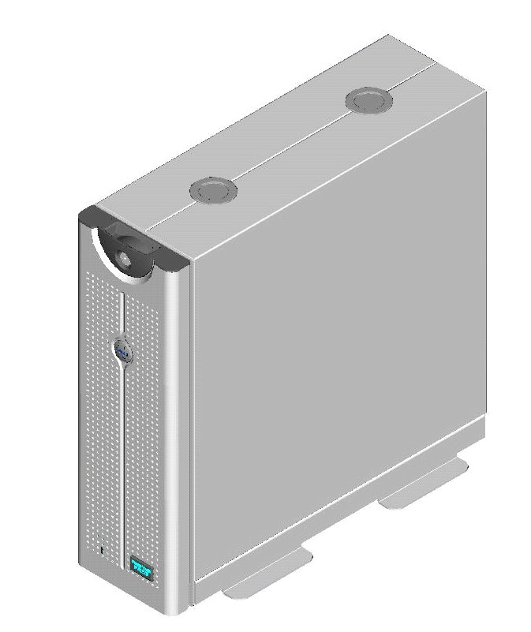

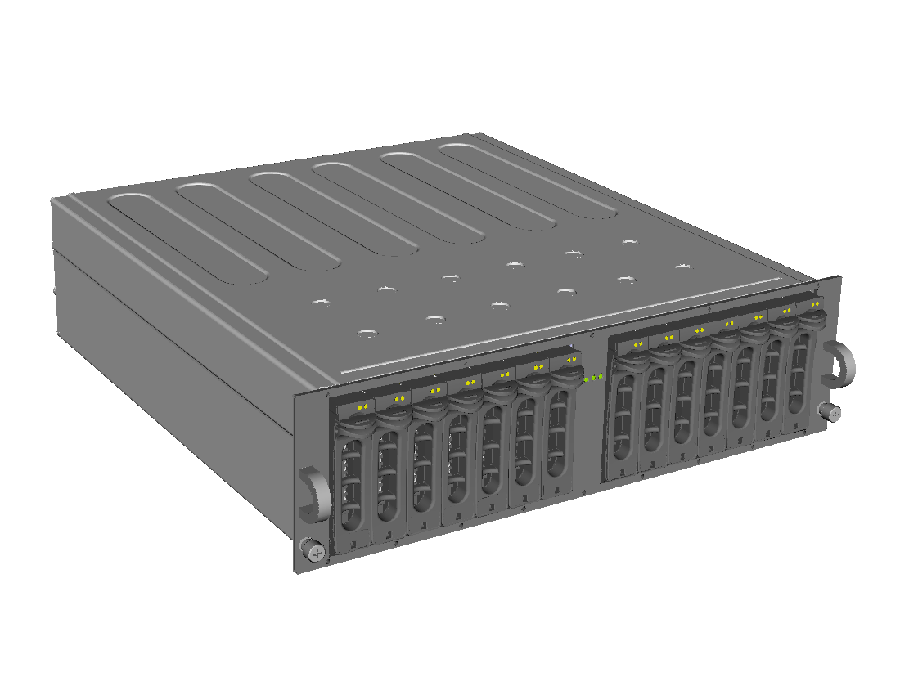

PowerVault 220S Rack-optimized SCSI Storage Enclosure

PowerVault 221S Tower SCSI Storage Enclosure
The PowerVault 22xS is Dell’s high-performance direct attached SCSI storage enclosure providing capacity expansion for PowerEdge™ servers and PowerVault™ Network Attached Storage (NAS) servers.

Key Points

- The Dell™ PowerVault™ 22xS is designed to provide affordable, expandable storage for Dell PowerEdge™ servers and PowerVault™ Network Attached Storage (NAS) servers with fourteen (14) 1-inch SCSI 320 MB/s hard disk drives providing up to 4,200GB per enclosure and up to 33TB on select servers.
- The PowerVault 22xS is supported on two generations of Dell PowerEdge RAID (PERC) cards: PERC3 provides high capacity RAID protection with U160 bandwidth; PERC4 provides high performance RAID protection with U320 bandwidth.
- The PowerVault 22xS performs reliability through redundant power supplies, cooling units, management modules, and supports RAID levels 0, 1, 5, 10, and 50 provided by Dell’s PowerEdge RAID Controller (PERC) cards.
- The PowerVault 22xS provides high availability features including hot plug hard drives, hot plug cooling units, hot plug power supplies, and support for Dell cluster kits.
- The PowerVault 22xS provides high performance with 15,000-RPM hard disk drives in a capacity-dense 3U amount of rack space.
- The PowerVault 22xS is the latest revision of Dell’s direct attached storage product family that supports the latest Ultra320 SCSI disk drive technology.
- The PowerVault 22xS provides direct attached SCSI storage with high performance at a low price. If storage scalability is required in a Storage Area Network (SAN) environment, Dell/EMC Fibre Channel storage arrays are recommended as an alternative.

Background

The external storage market can be segmented into three basic product types: direct attached storage (otherwise known as server-attached storage), Network Attached Storage (NAS), and Storage Area Networks (SAN). The PowerVault 22xS is a direct attached storage enclosure that connects directly to a server – or a PowerVault NAS server. It is often referred to as “spill-over” storage since it is designed to provide additional low-cost storage capacity whenever it is needed. Direct attached storage often complements NAS and SAN in an enterprise environment, providing benefits that network storage offerings may not offer, such as leveraging existing server infrastructure and backup capabilities.
Dell introduced its first direct attached storage enclosure in 1999. Known as the PowerVault 200S, it enhanced Dell’s server solution by allowing hard disk drive capacity to be added to a server when its internal capacity had been exhausted. The original rackmount offering was expanded to include a tower version, the 201S; both supported eight (8) 1.6-inch drives in 3U (1U = 1.75-inches) rack space. Later, the amount of available capacity was increased by 50% with the introduction of the PowerVault 210S and 211S (rackmount and tower assembly, respectively) which offered twelve (12) 1-inch drives in 3U of rack space. Today, the PowerVault 220S and 221S further increases the available capacity by supporting fourteen (14) 1-inch drives in the same (3U) rack space. A comparison of these SCSI direct attached products is shown in Table 1.
Table 1 Comparison of PowerVault SCSI Products

 | PowerVault 20xS | PowerVault 21xS | PowerVault 22xS
Density | 8 1.6” drives in 3U-rack/tower | 12 1” drives in 3U-rack/tower | 14 1” drives in 3U-rack/tower
Speed | 160 MB/s SCSI backward- compatible to 80 MB/s | 160 MB/s SCSI backward- compatible to 80 MB/s | 320 MB/s SCSI backward- compatible to 160 MB/s.

Product Description

Dell’s PowerVault 22xS storage enclosure is available in tower (PowerVault 221S) or rack-optimized (PowerVault 220S) configurations. Each configuration supports two to fourteen 1-inch SCSI hard disk drives to provide up to 4,200GB (with fourteen 300GB drives) in a single enclosure. The enclosure can be configured with 36GB, 73GB, or 146GB hard disk drives at 15,000, or 36GB, 73GB, 146GB, or 300GB hard drives at 10,000-RPM. The enclosure is used as capacity expansion for Dell PowerEdge servers and PowerVault NAS servers by configuring a PERC card within the host. The storage enclosure can be attached to one server in a 14-drive joined-bus configuration; to one or two servers in a split-bus configuration where each bus controls seven drives; or to two servers with 13 drives as part of a cluster configuration.
Dell OpenManage™ Storage Manager is used to configure and manage the storage enclosure’s RAID protection. This software also reports the status and environmental conditions of various components within the chassis.
The storage enclosure can be configured with or without fully redundant power supplies or management modules for improved fault tolerance.
- Value Options
- Fully non-redundant
- Non-redundant power supplies
- Non-redundant Enclosure Management Modules (EMM) (joined-bus configuration)
- 2-14 hard disk drives
- Redundant cooling units
- Redundant Power
- Non-redundant EMM (joined bus configuration)
- 2-14 hard disk drives
- Redundant cooling units and power supplies
- Redundant Management
- Joined, split-bus, or cluster configuration
- Non-redundant power supplies
- 2-14 hard disk drives
- Redundant cooling units, EMM
- High Availability Option
- Fully Redundant
- Joined, split-bus, or cluster configuration
- 2-14 hard disk drives
- Redundant cooling units, power supplies, EMM
PowerEdge RAID Card (PERC) Options for the PowerVault 22xS
In order to connect the PowerVault 22xS SCSI storage array to a server or NAS server, Dell offers the PERC 4 RAID card, supporting RAID levels 0, 1, 5, 10 and 50. For high performance storage needs, the PERC 4 RAID controller provides cluster-ready support for up to 2 PowerVault 22xS storage arrays per card. The dual-channel PERC 4/DC supports up to 4TB of storage per controller and delivers U320 performance.

Direct Attached Storage versus NAS
Both direct attached storage (DAS) and network attached storage (NAS) provide additional storage for servers. DAS is a one-to-one paradigm (storage enclosure seen only by one server), whereas NAS is a one-to-many paradigm (storage server seen by many clients/servers) that allows for consolidation and centralization of storage. That is not to say that direct attached storage and NAS are mutually exclusive. In fact, many users implement both solutions to meet a variety of storage needs. For example, a PowerVault 22xS SCSI enclosure can serve as expansion storage for the PowerVault 745N network attached storage server.
Direct attached storage is a trusted and well-understood method of adding storage. It satisfies the immediate storage needs of a server, offering solid performance and reliability. Dell’s direct attached storage products offer great serviceability and modularity to meet current storage needs, and provide a solid foundation for future requirements.

Target Markets/Applications

The PowerVault 22xS addresses the host-based RAID direct attached storage market, and is ideal for customers who are seeking spillover storage for their PowerEdge servers and PowerVault network attached storage servers. For customers who are familiar with SCSI, the PowerVault 22xS provides affordable, high performance disk space to help maximize storage potential on the host to which it is attached.
The configurability of the PowerVault 22xS means it will work well for both small-to-medium business environments needing additional storage for their PowerEdge or PowerVault storage servers, as well as enterprise environments seeking cost-effective, highly available storage solutions.
The PowerVault 22xS offers extensive flexibility. For example, a cost sensitive entry-level user can directly attach storage to a server with a few inexpensive hard drives configured in the PowerVault 22xS. Or, a departmental user can split the backplane of the PowerVault 22xS and attach it to two servers for a low-cost way to expand both servers. A third usage scenario is a Datacenter requiring high availability and using the PowerVault 22xS in a clustered configuration.
The PowerVault 22xS also supports databases applications with high transaction rates typically requiring high drive spindle count. The technique of maximizing drive spindle count to achieve higher performance is an inherent feature of most of the popular RAID levels and can be enhanced by the 15,000-RPM hard disk drives offered by Dell for the PowerVault 22xS.
The PowerVault 22xS is great for applications requiring highly available, cluster-ready external storage. Examples of such applications include the following:
- Database applications such as Microsoft® SQL Server™ and Oracle®
- Collaboration applications such as Microsoft® Outlook® or Lotus Notes®
- Backend storage for file/print servers and web servers

Features and Benefits

The features of the PowerVault 22xS include the following:
- 14 1-inch SCSI drives in 3U rack or tower configuration
- Support for 10,000-RPM (36GB, 73GB, 146GB, and 300GB) and 15,000-RPM (36GB, 73GB, or 146GB) hard disk drives
- Capacity of up to 4,200GB per enclosure (using 300GB disk drives)
- Hot plug disk drives, power supplies, and cooling modules
- Redundant cooling modules, optional redundant power supplies, optional redundant enclosure management modules (EMM) (reports the status of components such as power supplies and cooling modules). A fully redundant configuration is recommended for higher levels of fault tolerance.
- Configurable in single 14-drive bus (joined-bus mode), two 7-drive busses (split-bus mode), or 13-drive cluster mode.
- When used in conjunction with a Dell PERC 4 RAID controller, disk drives housed inside the PowerVault 22xS can be configured with RAID levels 0, 1, 5, 10 or 50. RAID management and enclosure reporting provided by Dell OpenManage Storage Manager.
- Fully managed support for Microsoft Windows NT®, Windows 2000, Windows 2003, and Novell NetWare® operating systems.
- Designed, tested, and integrated to work seamlessly with Dell PowerEdge servers and PowerVault storage servers to provide a complete solution when coupled with PERC RAID card and OpenManage software. This turnkey solution is backed by Dell technical service and support.
Table 4 shows the features, functions, and benefits of the PowerVault 22xS.
Table 4 The Features, Functions, and Benefits of the PowerVault 22xS

Feature | Function | Benefit
Reliability | Offers redundant cooling, optional redundant power supplies, and optional redundant management modules. Hot plug power supplies, cooling units, and hard disk drives. Optional cluster configurations. | Improved fault tolerance (over the PowerVault 21xS) through redundancy or clustering ensures system and data availability. Hot plug components enable the replacement of components without taking the system down.
Backplane Configuration Flexibility | Configurable in a single 14-drive bus in joined-bus mode, two 7-drive busses in split-bus mode, or as a single 13-drive bus in cluster mode. | Allows one enclosure to be deployed in a variety of configurations to meet different needs. The Split bus configurations allow users to leverage one enclosure as if it were two without the cost of duplicating supporting components such as fans. Clustering allows redundant paths to the data through connections to two servers with failover capability, helping to create a high availability environment.
Form Factor Flexibility | Offered as 3U rack or tower. Can be converted between the two form factors. | Allows flexibility in positioning the enclosure as a stand-alone tower unit or to be used within a rack. Provides investment protection should the deployed configuration need to change. Allows reduced number of spare parts, as all components are common between the rack and tower configurations.
RAID | Attaches to a Dell PERC 4 RAID controller to offer support for RAID levels 0,1,5,10, or 50. | Allows choice of proper RAID level to meet various performance, cost, and fault tolerance trade offs.
Scalability | Factory installation of up to 8 enclosures per platform through support of 2 PERC 4/QC RAID controllers in the server or storage server platform. | Provides up to 33TBs of expansion storage with PERC 4/QC. Allows storage capacity to grow incrementally.
Key Customer Benefits

- Wide variety of configurations
The PowerVault 22xS provides a variety of configurations with options offering various levels of redundancy, availability, and performance. Redundant power, fans, and Enclosure Management Modules (EMM) offer higher availability; joined-, split- and cluster-configurations offer a variety of techniques to meet storage capacity with optimal price/performance.
- High Performance at a Low Cost
The PowerVault 22xS is designed for optimized performance under the industry Ultra 320 SCSI (320 MB/s) specification. When combined with high performance 15,000-RPM drives, storage can be optimized for heavy usage transactional or random access database environments.
- Dell Certified and Supported
Dell PowerEdge servers and PowerVault NAS are supported by the PowerVault 22xS. This is designed to ensure that a complete solution including a RAID card, management software, and enclosure will function right out of the box for any supported configuration. In addition, the turnkey solution is backed by Dell technical service and support.

Service and Support

- Three-year limited warranty1
- Three years of standard next business day parts replacement and one year of next business day on-site2 labor.
- Pre-Failure Alert Program for storage systems with a hard disk drive.
- 7-day/24-hour Lifetime Telephone Technical Support for troubleshooting and diagnosis of Dell hardware.
- 7-day/24-hour E-support services featuring extensive online support capabilities.

Dell, PowerVault, and PowerEdge are trademarks of Dell Computer Corporation. Other trademarks and trade names may be used in this document to refer to either the entities claiming the marks and names or their products. Dell disclaims proprietary interest in the marks and names of others.
©Copyright 2005 Dell Computer Corporation. All rights reserved. Reproduction in any manner whatsoever without the express written permission of Dell Computer Corporation is strictly forbidden. For more information contact Dell. Dell cannot be responsible for errors in typography or photography.

For hard drives, GB means 1 billion bytes; accessible capacity varies with operating environment. TB means 1,000 GB. 2 Capacity achieved when used with PERC 3/QC RAID controller with U160 bandwidth.
1 1 For a complete copy of our Guarantees or Limited Warranties, please write Dell, USA, L.P., One Dell Way, Round Rock, Texas 78682.
2 2 Service may be provided by third-party. Availability varies. Technician will be dispatched if necessary following phone-based troubleshooting. To receive next business day service, Dell must notify the service provider before 5pm (depending on service contract) customer time. Availability varies.

