SPM003 Multi-Function Digit

\ j> J(I() 1111111 i-func: 1 (JJI I )I !1 11 :II lll'-'l,·r can llll'<l llre AC \'Ol 1<!!,'-'-'- _;\ ( c IIITl'lll. :1d1 \ e p

l-1 ,·q lll'll cy :1nd .._·kctri c L-JJLI- \ Ill _l I 1 I) h <h adopt J'nr di :-;pi :1\' llHH.Ittle

Technical Indicators

lAccuracy: 1%±2 words

:2_1\.all!-!L'

• :\l '"ltaf',C ;\(' krr 11-1111! II\ 21!0 11-l:iCJ CJV r Y<•l! slwuld select the ""t

llll'tlr '' ll\..'11 ·our 11 1<1k in11rdt:r 1

• \l cmrcnt *·\C ()* '111 'i'l;\ tllllttmum rcsolutt<lll IS CJ 01/\

e ll<lll cr frequen,e

• po,rcr facto!

• :lC11\T JHl\\ CJ

-1 '> II11;-(,'> 0 II;

II ()(1-l 001'1

11--1'>111111\\ 11hcn the active l)(lllr:t hct11ee·n ()and ()<J'l'l

accuran is 0.1 W

• ·lectri e· encrg1 0-'1 119'1'1'1k 11!L 11 hen the *e* lcctri r; pill\ er between 0 and 1

d"pla1 accuraCY 1s () 01 kwh. 11hen bct11cen 10000 U-')

:tccmacl ts ll_ikllh. when bet11cen IIJOIJI! IJ and 99 1!9

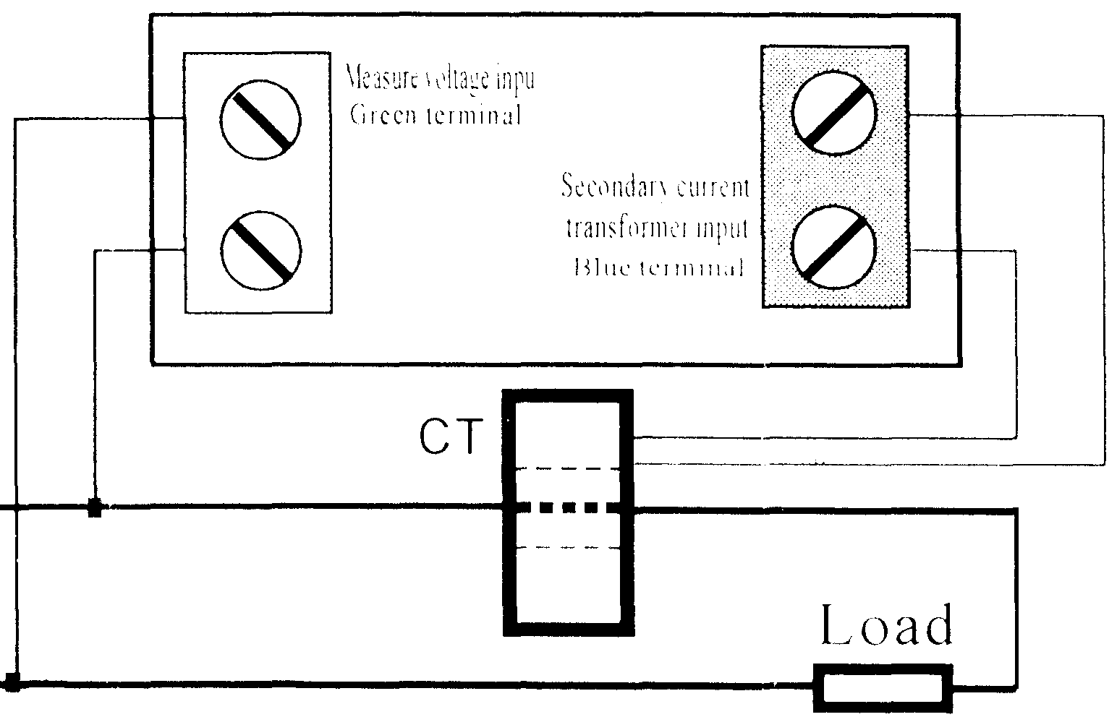

a ._·cura\ i..., 1 k\\ h

\pe·e·d *2* times pc1 sr:u>nd

\t;c 7'!"-1_3*-IX

s lthtallatttllt St;e_ 71l' 39

r1 \lll\1-\;lYing. \\IH:n ptl\\ c1 olT thL' electric energy\\ ill be :;;_ned. The saved

lk <lc·cutnulakd continue 11 hen the meter po\\er-onnc;.;t time.

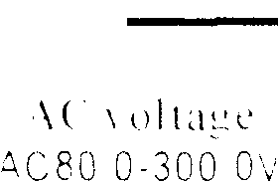

Cunncctiun graph

+---------. \lake the\\

the hole in