R40 Model Identification

Bandsplits
As always with PBR conversions, you need to make sure you have the correct model to ensure that the conversion is viable or even possible.
They might all look the same but can be worlds apart in their operational capabilities
Model | Power | Band Centres
RC40 | 25W | 150 MHz
RC40 | 25W | 230 MHz
RD40 | 25W | 450 MHz
Most in the UK have a head with a full display and keyboard but there is a model variant with no head and a microphone with a simplified display and keypad.

Labeling
There are two lables associated with each radio. One is behind the head just below the D15 connector 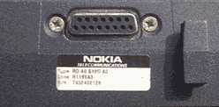
and the other label is inside the top of the radio near the heatsink.
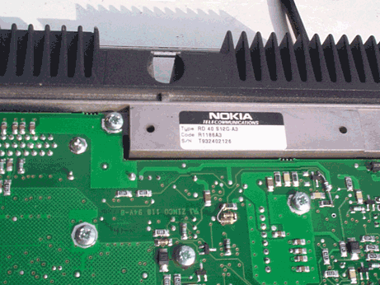
Both these labels should be identical

OPERATING INSTRUCTIONS

Switching the unit on and off

To power on: press PWR only once
On powering up normally, the radio displays Self test and then Self test OK 000200 or Self test OK 000243 in the case of the 2 metre set.
Then reverts to normal mode displaying DD-Mth-yyyy hh:mm xm
70cm Amateur Band
The power light flashes slowly during normal operation.
To power off: press PWR again only once
Some versions take a few seconds to power down completely. This may be while they save settings to EEPROM
When I got mine, they had been in storage for an extended period although the RTC was showing the time/ date with a good accuracy. The R40 has a large CR2450 lithium button cell soldered to the logic board.
If you press PWR twice to switch on, the radio seems to go through its self test routine and then power down again.

[ Back to Top]

To select a short code channel
The memory slots are accessed by pressing the slot number (channel number) folowed by RCL then #
Memory slots are only valid for slot numbers 1-43, after that, channels 44-51 are accessed by keying *55*44# etc. ie. For channel 51, press *55*51#
The radio has the capacity for 250 numerical channels, 1-250
There are 43 memory slots which can have any of the numerical channels stored in them.
To go to a specific channel, consult the channel table to find the required channel, ie S20 145.500 (which is memory slot 20 in the 2m version RC40).
Press: 20 RCL, the display will display
Name: S20 145.000
Show: 20
Then press # to send it to the channel in that memory slot.
The display will now show
Simplex channel: 121
Squelch ON Mode OPEN
Note: Always momentarily key the mic PTT after sending to channel. This closes the squelch which sometimes stays open when going to a channel.
It also ensures that the synthesiser has gone to the correct channel.
Once you have correctly gone to a channel, on the bottom row of the display, it will show
Squelch ON Mode OPEN
Indicating that it is in normal operating mode. In this state, the Up/Dn arrows act as the volume control.

[ Back to Top ]

To go to any of the 250 channels
This method allows you to go to any channel, regardless of whether or not it is assigned to one of the memory slots.
Press *55*xxx # (where xxx is one of the programmed channels).
ie. for S20, press *55*121#
ie. for 144.000 which is numerical channel 1, press: *55*1
Note: When using a repeater channel, the display wil show Simplex channel: xxx The actual repeater shift is pre-programmed and will automatically come into effect.

[ Back to Top ]

Other functions

Carrier squelch, Selcall and loudspeaker mute
Function | Action | Sequence
Squelch | OFF | #56#
Squelch | ON | *56#
Loudspeaker | mute | FCN 6
Loudspeaker | unmute | FCN 6
Selective Call | SELECTIVE | *52#
Selective Call | OPEN | #52#

Configuration Menu
There's a very comprehensive menu system which allows a huge amount of customisation over the user interface and other functional parameters.
To access the menu, press FCN then Menu.
The MENU flag will show on the display.
Menu items can be scrolled by using the up/down arrow keys.
- 00: Memory recall and store functions
- 01: Call request and status sending
- 02: Data message sending
- 03: Send a call
- 04: Diversion settings
- 05: Call back settings
- 06: Display settings
- 07: Call settings
- 08: Clock settings
- 09: Volume settings
- 10: Special call functions
- 11: Additional functions
- 12: Exit menu FCN CLA

00: Memory recall and store functions

  - Write short code memory
  - Read short code memory
  - Received call and status buffer
  - Received data call buffer
  - Write status text
  - Write data to slot 1-5 *2*message

01: Call request and status sending
  - Send call request
  - Cancel call request
  - Send status call
  - Exit to upper level

02: Data message sending

  - Send data message
  - Send data from slot 1
  - Read data from slot 1-5
  - Exit to upper level

03: Send a call

  - Give number

04: Diversion settings

  - Diversion ON *nn* number
  - Diversion OFF
  - Incoming diversion OFF
  - Speech diversion ON
  - Speech diversion OFF
  - Incoming speech OFF
  - Data diversion ON
  - Data diversion OFF
  - Incoming data OFF
  - Exit to upper level

05: Call back settings

  - Call back ON
  - CAll back OFF
  - Speech call back ON
  - Speech call back OFF
  - Data call back ON
  - Data call back OFF
  - Exit to upper level

06: Display settings

  - Display light control
  - Display backlight level
  - Display viewing angle
  - Show/hide date and time in display
  - Show/hide network in display
  - Show call duration during conversation
  - Exit to upper level

07: Call settings

  - Automatic/manual call to diverted number
  - Automatic/manual joining to group call
  - Speaker ON/OFF duing conversation
  - Call to default number by pressing PTT
  - Paging ON/OFF *53/#53
  - Exit to upper level

08: Clock settings

  - Set date and time
  - Show date and time
  - 12/24h time format
  - Show last call and total duration
  - Exit to upper level

09: Volume settings

  - Alert tone level compared to volume level
  - Volume level
  - Test alert tones
  - Exit to upper level

10: Special call functions

  - Send priority call
  - Send executive call
  - Send emergency call to number in slot 47
  - Send broadcast call
  - Send modem call
  - Read mailbox
  - Call to number in system memory slot **nn##
  - Set keyboard to DTMF mode
  - Functions for simplex and open channel
    - Simplex operation
    - Exit simplex operation
    - Squelch OFF
    - Mode SELECTIVE
    - Exit to upper level
  - Exit to upper level

11: Additional functions

  - External alarm setting
  - Program version number
  - Select network
  - Own subscriber number
  - Exit to upper level

12: Exit menu FCN CLA

Write short code memory
This allows you to edit the name of one of the 43 short code channels and assign a pre-programmed channel to it..
Give number
and press OK
So you give one of the
Give memory slot
and press OK
To delete a speed dial channel, you don't even need to go to the menu. Simply press FCN then STO.

Software
The ActionMan or 'Amanda' PC software went through many revisions. Early versions were DOS and later releases ran under Windows. Later versions cover other Nokia radiotelephones as well.
As well as the usual cable, you will need a software copy protection dongle to program the R40. The software will open and run under demo mode without the dongle but writing to the radio is not possible.
You also need the red service head in order to enter programming mode on the radio. Without this, it will not communicate in either direction.
Software is specific to the firmware version installed in the radio.
Version history:
Version | Released | Revision Notes | Environment | Firmware | Notes
2.16 | 1997 |  |  | Cr13
1.0 | 25/01/1999 | Original version |  | Cr14
2.0 | 12/02/1999 | Note about parameter 778 added |  | Cr14
3.0 | 22/02/1999 | Installation instructions added |  | Cr14
4.0 | 23/12/1999 | Multi instance installation re-designed, instructions for R72 users added. |  | Cr14 | Includes 3.13 R40 software. A cracked version is known to be in existance.
The 3.13 Windows software has a user level setting. The default setting is Dealer and with a password, you can access the service level features.

Firmware
The firmware is held in EPROM on the logic board in the main unit.

Model | Type | Code | S/N | Firmware | Date | Checksum | EPROM
RC 40 | S11G-A3 | R1160A3 | TA95518549 | Cr 13.05-2
RD 40 | S12G-A3 | R1186A3 | T932402371 | Cr 13.04-5
RD 40 | S12G-A3 | R1186A3 | T932402126 | Cr 13.05-0 | 18.04-94 | FA5E | 27C020
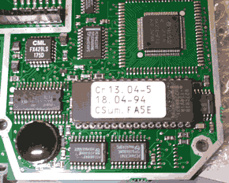
A 27C020 EPROM holds the firmware.

Connections
- D44 - Rear of radio
- D25 - RS232
- RJ45 - Microphone
- D15 - Head unit
The R40 has a double density 44 pin D connector at the rear.
The RF connector is a flying TNC type. 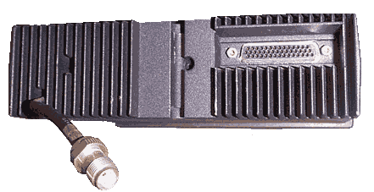I had two types of harness supplied with my R40s but the common one I can describe as follows.
The power lead terminates in a modular housing which encompasses two 1/4" blade connectors. Correct fusing is naturally required upstream. The mic breaks out to an RJ45 socket, and the speaker breaks out to a mono 3.5mm jack socket. The R40 has no internal loudspeaker.
There are also two other mono 3.5mm flying jack sockets on the harness and these are labled HF-PTT (Handsfree PTT) and HF-MIC (Handsfree Mic). There's a button on the front panel labled HF which presumably engages handsfree operation if the software has configured this function as such.
Shorting the HF-PTT does not key my rig. It produces an error bleep instead, as does pressing the HF button. The HF flag on the display does not show either.

44 Pin rear connector
Pin | Function | Colour  (harness) | Harness Leg(s) | Direction  (WRT Radio) | Notes
01 | RSSI | - |  |  | Signal strength
02 | Tx_Q | - |  |  | Transmitted Quick data
03 | 3 Rx_Q | - |  |  | Received Quick data
04 | VS | GRA | D25
05 | MIC | RED | D25 Pin 11 | IN
06 | ERP | YEL | D25+RJ45 | OUT | Earphone
07 | LSP | GRA | RJ45 |  | Loudspeaker (DC Isolated?)
08 | LSP1 | WHI | LSP-B |  | Isompi kaiutin, +
09 | LSP2 | VIO | LSP-B |  | Isompi kaiutin, -
10 | LSP2 | - |  |  | Isompi kaiutin, -
11 | LSP1 | - |  |  | Isompi kaiutin, +
12 | HOOK | BLU (light) | RJ45 | IN
13 | RxD | BRN |  |  | (RS232)
14 | TxD | GRN (light) |  |  | (RS232)
15 | RTS | - |  |  | (RS232)
16 | 0V | YEL | Power 0V | GND
17 | 0V | YEL | Power 0V | GND
18 | +12V | YEL | Power 12V | IN
19 | +12V | YEL | Power 12V | IN
20 | MIC_IN | Pale GRN/YEL | RJ45 | IN
21 | AGND | Braid | RJ45 | GND | Analogue Ground for mic
22 | PTT | BLA + GRN | D25 + RJ45 | IN | Push to talk
23 | GND | BLA | RJ45 Pin 4 | GND
24 | CRM | - | - |  | Car Radio Mute
25 | IGN | - | - |  | Ignition sensor
26 | SCL | - | - |  | I²C Serial Clock
27 | ON_OFF | - | -
28 | DSR | - | - |  | (RS232)
29 | CTS | VIO | D25 Pin 5 |  | (RS232)
30 | DCD | - |  |  | (RS232)
31 | 0V | YEL | Power 0V | GND
32 | 0V | YEL | Power 0V | GND
33 | +12V | YEL | Power 12V | IN
34 | +12V | YEL | Power 12V | IN
35 | HF_MIC_IN | YEL (centre) | HF-MIC | IN
36 | AGND | Braid | HF-MIC | IN
37 | PTT_HF | WHI | HF-PTT | IN
38 | GND | VIO+BRN+WHI | HF-PTT+D25
39 | ALARM | -
40 | SDA | - |  |  | I²C Serial Data
41 | I2C_INT | -
42 | CLK_RS232 | - |  |  | Async. clock (RS232)
43 | DTR | BLU | D25 |  | (RS232)
44 | RI | - | - |  | (RS232)

D25 RS232 Female
This is the D25 female as found on the standard harness. It carries RS232 with the standard pin configuration, plus a few more functions besides.
Function | Pin (D25) | Colour | Pin  D44
Digital GND | 1 | WHI | 38
TxD | 2 | GRN | 14
RxD | 3 | BRN | 13
CTS | 5 | VIO | 29
Digital GND | 7 | BRN | 38
VS | 9 | GRA | 04
PTT | 10 | BLA | 22
Audio in (Mic) | 11 | RED | 05
Analogue GND | 12 | - | -
ERP | 19 | YEL | 06
DTR | 20 | BLU | 43

Microphone
The R40 sports the smallest microphone I've ever seen on a PBR radio. It's a an electret type having an RJ45 connector with only three pins in use in the mic lead. There are other wires which go from the D44 to the RJ45 socket which carry unexploited functions.
Function | Colour  (mic) | Pin  RJ45 | Colour  (mic leg of harness) | Pin  D44 | Note
MIC_IN | YEL | 1 | Pale GRN/YEL | 20 | This is the centre of a coaxial cable in the mic leg
AGND | Braid | 2 | Braid | 21 | This is the outer of a coaxial cable in the mic leg
HOOK | - | 3 | BLU | 12
GND | - | 4 | BLA | 23
PTT | RED | 5 | GRN | 22 | Combined in D44 shell
ERP | - | 6 | ORA | 06 | Earphone
VS | - | 7 | RED | 04
LSP | - | 8 | GRA | 07

Head Unit
The head is removed by popping off the small panel bearing the word 'Nokia' and sliding the metal paddle to the right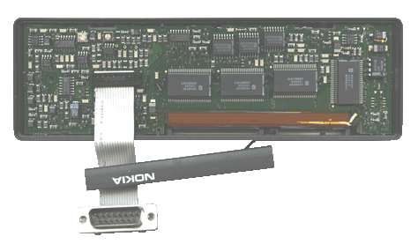This picture shows the four large chips which drive the huge display.
The head varies in component occupancy and layout throughout various models. The one shown here has more components than others I've seen.
This, I believe may possibly be the head unit wiring (Note the mistake with the numbering). The head unit mating connectors and also the extension cable use D15 connectors. Internally there is a 15 way ribbon cable.
1 SCL
2 SDA
3 I2C-INT
4 VS
5 HOOK
6 AGND
7 MIC
8 MIC_OUT
9 PTT
10 ON_OFF
11 GND_DIGIT
12 LSP
13 EMERG_PTT
14 GND_ANALOG
16 HF_MIC_OUT
16 NC
The 'Red Head' is used to configure the radio and is also required to run the software. This, apart from its striking colour, is not dis-similar to the standard CU42 head. To upgrade a CU42 head to service level, a binary is programmed into an EEPROM and then the EEPROM is soldered into place in the head. A resistor is also added. You might then want to take the head down the paintshop for a re-spray.

Memory channels as programmed to my R40s
- RC40 (VHF)
  - S20
  - R 1
- RD40 (UHF)
  - SU16
  - SU20
  - RB0
  - RB10
These channels are currently programmed into my R40s but they are arbitary and were presumably entered at some stage with PC software or by radio to radio cloning.
The menu alllows the user to change the name of the alphatag etc.
Note that with the pre-programmed channels, both VHF and UHF transceivers are capable of going outside the UK bandplan so caution is needed.
The column headed RX synth or TX synth seems to be a logical frequency number based on 6.25kHz steps. The base channel for either transmit or receive can therefore be extrapolated to a frequency of 400MHz for the RD40.
N = (f - 400)/0.00625
And for the RC40
N = (f - 138)/0.00625

RC40 (VHF)
I have no printed data for this so I'll figure what I can from the radio. This list is not yet complete, you may need to fill the blanks in yourself.
It looks to me as if there's a bit of a cock up with the 2m repeater frequencies. You'll see what I mean below. RV48 for instance, is listed as RV1
Channel | RX/TX Freq | RX Synth | TX Freq | TX Synth | Mem Slot | NAME
001 |  |  | 144.00000 |  | -
002 |  |  | 144.01250 |  | -
003 |  |  |  |  | -
004 |  |  |  |  | -
005 |  |  | 144.05000 |  | -
006 |  |  |  |  | -
007 |  |  |  |  | -
008 |  |  |  |  | -
009 |  |  |  |  | -
010 |  |  | 144.11250 |  | -
011 |  |  |  |  | -
012 |  |  |  |  | -
013 |  |  |  |  | -
014 |  |  |  |  | -
015 |  |  | 144.17500 |  | -
016 |  |  |  |  | -
017 |  |  |  |  | -
018 |  |  |  |  | -
019 |  |  |  |  | -
020 |  |  | 144.23750 |  | -
021 |  |  |  |  | -
022 |  |  |  |  | -
023 |  |  |  |  | -
024 |  |  |  |  | -
025 |  |  | 144.30000 |  | -
026 |  |  |  |  | -
027 |  |  |  |  | -
028 |  |  |  |  | -
029 |  |  |  |  | -
030 |  |  | 144.36250 |  | -
031 |  |  |  |  | -
032 |  |  |  |  | -
033 |  |  |  |  | -
034 |  |  |  |  | -
035 |  |  | 144.42500 |  | -
036 |  |  |  |  | -
037 |  |  |  |  | -
038 |  |  |  |  | -
039 |  |  |  |  | -
040 |  |  | 144.48750 |  | -
041 |  |  |  |  | -
042 |  |  |  |  | -
043 |  |  |  |  | -
044 |  |  |  |  | -
045 |  |  | 144.55000 |  | -
046 |  |  |  |  | -
047 |  |  |  |  | -
048 |  |  |  |  | -
049 |  |  |  |  | -
050 |  |  | 144.61250 |  | -
051 |  |  |  |  | -
052 |  |  |  |  | -
053 |  |  |  |  | -
054 |  |  |  |  | -
055 |  |  | 144.67500 |  | -
056 |  |  | 144.68750 |  | -
057 | 144.70000 |  | 144.70000 |  | 37 | 144700
058 | 144.71250 |  | 144.71250 |  | -
059 | 144.72500 |  | 144.72500 |  | 38 | 144725
060 | 144.73750 |  | 144.73750 |  | -
061 | 144.75000 |  | 144.75000 |  | 39 | 1447500
062 | 144.76250 |  | 144.76250 |  | -
063 | 144.77500 |  | 144.77500 |  | 40 | 144775
064 | 144.78750 |  | 144.78750 |  | -
065 | 144.80000 |  | 144.80000 |  | 41 | 144800
066 | 144.81250 |  | 144.81250 |  | -
067 | 144.82500 |  | 144.82500 |  | 42 | 144825
068 | 144.83750 |  | 144.83750 |  | -
069 | 144.85000 |  | 144.85000 |  | 43 | 144850
070 | 144.86250 |  | 144.86250 |  | -
071 |  |  |  |  | -
072 |  |  |  |  | -
073 |  |  |  |  | -
074 |  |  |  |  | -
075 |  |  | 144.92500 |  | -
076 |  |  | 144.93750 |  | -
077 |  |  | 144.95000 |  | -
078 |  |  | 144.96250 |  | -
079 |  |  | 144.97500 |  | -
080 |  |  | 144.987500 |  | -
081 | 145.00000 | 1120 | 145.00000 | 1120 | 01 | RV 1 INPUT
082 | 145.01250 |  | 145.01250 |  | -
083 | 145.02500 |  | 145.02500 |  | 02 | RV 2 INPUT
084 | 145.03750 |  | 145.03750 |  | 03 | RV 3 INPUT
085 | 145.05000 |  | 145.05000 |  | 04 | RV 4 INPUT
086 | 145.06250 |  | 145.06250 |  | 05 | RV 5 INPUT
087 | 145.07500 |  | 145.07500 |  | 06 | RV 6 INPUT
088 | 145.08750 |  | 145.08750 |  | -
089 | 145.10000 |  | 145.10000 |  | 07 | RV 7 INPUT
090 | 145.11250 |  | 145.11250 |  | 08 | RV 8 INPUT
091 | 145.12500 |  | 145.12500 |  | -
092 | 145.13750 |  | 145.13750 |  | -
093 |  |  |  |  | -
094 |  |  |  |  | -
095 |  |  |  |  | -
096 |  |  |  |  | -
067 | 144.82500 |  | 144.82500 |  | -
098 | 145.21250 |  | 145.21250 |  | -
099 | 145.02250 |  | 145.02250 |  | 09 | S9 1450225
101 | 145.02500 |  | 145.02500 |  | 10 | S10 1450250
103 | 145.02750 |  | 145.02750 |  | 11 | S11 1450275
105 | 145.03000 |  | 145.03000 |  | 12 | S12 1450300
107 | 145.03250 |  | 145.03250 |  | 13 | S13 1450325
109 | 145.03500 |  | 145.03500 |  | 14 | S14 1450350
111 | 145.03750 |  | 145.03750 |  | 15 | S15 1450375
113 | 145.04000 |  | 145.04000 |  | 16 | S16 1450400
115 | 145.04250 |  | 145.04250 |  | 17 | S17 1450425
117 | 145.45000 |  | 145.45000 |  | 18 | S18 145450
119 | 145.47500 |  | 145.47500 |  | 19 | S19 145475
121 | 145.50000 | - | 145.50000 |  | 20 | S20 145550
122 | 145.51250 |  | 145.51250 |  | -
123 | 145.52500 | - | 145.52500 |  | 21 | S21 145525
124 | 145.53750 |  | 145.53750 |  | -
125 | 145.55000 |  | 145.55000 |  | 22 | S22 145550
126 | 145.56250 |  | 145.56250 |  | -
127 | 145.57500 |  | 145.57500 |  | 23 | S23 145575
128 | 145.58750 |  | 145.58750 |  | -
129 | 145.60000 |  | 145.00000 |  | 24 | RV1 145600
130 | 145.61250 |  | 145.01250 |  | -
131 | 145.62500 |  | 145.02500 |  | 25 | RV2 145625
132 | 145.63750 |  | 145.03750 |  | 26 | RV3 1456375
133 | 145.65000 |  | 145.05000 |  | 27 | RV4 145650
134 | 145.66250 |  | 145.06250 |  | 28 | RV5 1456625
135 | 145.67500 |  | 145.07500 |  | 29 | RV6 1456750
136 | 145.68750 |  | 145.08750 |  | -
137 | 145.70000 |  | 145.10000 |  | 30 | RV7 145700
138 | 145.71250 |  | 145.11250 |  | 31 | RV8 1457125
139 | 145.72500 |  | 145.12500 |  | 32 | RV9 1457250
140 | 145.73750 |  | 145.13750 |  | 33 | RV10 1457375
141 | 145.75000 |  | 145.15000 |  | 34 | RV11 145750
142 | 145.76250 |  | 145.16250 |  | 35 | RV12 1457625
143 | 145.77500 |  | 145.17500 |  | 36 | RV13 1457750
144 | 145.78750 |  |  |  | -
145 |  |  |  |  | -
146 |  |  |  |  | -
147 |  |  |  |  | -
148 |  |  |  |  | -
149 |  |  |  |  | -
150 | 145.86250 |  |  |  | -
151 |  |  |  |  | -
152 |  |  |  |  | -
153 |  |  |  |  | -
154 |  |  |  |  | -
155 |  |  |  |  | -
156 |  |  |  |  | -
157 |  |  |  |  | -
158 |  |  |  |  | -
159 |  |  |  |  | -
160 | 145.98750 |  |  |  | -
161 | 146.00000 |  |  |  | -
162 | 146.12500 |  |  |  | -
163 |  |  |  |  | -
164 |  |  |  |  | -
165 |  |  |  |  | -
166 |  |  |  |  | -
167 |  |  |  |  | -
168 |  |  |  |  | -
169 |  |  |  |  | -
170 |  |  | 147.12500 |  | -
171 |  |  |  |  | -
172 |  |  |  |  | -
173 |  |  |  |  | -
174 |  |  |  |  | -
175 |  |  |  |  | -
176 |  |  |  |  | -
177 |  |  |  |  | -
178 |  |  |  |  | -
179 |  |  |  |  | -
180 | 148.37500 |  | 148.37500 |  | -
181 |  |  |  |  | -
182 |  |  |  |  | -
183 |  |  |  |  | -
184 |  |  |  |  | -
185 |  |  |  |  | -
186 |  |  |  |  | -
187 |  |  |  |  | -
188 |  |  |  |  | -
189 |  |  |  |  | -
190 | 149.62500 |  | 149.62500 |  | -
191 |  |  |  |  | -
192 |  |  |  |  | -
193 |  |  |  |  | -
194 |  |  |  |  | -
195 |  |  |  |  | -
196 |  |  |  |  | -
197 |  |  |  |  | -
198 |  |  |  |  | -
199 |  |  |  |  | -
200 | 150.87500 |  | 150.87500 |  | -
201 | 151.00000 |  | 151.00000 |  | -
202 | 151.12500 |  | 151.12500 |  | -
203 |  |  |  |  | -
204 |  |  |  |  | -
205 | 151.50000 |  | 151.50000 |  | -
206 |  |  |  |  | -
207 |  |  |  |  | -
208 |  |  |  |  | -
209 |  |  |  |  | -
210 | 152.12500 |  | 152.12500 |  | -
211 |  |  |  |  | -
212 |  |  |  |  | -
213 |  |  |  |  | -
214 |  |  |  |  | -
215 |  |  |  |  | -
216 | 152.87500 |  | 152.87500 |  | -
217 | 153.00000 |  | 153.00000 |  | -
218 |  |  |  |  | -
219 |  |  |  |  | -
220 | 153.37500 |  | 153.37500 |  | -
221 | 153.50000 |  | 153.50000 |  | -
222 | 153.62500 |  | 153.62500 |  | -
223 | 153.75000 |  | 153.75000 |  | -
224 | 153.87500 |  | 153.87500 |  | -
225 | 154.00000 |  | 154.00000 |  | -

R40 dismantling and assembly
The body contains two boards, one at the top for logic and one at the bottom for RF.
It's just about possible to remove the logic board on its own but fitting it back in is another matter.
To get at the other side of the logic board, you really need to remove the RF board first.

RF board - Removal
- Remove the outer cover (4 screws M3x6)
- Remove the two M3x6 screws which hold the strain relief saddle for the coax cable.
- Remove the two rubber bungs nestled in the rear heatsink
- Remove the two socket cap screws holding the PA block in place (2.5mm hex key)
- Remove all 25 PCB screws including the shielding block
- Ease out the board

Logic board removal
- Remove outer panel (4 M3 screws)
- Remove all 11 screws which hold the PCB to the chassis
- Remove the D44 securing pillars (5mm nut spinner)
- Remove the two screws holding the head D15 connector
- Withdraw the board
Caution! This board is live at all times due to the on-board lithium battery. If it is allowed to short against a conductive object, damage may occur and all settings may be lost.

Logic board re-fitting
- Fit head socket (two countersunk screws)
- Seat board in position without interconnecting pins
- Fit D44 securing pillars (5mm nut spinner)
- Fit the three M3x8 screws which pass through semiconductor heatsinks (note)
- Fit the other eight screws which hold the PCB to the chassis
- Refit the outer cover noting the locating key

RF board re-fitting
- Fit the three rows of interconnecting pins, long pins towards you
- Ensure that the two PA nuts are in place
- Ensure there is a liberal coating of lithium grease
- Place the cocket cap screws in position through the PA block
- Ease the board into position ensuring that all pins are positioned correctly
- Refit the two socket cap screws for the PA block and insert rubber bungs
- Refit M3x8 screw to the regulator on the centre of the board
- Refit the sheilding piece with two M3x6 screws
- Refit all 26 of the other M3x6 screws
- Refit the two M3x6 screws which hold the strain relief saddle for the coax cable.
- Refit the outer cover noting the locating key

Nokia R40 Modifications

The R40 is by nature a trunked radio but can be modified for conventional operation on amateur frequencies.

VCO Adjustment

The R40 appears to have an unusual method of tuning the VCO.
There's what looks like an RF modification shown on the PI4VAD site (see link below) but it's actually to tune the VCOs. I'm not sure if this is necessary for ex-gasboard models but the VCO will happily lock within a 10MHz bandwidth.
The method is to put the radio into service mode, selecting the bottom of the required band, then the top of the required band and check that each VCO is reading within parameters on each respective testpoint whilst either receiving or transmitting as appropriate.
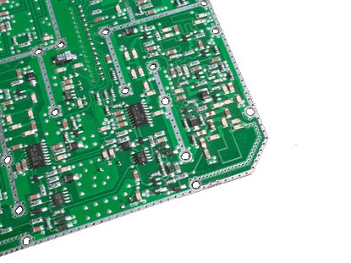This photo shows on the right hand corner the underside of the RF board. The PCB track is tuned by physically modifying it with a drill, or linking with soldering.
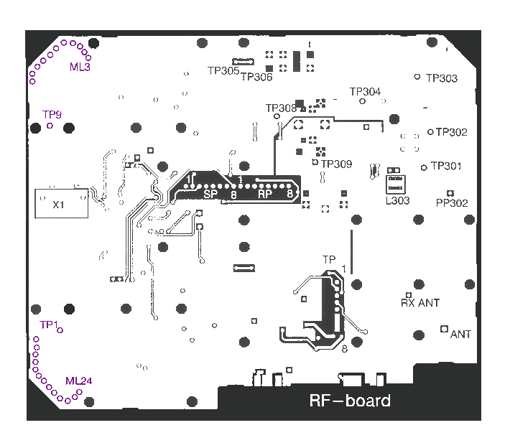
VCO | Test  Point | Freq. | Vmin | Vmax | Adjust
RX | TP9 | min | 2.2 | 4.0 | ML3
RX | TP9 | max | - | 12 | ML3
TX | TP1 | min | 2.0 | 4.0 | ML24
TX | TP1 | max | - | 12 | ML24
More detail (in German) produced by Leen PA2LAD and Andreas HB9NBI can be found on http://www.siux.ch/~andi/hobby/radio/index.html

