· - ' • !! :·



I DIIIIIDC I

.. . . . • • .



**TRAN _ S I S T 0 R - P R lJ f G E . R *1 * T**

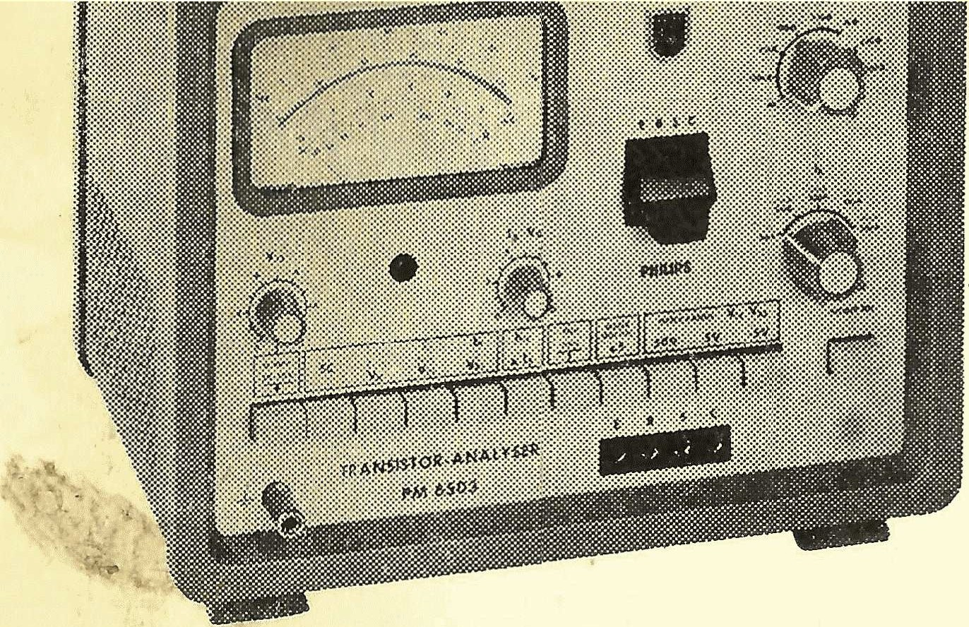

**p.m 6503**

This Notebook after use again behind the clamp at the right Page of devices put.

measurement guide

This measurement guide includes the most common measurement types, the with dem p.m 6503 through guidable are. As starting position miss all Keys unpressed be and the knobs are i n d in the red marked positions set. Before everyone Measurement first the Choice PNP or NPN _ _ make; then with the button "POWER ON" turn on. Below the device operation in the Series the numbering perform your n . ·

The button . X5 is for ail measuring ranges applicable, with Exception . at Measurement "SC " .

*. .t*

MEASUREMENTS Short-circuit measurement SC

- button Press "SC".

- ohm value on n scale read off

Data: V c:m == 2 V ( fixed ) display 0-5 kn

residual current measurement lcEo, l e ER , Ice

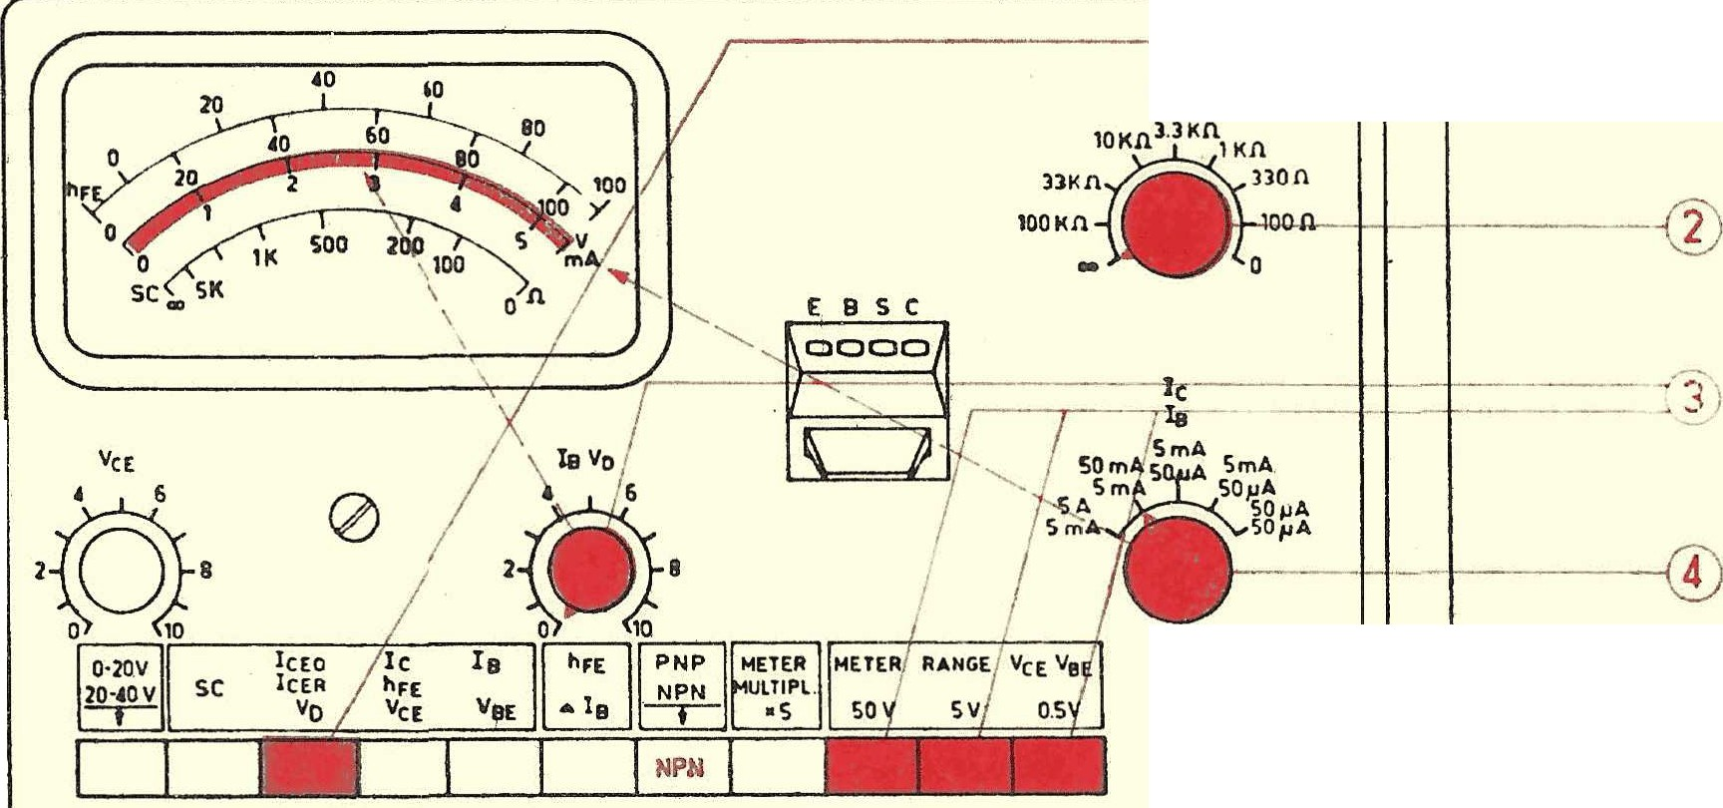

E a s *c _*

RaE

•

I cEo button _ press

OO == lcEO



100 kn-100 n == l e ER

0 n == I c ES range button press setting V c E make

lc Area choose; IC read off

POWER ON

loooool

diodes: At the sockets E and C (at PNP: cathode at E )

D

PE H 10S4

Note: Fi.ir height sensitivities can

a · strengthen r volt meter external connected _ become. (1 mV swing corresponds _ one I cE o from 0.5 *ItA ) .* _

sieves also Chapter vii c2 _ and viii C

the Directions.

Data for lcEo and vn: Measuring ranges: *50.uA,* .5mA, 5mA VeE: 0-150V; :rviessbereich: 5V, 50V

**breakdown voltage v** n

x s .

*xs.*

suitable IC area choose n

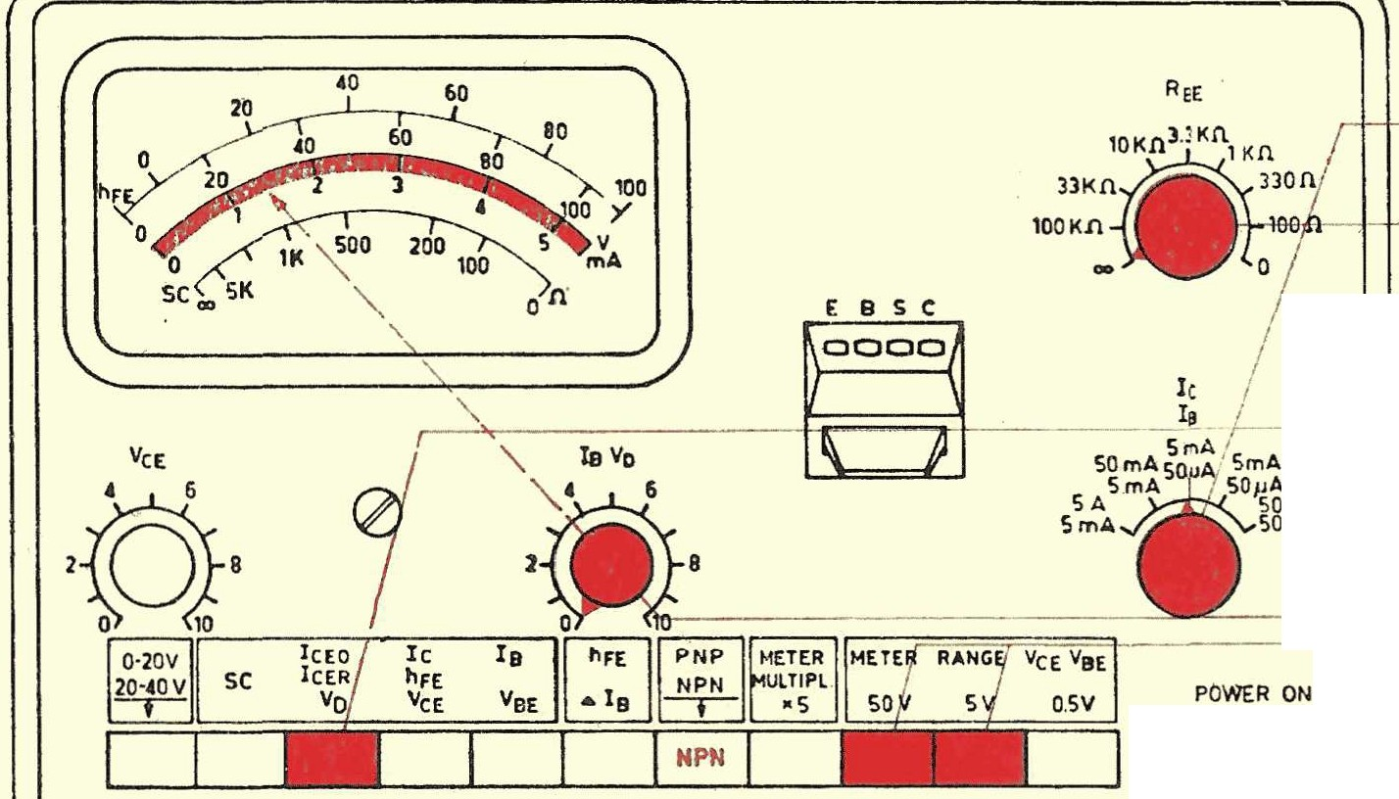

RBE; normal: red

V n - button press

I

i'

E B 5 *C*

loooool

A

I'A _ _

•

D



v n increase, until the Electricity more quickly increase t . Then revert e l n until straight before this point and v n read off. Please refer also Chapter VI I . Approx and viii C the instructions . _

**characteristic recording;** IC = **f( V** cE) **at constant** IB

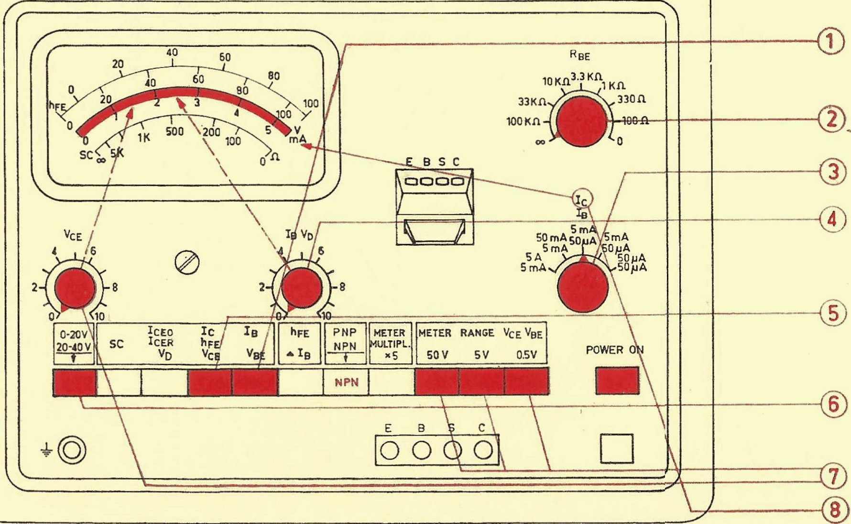

PEM 20

Rm . _ and 100 n- ooh normal ooh

IC area choose _ _

IB set

VeE

V cE - area

V cE set

IC read off

After dem push in the button "METER R NGE" alternately with dem potentiometer V c E



the Tension set and then deIc current read off.

Data for

characteristic recording

Ic measuring ranges: *50pA,* .5mA, 5mA, SOmA, .5A

V cE: 0-20 V stabilized, 20-40 V additional voltage.

Measuring ranges: .5V, 5V and 50V X 5.

xs.

IB: Control ranges: 0-1 5 *f!A, 0-150ftA,* 0-l,SmA, 0-15mA.

Measuring ranges: *50ftA,* .5mA, 5mA xs.

VBE : 0-96 V stabilized,

Measuring ranges: .5V, 5V, 50V X 5.

characteristic recording; IC = f(IB) at more constant V cE

The order of operation How at constant IB make.

Alternately the Keys IB and IC press by _ man at more depressed IB button _ at the

potentiometer IB adjusts and at pressed Ic button _ the collector current reads

**characteristic recording;** yes = **f( V** BE ) **at more constant V** no

RBE 100 n-co; normal: ooh

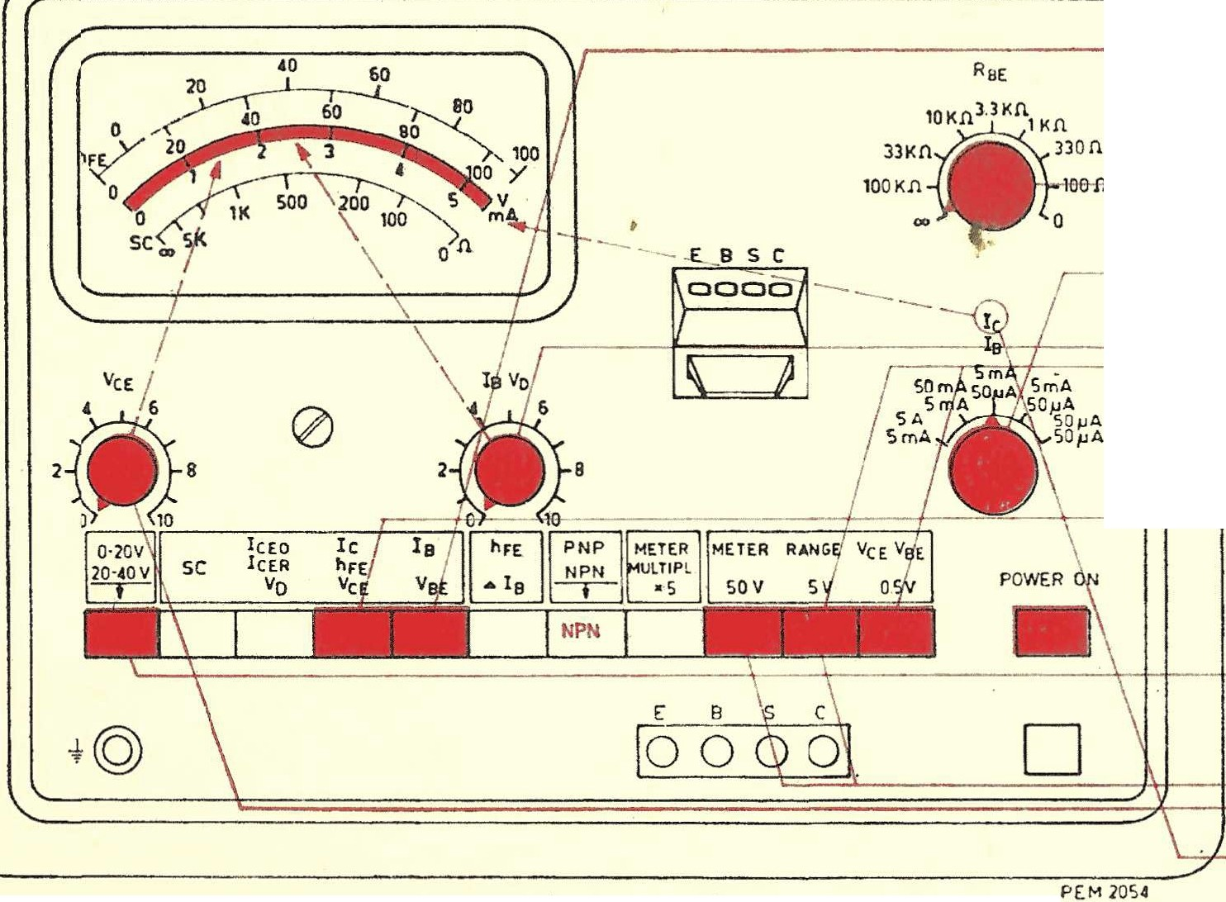

io area choose _ _

VeE

H--+- - --® V oE range

' " 1 - . • . !

V oE set

V BE set

· yes read off

After dem push in the button "METER RANGE" alternately n1it dem potentiometer IBVn

the Tension V BE set and then the Ia - current read off.

static current gain hFE

R a E



IB at left stop put hFE

RBE 100 n- ooh norn1al ooh

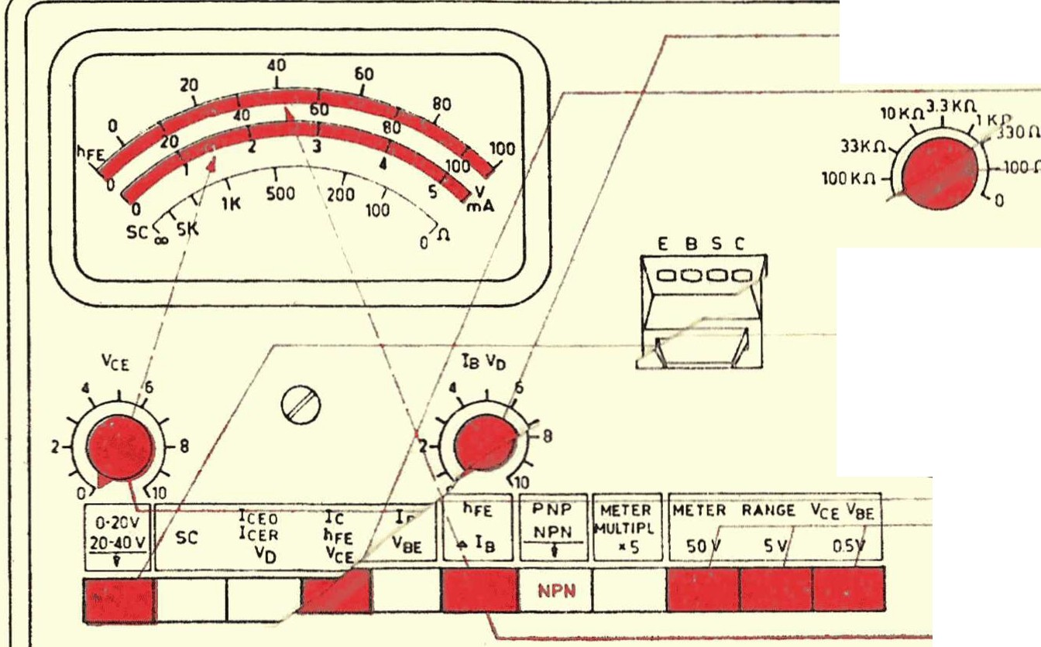

*r-* .. !a area choose

- } ! A / - 1 -1--+ - - ---- ® • V cE range

5 0 S m A 5 0 A S S O m ,A

5 A 5 0 A S m A, so , ..A

E8SC _ _ *_*

P O WER ON

V c E set

hFE read off (lower scale )

t @ lo oool D

P [ M 1 0 5 4

hFE = . At hFE > 100 the button X *5* press.

I

IB

Annotation: The most sensitive Area (Ic *50)-tA)* can only for rest trome used become. At the device type p.m 6503/01 is aFE on the scale 0-5 read and with the 1st factor 20 to multiply.

**static current gain** hFiu **with** Ice oil ( compensation

E B S *C*

100 Jl

I c area choose

OO J l- - l - 4 -1- - *(* RnE 100 n- ooh normal ooh

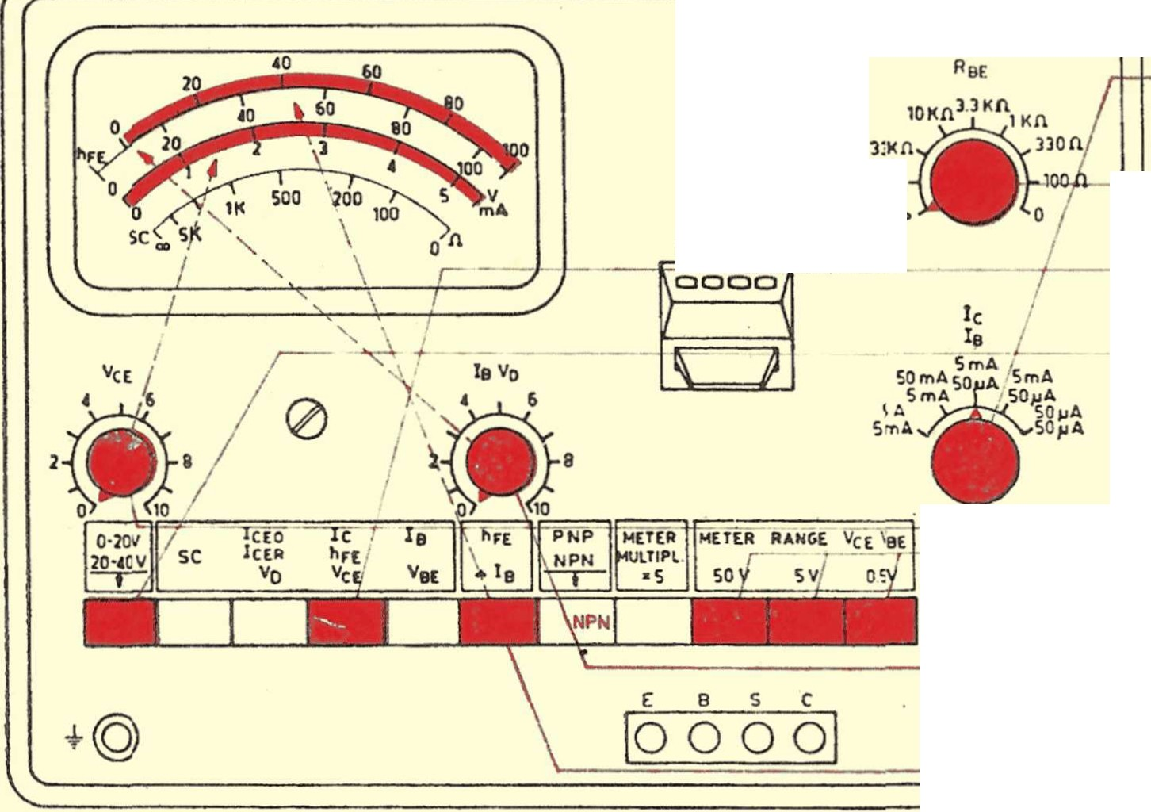

hFE



P O WER ON

- 5

D

P[M 1 0 54

V cE set

IB on 0 the upper scale ei!_\put

hFE on the upper scale read off.,

lc-loEo

**At** hFE > **100,** button X *5* press. zero adjustment anew make. hFE = --

IB