· - .. . . · . · · . · . '' , . : · .

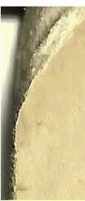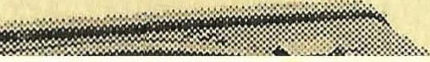

I DIIIIIDC I

........

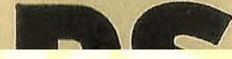

TRAN _ S I S T 0 R - P R lJ f G E.R _ *1(* T

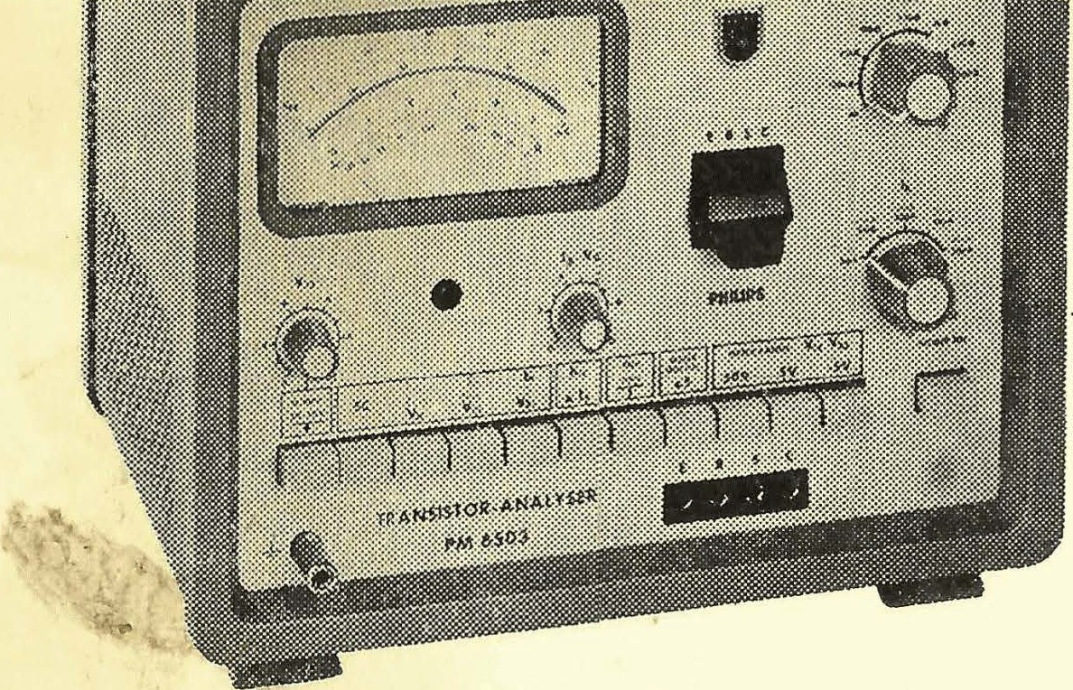

.,

p.m 6503

This Notebook after use again behind the clamp at the right Page of devices put.



measurement guide

This measurement guide includes the most common measurement types, the with dem p.m 6503 through guidable are. As starting position must all Keys unpressed be and the knobs are in the red marked positions set. Before everyone Measurement first the Choice PNP or NPN _ _ make; then with the button "POWER ON" turn on. Below the device operation

tion in the Series the numbering perform. · ·

*:* .

The button . X *5* is flir all measuring ranges applicable, with Exception . at Measurement "SC " .

MEASUREMENTS Short-circuit measurement SC

- button "SC" press

- ohm value on n scale read off

Data: V cE == 2 V ( fixed ) display 0-5 kn

residual current measurement lcEo, I o mR, Ice

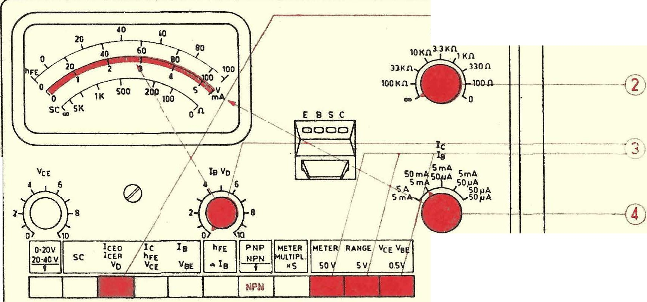

E B S ' c

RaE

•

I cEo button _ press

OO == lcEO

100 kn-100 n ==empty



0 n ==IcEs

range button press

Attitude V c:m make

lo Area choose; yes read off

POWER ON

loooool

diodes: At the sockets E and C (at PNP: cathode at E )

D

PEM 2054

Note: for height sensitivities can

a Supply Hirker voltmeter external connected become. (1 mV deflection corresponds to one Io:mo from 0.5 /hA ) .

Please refer also Chapter vii c2 _ and viii C

the Directions.

Data flir lcEo and vn: Measuring ranges: *50ttA,* .5mA, 5mA VcE: 0-150V; l\1measuring areas: 5V, 50V

**breakdown voltage v** n

*xs.*

*xs.*

suitable IC area choose

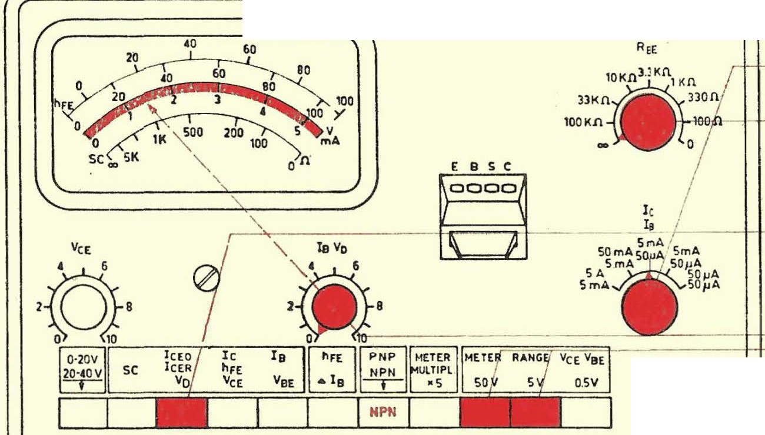

RBE; normal: rfJ

Vn - button press

E B S *C*

loooool

P O WER ON

0

vs increase, until the Electricity more quickly increases. Then reset until straight before this point, and VD _ read off. Please refer also Chapter VII Approx and viii C the Directions.

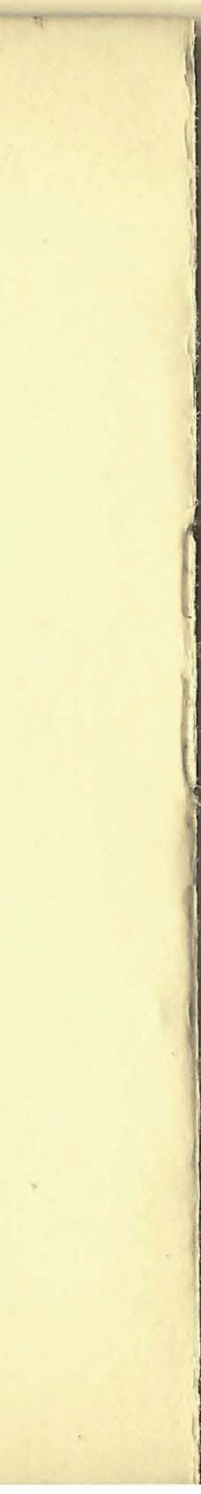

**characteristic recording;** yes = **f( V** oE) **at constant** IB



RB: m 100 Q- ooh normal ooh

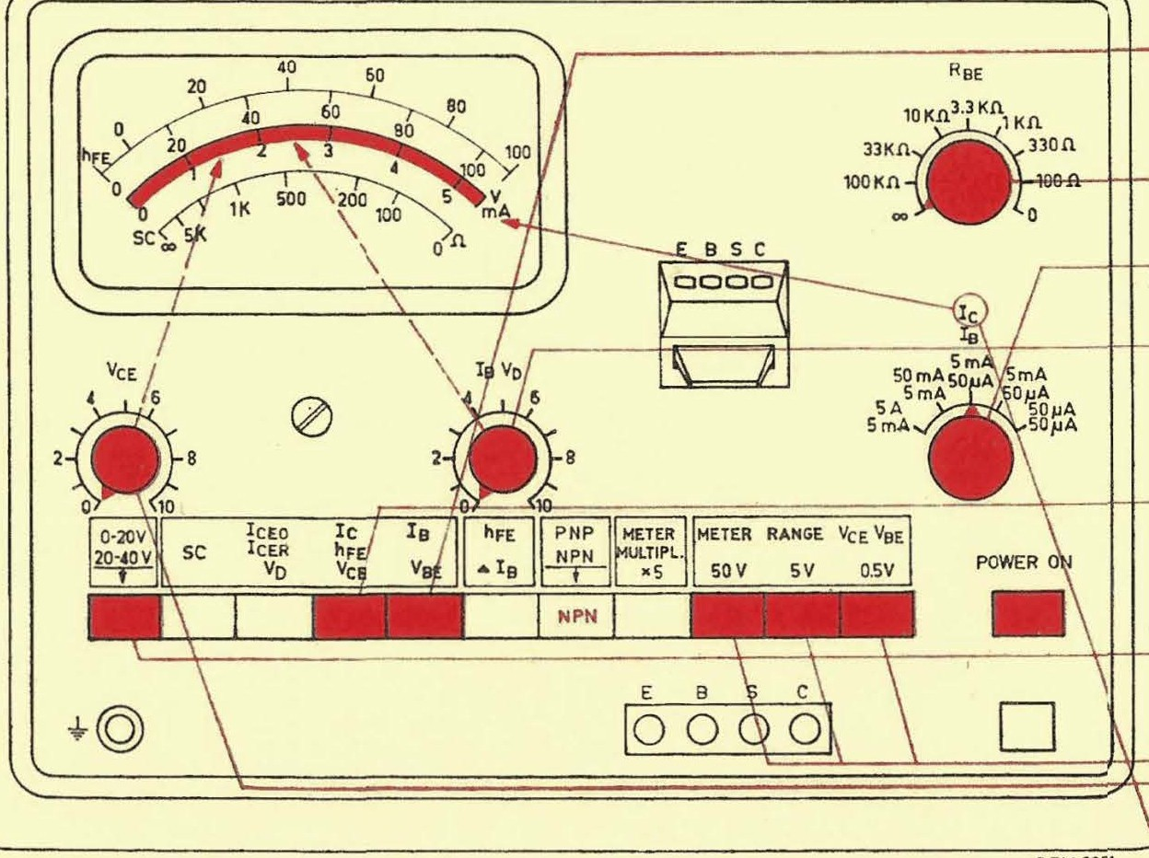

IC area _ choose

Set IB

From the

VeE area

V o:m set

IC read off



After dem push in the button "METER RANGE" alternately with dem potentiometer V c :m the Tension set and then de Io current read off.

Data for

characteristic recording

Ic measuring ranges: *SOPA,* .SmA, SmA, SOmA, *.SA*

v01 _ : 0-20 V stabilized, 20-40 V additional voltage.

Measuring ranges: .SV, SV and SOY X *S*

xs.

IB: Control ranges: 0-1 5 *flA,* O-l50flA, 0-l,SmA, 0-lSmA.

Measuring ranges: *50ttA,* .SmA, 5mA X *S*

VBE : 0-96 V stabilized,

Measuring ranges: .5V, 5V, 50V X *S*

characteristic recording; IC = f(IB) at more constant V cE

The order of operation How at constant IB make.

Alternately the Keys IB and IC press, by man at more pressed IB button _ at the

potentiometer IB adjusts and at more pressed Ic button _ the collector current reads

**characteristic recording;** IC = **f( V** BE ) **at more constant V** cE

RBE 100 nc o ; normal: ooh

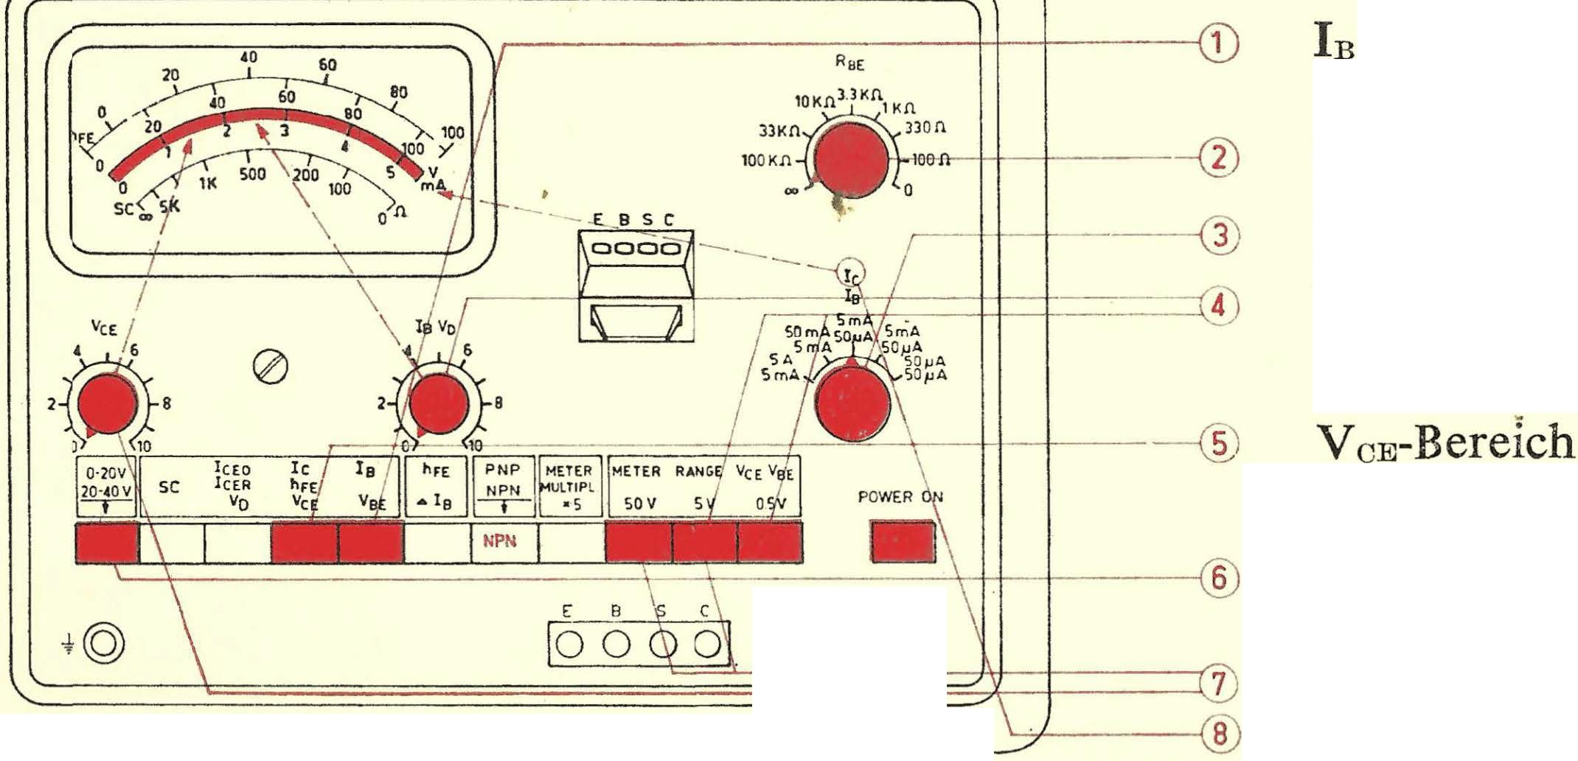

IC area _ choose _ _

VeE

' 1 1 . ,.1

D

P(M 2 0 S4

V cE set

V BE set

· IC read off

After dem push in the button "METER RANGE" alternately n1it dem potentiometer IBVD

the Tension V BE set and then the Ic current _ . read n .

static current gain hFE

I

I in at left stop place

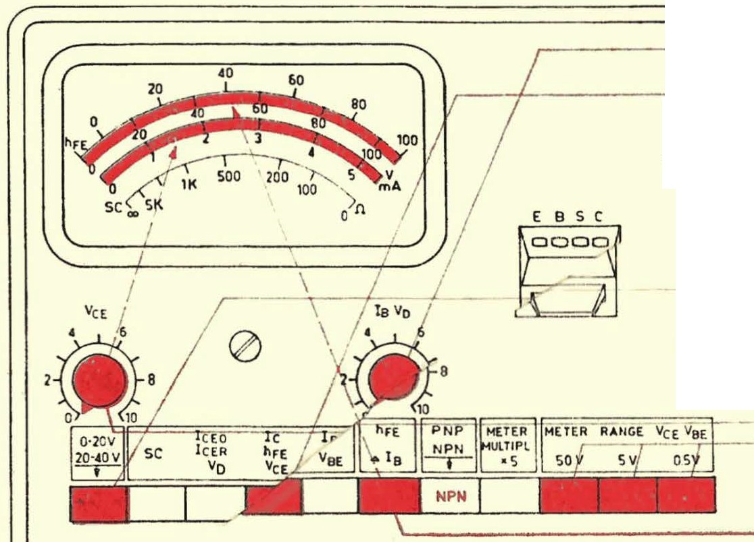

R a E

1DKn 3 . 3kn

33K "1lon

l O O Kn la lo oo n

hFE

- - - @RnE _ 100 n- ooh norn1al ooh

' I *r* .. Ia - area choose

- --s;; ; - At / _ -l -- 1--1 _ _ _

. . J2 \ V _

c E - ere 1 &quot ; c h

SO _ m A s o A S mA



SA SmA SO IJA

5 rn A, SO IJA

---

E8SC _ _ _

P O WER 0"

V c E set

hFE read off (lower scale )

loooool D

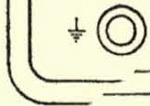

hFE = . At hFE > 100 the button X *5* press.

I

In

Annotation: The most sensitive Area (lc *50)-tA)* can only for rest trome used become. At the device type p.m 6503/01 is *aFE* on the scale *0-5* read and with dem factor 20 to multiply.

**static current gain** hFE **with** Ice oil ( compensation

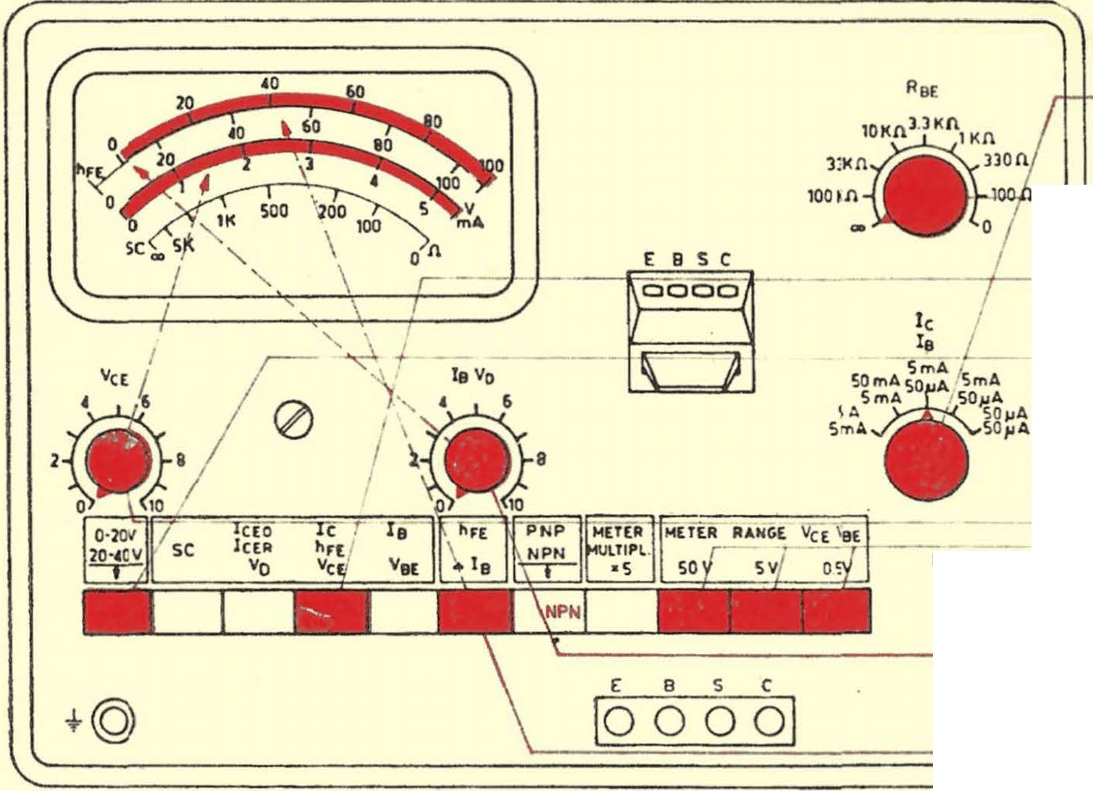

io area choose

H-- 1 00 , 1 1- - H- + - *. f 2 )* RnE 1 00 Q- ooh ; normal ooh

hFE

*r 4...* V cE berel according to

P O WER ON

D

s V cE set

IB on 0 the upper scale egg put hFE on the upper scale read off,

P (H 1 0 S4

**At** hFE > **100,** button X *5* press. zero adjustment anew make. hFE Ic-ImJJo

In