
Refurbished
36Vdc 6.25A & 4.2A Switching Power Supplies
225W and 150W - Burroughs / Unisys B25
Preamble:
This document intended to serve as a brief guide to technically qualified users familiar with operating mains and low voltage DC equipments etc. All responsibility for electrical safety and consequences in use of the equipment rests with the buyer. If in doubt, please ask (someone who knows).
Warning – be aware - the electrical voltages internal to this equipment are a hazard

Introduction:
These 2 physically similar PSUs (the 225W unit has a cooling fan and the 159W unit has both EIA mains input + output connectors and weighs 1.6kg and the 225W unit weigh 1.95kg) were originally deployed in running the Burroughs/Unisys B25 Modular-PCs. They have a standard EIA plug for 120~240Vac input (switch selected) and a RJ8 pole heavy-duty ribbon connector/cable for the regulated 36V dc output.

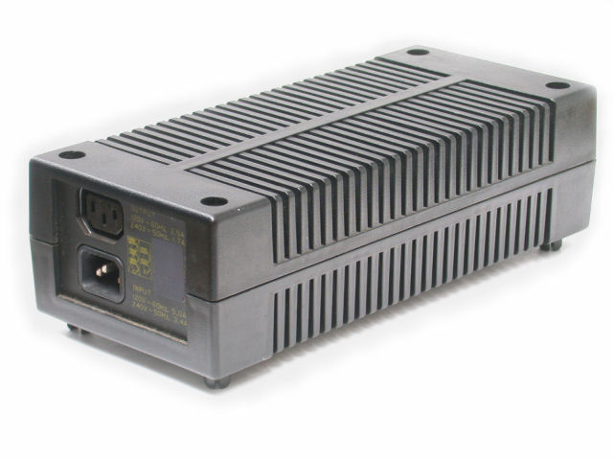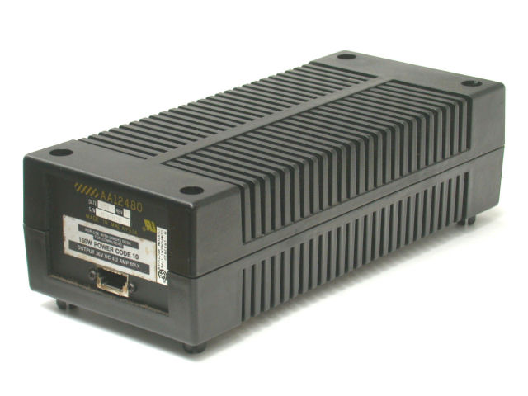

Applications:
Typical re-uses include power supplies for small DC servo motor and stepper motors when used in conjunction with PC based motor controllers for NC or CNC or robotic projects. The 36V provides headroom for other voltage regulators (5V, 12V, 15V, 24V) and gives the typical boost-voltage for running 1 or more concurrent motors in X-Y and X-Y-Z axis control of small machines and industrial plant etc. within the 4.2A or 6,25A capacity of the individual power supplies.
Assuming appropriate environment, the units may be used within their original black plastic cases or just deploying the inner metal case (6.25A) or open chassis (4.2A) with semi-exposed mains connections etc..
.
Photographic References:
Detailed photos of the 2 models are here:
<http://ml370/Equipment/Power/Psu/Gallery/>
Note - they may eventually be transferred to the "Switching" directory:
<http://www.casa.co.nz/Equipment/Power/Psu/Switching/>

Brand: Unisys (alias Burroughs)
Style B25 PS1 3396_7142_1 (225W)
Style B25 PS 3326_0040_1 (225W)
OEM: Elec & Eltek (Hong Kong) and/or Astec
Model: 122504-SA-04 (225W)

Specification:
Input: 120~240Vac 50~60Hz
Output: 36Vdc @ 4.4 and 6.25 Amps
Size: 260L x 120W x 75H (nominal)
Fixing: 4 holes (M4 clearance) on rectangle 233 x 89mm
Weight: 1.6~1.9kg (net)

Refurbishment:
Units are stripped and high-pressure dry-air-blast cleaned aided with brushes such that any accumulated dust is loosened and removed. The units are visually inspected before test-voltages are applied. Partial re-assembly is done to a standard permitting safe performance of the pre-delivery electrical tests.

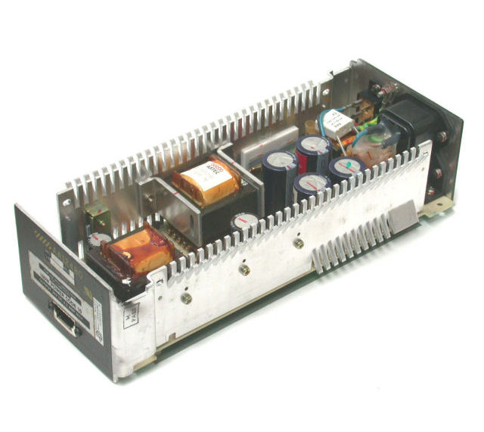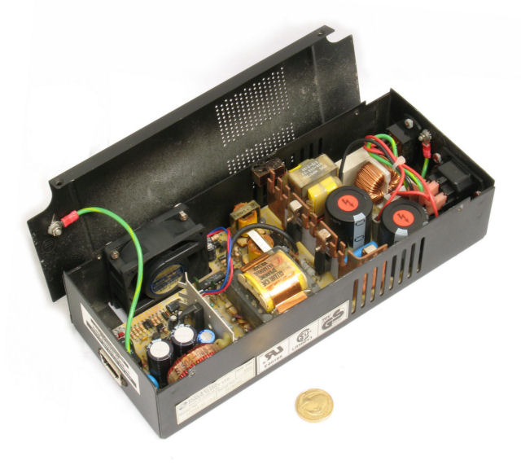

Pre-Delivery Tests:
Connect output to a 8~10 Ohm (select to suit calculations below) 150~200 watt resistor (or equivalent composed of selected individual smaller resistors in series/parallel) and run on this load for approximately 10 minutes verifying that the output voltage is 36V and free from excessive ripple/hum or un-wanted hash by looking on a scope or AC millivoltmeter.
Units that survive shall be labelled with a CASA self-adhesive or tie-on label marked TESTED-OK with the DATE of testing and INITIALS of the tester.
Test Load: 36V @ 6.25A = 225W into 5.76 Ohm load (36V/6.25A = 5.76 Ohms)
Test Load: 36V @ 4.2A = 151.2W into 8.57 Ohm load (36V/4.2A = 8.57 Ohms)

Output Connector Options:
It is proposed that the original RJ8-HD ribbon connector may be replaced with some more universal connector (D-sub) or terminal strip to suit the user/system/application. Disassembly, de-soldering and removing the RJ8 connector and substitution can be undertaken by the customer or by CASA at additional cost.

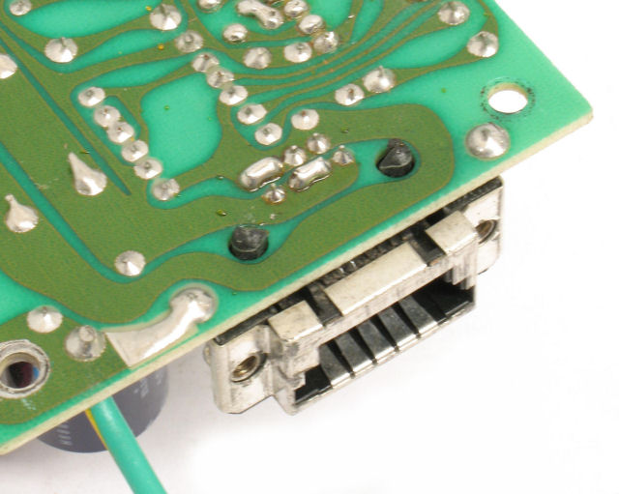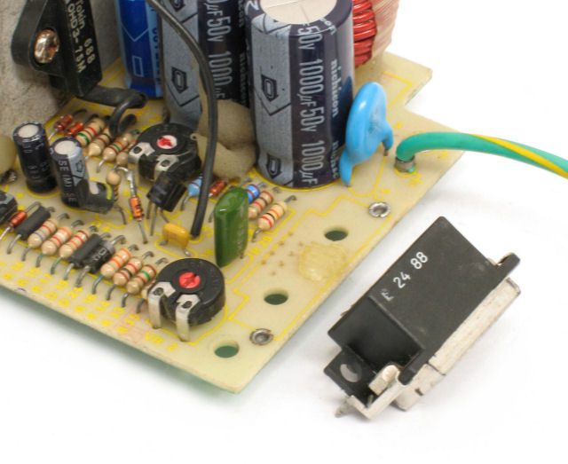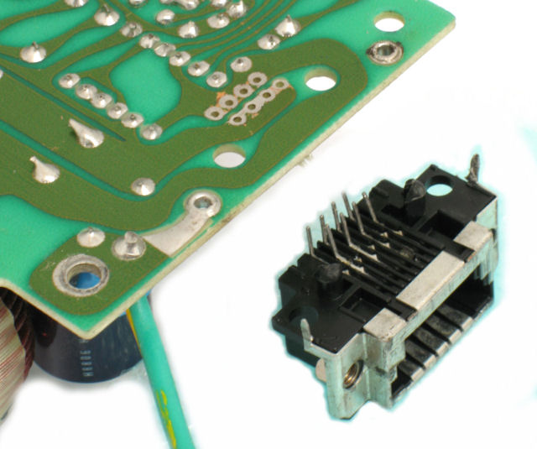

Date: 13/02/09
copyright - CASA ModularSystems 2009
Author: AlanD
sales@casa.co.nz
CASA Modular Systems
Wellington New Zealand

Phone: 64-4-9393 777
Fax: 04-9393 778
http://www.casa.co.nz/

