Hands-Free Smart-Phone Bluetooth Connection:

2016 Japanese (Kanji) Leaf - Hands-Free Smart-Phone Connection. Within this touch-panel translation 'guide' we need a step-by-step instruction for making a smart-phone blue-tooth connection to the hands-free system provided within the leaf.
Can you please produce this instruction including the touch-panel button sequence. Perhaps a flow-chart with the Kanji legend on the touch-screen would provide the best guide?
ChatGPT – 1st Response:
Alan, this is a very worthwhile addition to the 2016 Japanese-market Nissan Leaf G-Trim Touch-Panel English Guide you have been developing. The hands-free phone pairing procedure is one of the areas where the Japanese Kanji interface creates the greatest difficulty for an English-speaking owner.
For your guide, I suggest presenting it as a simple flow-chart first, followed by a button-by-button explanation. The exact Kanji wording can vary slightly depending on the Japanese navigation/audio unit fitted, but the sequence below matches the common Nissan Connect / CARWINGS touch-screen systems fitted to the ZE0/AZE0 Leaf generation.
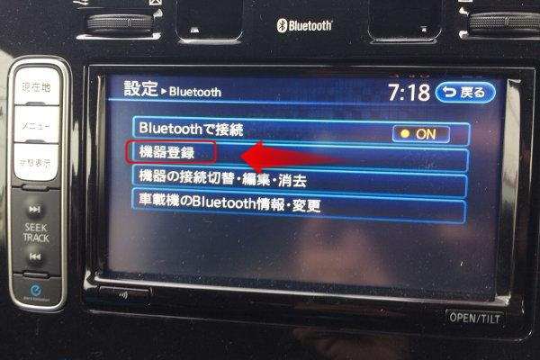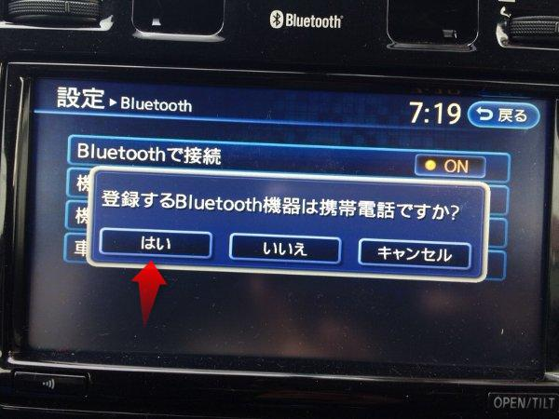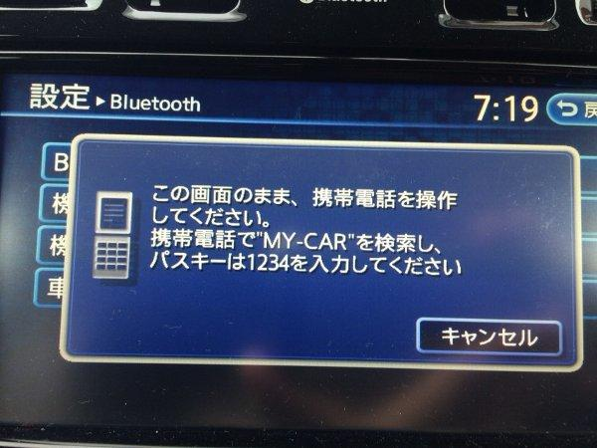
2016 Nissan Leaf (AZE0)
Bluetooth Hands-Free Phone Pairing Guide - Japanese Touch Panel → English Translation

Quick Flow Chart
START
│
▼
Press AUDIO button
(オーディオ)
│
▼
Press SETTING button
(設定)
│
▼
Select Bluetooth
(Bluetooth設定)
│
▼
Select Register Phone
(携帯電話登録)
│
▼
Touch "Add New"
(新規登録)
│
▼
Leaf displays:
"Waiting for Bluetooth connection"
│
▼
On Smartphone:
Settings
↓
Bluetooth ON
↓
Search Devices
↓
Select:
"NISSAN CONNECT"
or
"NISSAN"
│
▼
Confirm PIN code
(usually 0000 or displayed number)
│
▼
Pairing Complete
登録完了
│
▼
Enable:
Hands-Free Calling
Contacts Transfer (optional)
│
▼
FINISHED

Detailed Touch-Screen Button Sequence
Step 1 — Turn Vehicle ON
- Press brake pedal.
- Press POWER button.
- Allow the centre display to start.

Step 2 — Open Audio Menu
Touch:
オーディオ
AUDIO
Meaning:
Audio system menu

Step 3 — Open Settings
Touch:
設定
SETTING
Meaning:
System settings

Step 4 — Bluetooth Menu
Look for:
Bluetooth設定
English:
Bluetooth Settings
Possible alternative:
電話設定
English:
Phone Settings

Step 5 — Register a New Phone
Touch:
携帯電話登録
English:
Register Mobile Phone
or:
新規登録
English:
New Registration / Add Device

Step 6 — Vehicle Waiting Mode
The Leaf screen should show a message similar to:
Bluetooth接続待機中
Meaning:
Waiting for Bluetooth connection
The vehicle is now ready to be discovered.

Step 7 — Smartphone Procedure
On the smartphone:
SETTINGS
↓
Bluetooth
↓
Turn ON
↓
Search for devices
The phone should find something like:
NISSAN CONNECT
or
NISSAN
Select it.

Step 8 — Confirm Pairing Code
The Leaf and phone should display a PIN.
Common Nissan PIN:
0000
or
1234
or a generated number.
Confirm:
Phone:
PAIR
Leaf: はい
YES

Step 9 — Phone Functions
After pairing, the Leaf may ask:
Transfer phone book?
Japanese:
電話帳転送
Meaning:
Transfer Contacts
Recommended:
はい
YES

Automatic Connection
Enable:
自動接続
Meaning:
Automatic Connection
Recommended:
ON

Kanji Quick Reference Table
Japanese | English Meaning
設定 | Settings
オーディオ | Audio
電話 | Phone
Bluetooth | Bluetooth
Bluetooth設定 | Bluetooth Settings
携帯電話 | Mobile Phone
登録 | Register
新規登録 | New Registration
削除 | Delete
接続 | Connect
切断 | Disconnect
電話帳 | Phone Book
転送 | Transfer
はい | Yes
いいえ | No
戻る | Back

Steering Wheel Operation After Pairing
Once connected:
Receive call
Press:
☎ button
(on steering wheel)

End call
Press:
☎ button again

Voice operation
Press:
Voice button
(if fitted)

Recommended Addition to Your Leaf Guide
For the A4 beginner guide, I would place this as:
Chapter 4 — Connecting Your Smartphone
with:
Page 1:
Large flow-chart above.
Page 2:
Actual screen sequence:
Audio
↓
Setting
↓
Bluetooth
↓
Register Phone
↓
Pair
Page 3:
Kanji reference card.
This will complement the earlier chapters covering:
- Driver's view
- Three display panels
- Steering-wheel buttons
- Touch-screen navigation
- LeafSpy

One important note: because your Leaf is a 2016 Japanese domestic AZE0 G-Trim, there is a possibility that the fitted Nissan Connect unit is one of several Japanese variants (with CARWINGS, TV tuner, or different firmware). If you can later provide a clear photograph of the main Audio/Navigation screen showing the bottom-row buttons, I can produce a screen-by-screen facsimile guide matching your exact Kanji menus rather than the generic AZE0 sequence above.

