<http://casamodularsystems.com/index.php?main_page=product_info&cPath=3_378&products_id=670>

*Clamp-Hook-125x2BA-CP10-HB-TCC*

[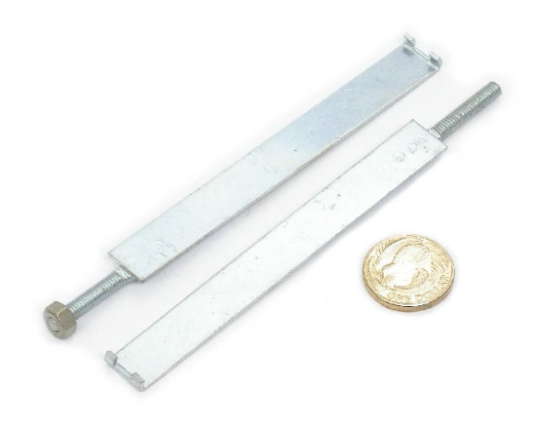](javascript:popupWindow('http://casamodularsystems.com/index.php?main_page=popup_image&pID=670'))**21 @ $1.75**

<http://casamodularsystems.com/index.php?main_page=product_info&cPath=3_249&products_id=433>

*4µF +/-20% 800Vdc @ 70C metal hermetic-sealed*

[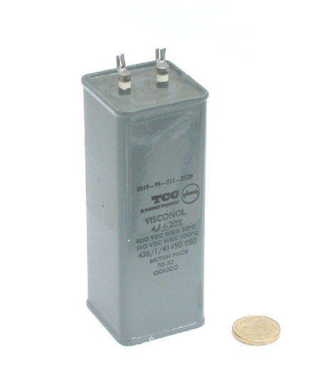](javascript:popupWindow('http://casamodularsystems.com/index.php?main_page=popup_image&pID=433'))**1 @ $44.56**

<http://casamodularsystems.com/index.php?main_page=product_info&cPath=3_249&products_id=2557>

*8µF +/-20% 800Vdc @ 70C? metal hermetic-sealed metal-case PM-film-dielectric*

[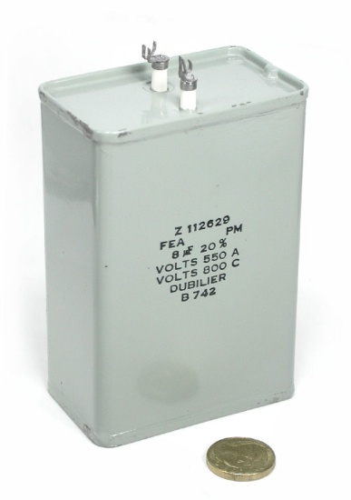](javascript:popupWindow('http://casamodularsystems.com/index.php?main_page=popup_image&pID=2557'))**9 @ $45.60**

<http://casamodularsystems.com/index.php?main_page=product_info&cPath=3_249&products_id=2563>

*8µF +/-20% 800Vdc @ 70C metal hermetic-sealed*

[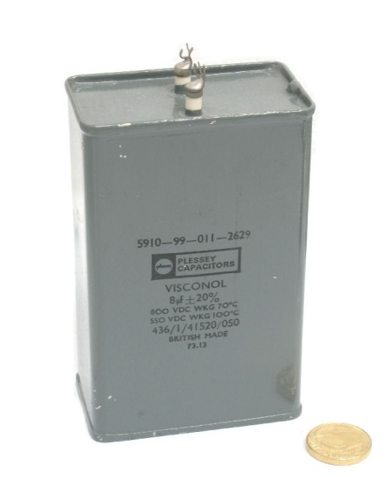](javascript:popupWindow('http://casamodularsystems.com/index.php?main_page=popup_image&pID=2563'))**22 @ $45.60**

[**http://www.casa.co.nz/Capacitors/Power/Gallery/images/8uF-800Vdc-CAN-CP152V-TCC_00.JPG**](http://www.casa.co.nz/Capacitors/Power/Gallery/images/8uF-800Vdc-CAN-CP152V-TCC_00.JPG)

*8uF-800Vdc-CAN-CP152V-TCC*

[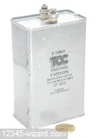](http://www.casa.co.nz/Capacitors/Power/Gallery/image302.html)**1 @ $50**

<http://casamodularsystems.com/index.php?main_page=product_info&cPath=3_249&products_id=425>

*4µF +/-5% 500Vdc @ 70C metal hermetic-sealed*

[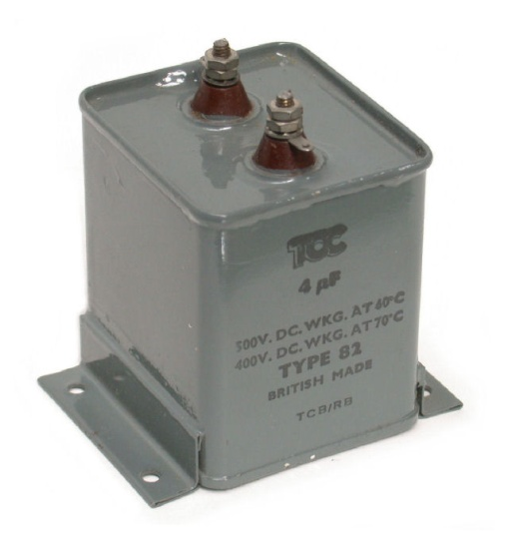](javascript:popupWindow('http://casamodularsystems.com/index.php?main_page=popup_image&pID=425'))**1 @ $24.56**

<http://casamodularsystems.com/index.php?main_page=product_info&cPath=3_249&products_id=666>

*Clamp-Hook-75x2BA-CP10*

[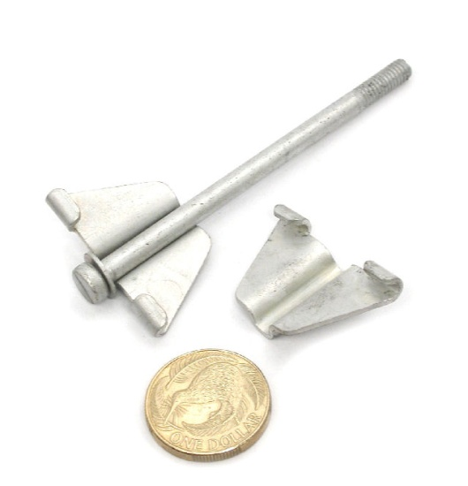](javascript:popupWindow('http://casamodularsystems.com/index.php?main_page=popup_image&pID=666'))**214 @ $2.25**

<http://casamodularsystems.com/index.php?main_page=product_info&cPath=3_249&products_id=679>

*Clamp-Hook-130x2BA-CP10-XZ11000x*

[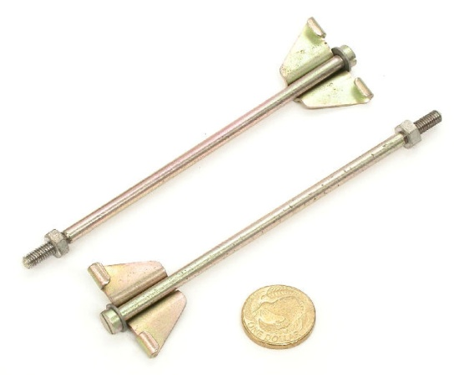](javascript:popupWindow('http://casamodularsystems.com/index.php?main_page=popup_image&pID=679'))**65 @ $2.35**

<http://www.casa.co.nz/Capacitors/Power/Gallery/images/100uF-125V-CAN-1S1000-Ducon_020.JPG>

*100uF-125V-CAN-1S1000-Ducon – COSMETICALLY paint-marked – see pictures*

[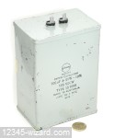](http://www.casa.co.nz/Capacitors/Power/Gallery/image30.html)**3 @ NZ$ $48.00**

<http://www.casa.co.nz/Capacitors/Power/Gallery/images/10uF-750Vdc-Type91-TCC_00.JPG>

*10uF-750Vdc-Type91-TC*

[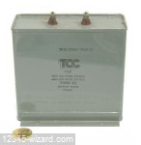](http://www.casa.co.nz/Capacitors/Power/Gallery/image32.html)**4 @ NZ$ $62.50**

http://www.casa.co.nz/Capacitors/Power/Gallery/

*4uF-350Vdc-CAN--Type62-TCC*

[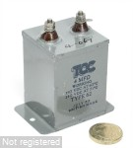](http://www.casa.co.nz/Capacitors/Power/Gallery/image191.html)**3 @ NZ$ 35.00**

<http://www.casa.co.nz/Capacitors/Power/Gallery/images/6uF-750V-CAN-431SE3-STC_00.JPG>

*6uF-750V-CAN-431SE3-STC -* Cosmetics paint-marked - see pictures

[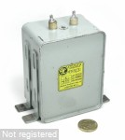](http://www.casa.co.nz/Capacitors/Power/Gallery/image261.html)**3 @ NZ$ 50.00**

<http://www.casa.co.nz/Capacitors/Power/Gallery/images/8uF-600V-CAN-Dubilier_00.JPG>

*8uF-600V-CAN-Dubilier (as new)*

[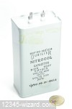](http://www.casa.co.nz/Capacitors/Power/Gallery/image280.html)**1 @ NZ$ 45.60**

<http://www.casa.co.nz/Capacitors/Power/Gallery/images/8uF-M-1k5Vdc-CAN-CP154GP-TCC_01.JPG>

*8uF-M-1k5Vdc-CAN-CP154GP-TCC – NEW but solder-terminals mushed/broken and some dents – see pictures*

[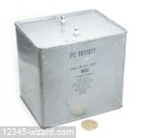](http://www.casa.co.nz/Capacitors/Power/Gallery/image288.html)**5 @ NZ$ 50.00 + 1 free(with major dent)**

[*http://www.casa.co.nz/Capacitors/Power/Gallery/images/8uF-M-200V-436141470010-TCC_022.JPG*](http://www.casa.co.nz/Capacitors/Power/Gallery/images/8uF-M-200V-436141470010-TCC_022.JPG)

*8uF-M-200V-436141470010-TCC – as already shipped (minor paint chips)*

[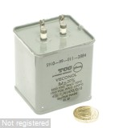](http://www.casa.co.nz/Capacitors/Power/Gallery/image329.html) **1 @ NZ$ 22.60**

<http://www.casa.co.nz/Capacitors/Power/Gallery/images/8uF-M-600V-CAN-B215-Dubilier_02.JPG>

*8uF-M-600V-CAN-B215-Dubilier – new but paint is chipped – see pictures*

[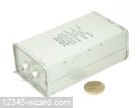](http://www.casa.co.nz/Capacitors/Power/Gallery/image322.html)**1 @ NZ$ 35.00**

<http://www.casa.co.nz/Transformers/DW/C-Core/Gallery/images/1k12V+840Vct-DW-KA30782-Cossor_011.JPG>

*1k12V+840Vct-DW-KA30782-Cossor*

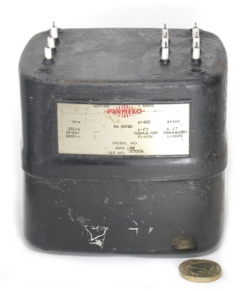**2 @ NZ$ 157.50**

<http://www.casa.co.nz/Transformers/DW/C-Core/Gallery/images/1k35Vct-100mA-DW-WIS489-11-Parmeko_08.JPG>

*1k35Vct-100mA-DW-WIS489-11-Parmeko*

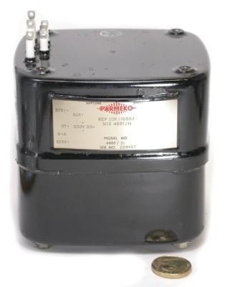**2 @ NZ$ 190.00**

<http://www.casa.co.nz/Transformers/DW/C-Core/Gallery/images/370-0-370V-500mA-DW-KA30780-Parmeko_011.JPG>

*370-0-370V-500mA-DW-KA30780-Parmeko*

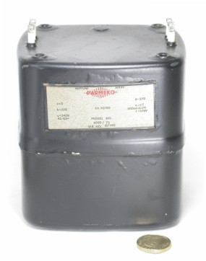**3 @ NZ$ 235.00**

<http://www.casa.co.nz/Transformers/DW/C-Core/Gallery/images/400-0-400-85mA+1k75V-DW-3558-GTL_00.JPG>

*400-0-400-85mA+1k75V-DW-3558-GTL*

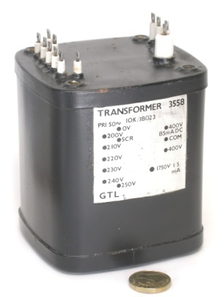**2 @ NZ$ 103.00**

<http://www.casa.co.nz/Transformers/DW/C-Core/Gallery/images/740Vct-50mA-DW-WIS4891-8-Parmeko_01.JPG>

*740Vct-50mA-DW-WIS4891-8-Parmeko*

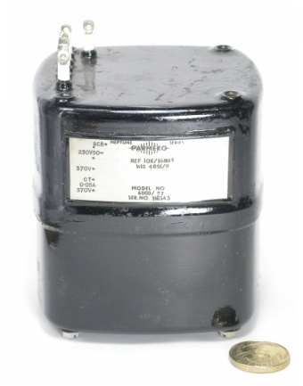**2 @ NZ$ 99.00**

<http://www.casa.co.nz/Transformers/DW/C-Core/Gallery/images/900V+700Vct+6V3+5V-DW-Wardray_00.JPG>

*900V+700Vct+6V3+5V-DW-Wardray*

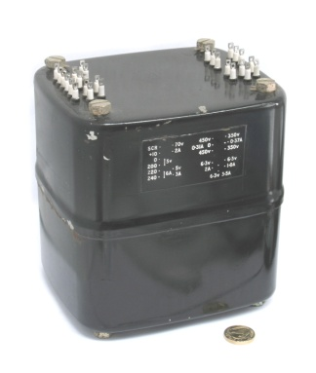**1 @ NZ$ 664.00**

<http://www.casa.co.nz/Transformers/DW/C-Core/Gallery/images/900Vct+6V3+5V-DW-Type-2924_00.JPG>

*900Vct+6V3+5V-DW-Type-2924*

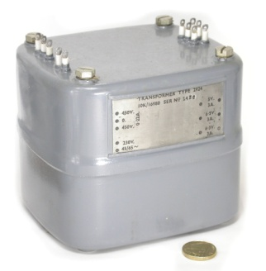**2 @ NZ$ 327.50**

<http://www.casa.co.nz/transformers/Chokes/Gallery/images/10H-225mA-6000-61-Neptune-01.JPG>

*10H-225mA-6000-61-Neptune*

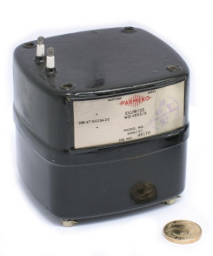**1 @ NZ$ 101.20**

<http://www.casa.co.nz/transformers/Chokes/Gallery/images/12H-200mA-KA30769-RA1822_02.JPG>

*12H-200mA-KA30769-RA1822*

***xxx @ NZ$ TBA***

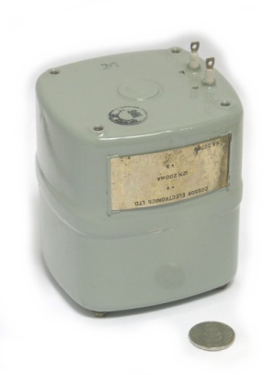

<http://www.casa.co.nz/transformers/Chokes/Gallery/images/20H-150mA-EE-1.jpg>

*20H-150mA-EE*

***xxx @ NZ$ TBA***

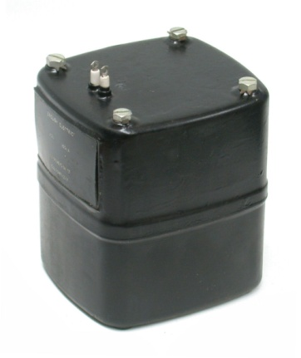

<http://www.casa.co.nz/Valves/Bases/Gallery/images/4P-Ceramic-AVH4-FQ-3.jpg>

*4P-Ceramic-AVH4-FQ*

***xxx @ NZ$ TBA***

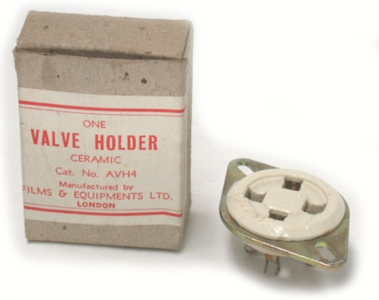

<http://www.casa.co.nz/Valves/Bases/Gallery/images/B9A-Ceramic-Au-1.jpg>

*B9A-Ceramic-Au*

***xxx @ NZ$ TBA***

