ZB-Audio – Proposed Order # 3

<http://www.casa.co.nz/transformers/Chokes/Gallery/images/12H-200mA-KA30769-RA1822_02.JPG>

*12H-200mA-KA30769-RA1822*

***xxx @ NZ$ TBA***

***Can’t find***

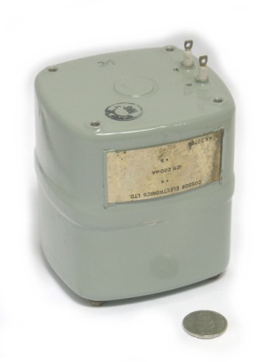

<http://www.casa.co.nz/transformers/Chokes/Gallery/images/20H-150mA-EE-1.jpg>

*20H-150mA-EE*

***xxx @ NZ$ TBA***

***cant find***

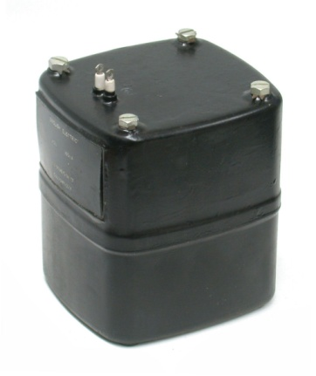

<http://www.casa.co.nz/Capacitors/Electro/Gallery/images/20uF-500V-Can-WR20-Dubilier-1.jpg>

*20uf-500V*

*64gms/each*

***1+ @ NZ$ TBA (can’t find bulk-stocks – unsure if any more left)***

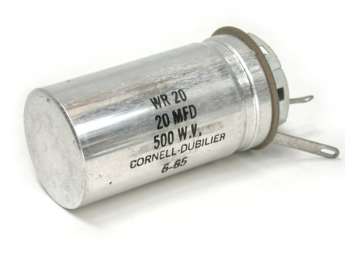

<http://www.casa.co.nz/Capacitors/Power/Gallery/images/100nF-M-1k5V-CAN-CP141GO-TCC_000.JPG>

*0.1uF-1500Vdc-TCC (Refurbished ? – some paint chips)*

*84gms/each*

***4 @ NZ$ 26.77***

<http://casamodularsystems.com/index.php?main_page=product_info&cPath=3_249&products_id=417>

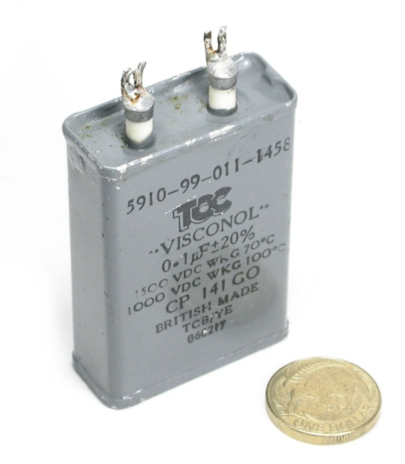

<http://www.casa.co.nz/Capacitors/Power/Gallery/images/19uF-200Vdc-CAN-211R1C196G-ElectroCube-01.jpg>

***19uF-200Vdc (refurbished – 2 brands – same Military specification)***

***130gms/each***

***3 @ NZ$ best offer considered(international scarce and some extreme prices being asked)***

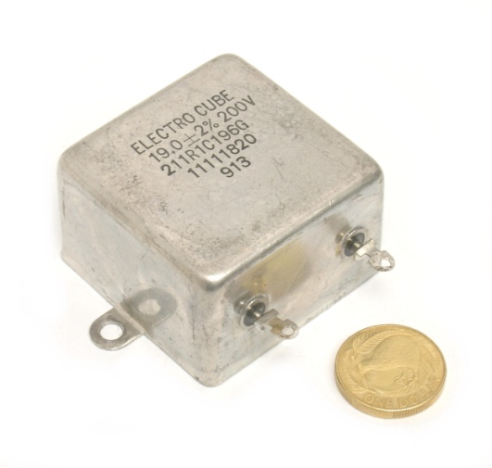

<http://www.casa.co.nz/Capacitors/Power/Gallery/images/1uF-M-1kVDC-CAN-436-TCC_00.jpg>

*1uF-1000Vdc-TCC*

*200gms/each*

***4 @ NZ$ 26.30/each***

<http://casamodularsystems.com/index.php?main_page=product_info&cPath=3_249&products_id=2552>

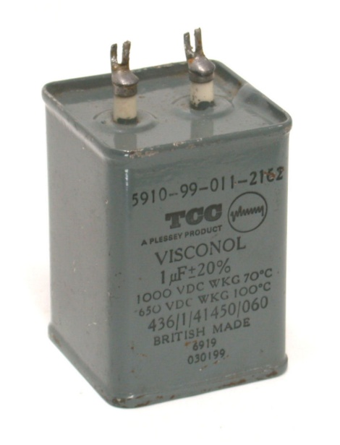

<http://www.casa.co.nz/Capacitors/Power/Gallery/images/4uF-200V-ZA1282-SC1144-Mil_00.JPG>

*4uF-200Vdc-Mil*

*125gms/ea*

***85 @ NZ$ 8.96/each (discount negotiable for quantity)***

<http://casamodularsystems.com/index.php?main_page=product_info&products_id=2556>

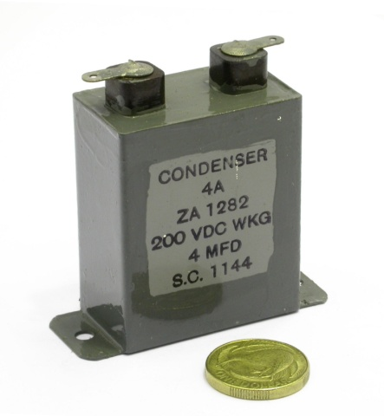

<http://www.casa.co.nz/Capacitors/Power/Gallery/images/500nF-750V-CAN-R372-Hunts_02.jpg>

*0.5uF-750Vdc-Hunts (refurbished – some paint chips – see pictures)*

*98gms/each*

***15 @ NZ$ 15.00/each***

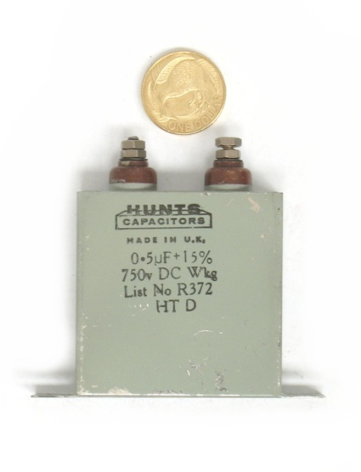

<http://www.casa.co.nz/Capacitors/Power/Gallery/images/500nF-M-1kV-CAN-CP147W-TCC_00.JPG>

*0.5uF-1000Vdc-TCC (1 new + 3 refurbished – 1 with broken solder-prongs)*

*100gms/ea*

***3 @ NZ$ 25.00***

***1 @ NZ$ 20.00 (or best offer)***

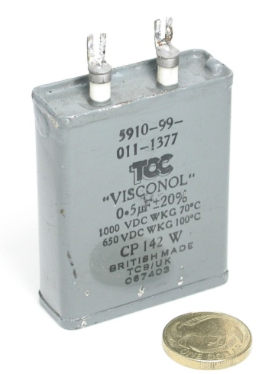

<http://www.casa.co.nz/Electrics/Switches/Rotary/Gallery/images/DSCN1450.JPG>

*1 pole x 24 position x 2 bank Rotary switch*

*xxgms/each*

***? @ NZ$ TBA***

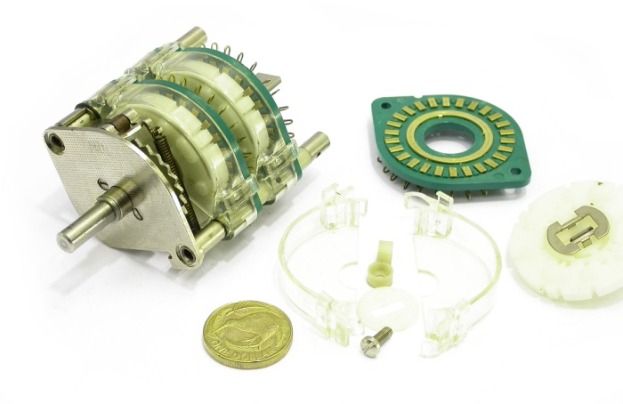

<http://www.casa.co.nz/Equipment/Audio/Gallery/images/CD101-05-Philips-1.jpg>

***sold?***

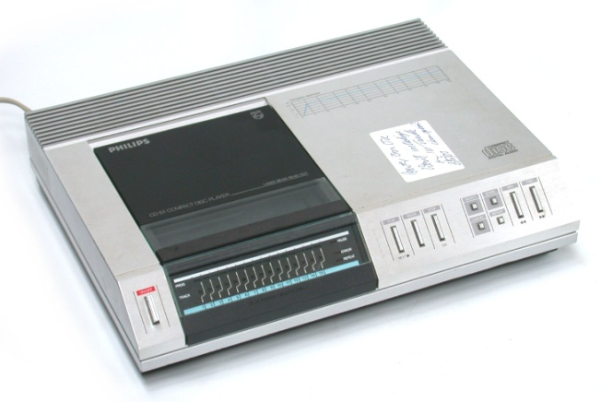

<http://www.casa.co.nz/Valves/Bases/Gallery/images/4P-Ceramic-AVH4-FQ-3.jpg>

*4P-Ceramic-AVH4-FQ*

***4 @ NZ$ TBA***

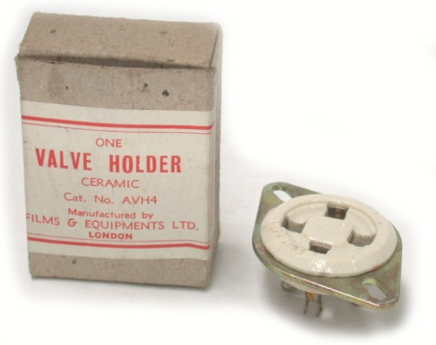

<http://www.casa.co.nz/Valves/Bases/Gallery/images/B9A-Ceramic-Au-1.jpg>

*B9A-Ceramic-Au*

***1 @ NZ$ TBA***

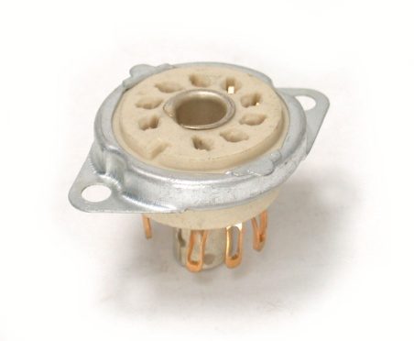

<http://www.casa.co.nz/Transformers/Gallery/images/CCore-96x58x32x18-Riko%20008.jpg>

***C-Core pairs***

***956 grams/pair***

***15pairs @ NZ$ 10/pair (could make good audio-HiFi ultra-linear 25 Watt output transformer)***

